CONTENT
 |  | Page
Chapter 1. | The subject, objects, tools and methodology of Animal Biotechnology | 2
Chapter 2. | Biosafety and Bioethics issues in Animal Biotechnology | 13
Chapter 3. | Basic technics in animal cell culture | 20
Chapter 4. | Stem cells technology | 35
Chapter 5. | Reproductive technologies in Animal Biotechnology | 53
Chapter 6. | Induction of superovulation | 57
Chapter 7. | Collection of sperm, oocytes and early embryos | 59
Chapter 8. | Artificial insemination | 67
Chapter 9. | In vitro fertilization | 71
Chapter 10. | Embryo transfer | 81
Chapter 11 | Cryopreservation of animal cells and tissues | 83
Chapter 12 | Chimeras. Xenotransplantation | 90
Chapter 13 | Cloning technology to produce animal clones | 96
Chapter 14 | Transgenic technologies in animal biotechnology | 107

Chapter 1. The subject, objects, tools and methodology of Animal Biotechnology

The present stage of scientific and technical progress characterizes the revolutionary changes in biology, which becomes the leader of natural science. Biology has reached the molecular and subcellular level, the methods of allied sciences (physics, chemistry, mathematics, cybernetics, etc.), System approaches are being intensively applied in it. Rapid development of the complex of biological profile with the expansion of the practical sphere of their application is also conditioned by the social and economic needs of society. Deficiency of food resources (especially proteins), environmental pollution, shortages of raw materials and energy resources, the need to develop new diagnostic tools and treatment cannot be solved by traditional methods. Therefore, there was an acute need for the development and application of fundamentally new methods and Technologies. A big role in solving a complex of these problems is given to biotechnology, within the framework of which the targeted use of biological systems and processes in various spheres of human activity is carried out.
The developing world is grossly unprepared for the new technological and economic opportunities, challenges and risks that lie on the horizon. In most developing countries, biotechnological applications relating to livestock need to be suitable for animal owners who are resource-poor small-scale operators who own little or no land and few animals.
The use of scientific achievements and practical advances in biotechnology are closely connected with fundamental research and are realized at the highest level of modern science.
Animal biotechnology is quite new science, which aroused from such of basic sciences as Developmental Biology, Cell Biology, Genetics and Molecular Biology, Gene Engineering. In this regard, we would like mark the amazing scientific diversity of animal biotechnology: its development and achievements are closely related and depend on a complex of knowledge not only in biological sciences, but also in many others (see the figure 1).
Developmental Biology
Cell Biology
Molecular Biology

Animal Biotechnology
Gene Engineering Developmental Biology
Geneticsy

Bioinformatics Bioinformatics Bioinformatics ss Developmental Biology
Electronics Electronics s Developmental Biology
Physics Physics s Developmental Biology
Chemistry Chemistry s Developmental Biology

Figure 1 - Interdisciplinary nature of Animal Biotechnology

Animal Biotechnology is innovative discipline. Animal Biotechnology provides new technologies for getting basic knowledge in:
- Biology
- Agriculture
- Medicine
- Pharmacology
- Ecology etc.
Animal biotechnology is the use of science and engineering to modify living organisms. The goal is to make products, to improve animals and to develop organisms for specific agricultural and medicine uses.
Animals are playing a growing role in the advancement of biotechnology, as well as increasingly benefiting from biotechnology.
Combining animals and biotechnology results in advances in four primary areas:
- Advances in human health
- Improved animal health and welfare
- Enhancements to animal products
- Environmental and conservation benefits
Examples of animal biotechnology include creating transgenic animals (animals with one or more genes introduced by human intervention or animals with a specific inactivated gene using gene knock out technology), chimeric (or alophaenic animals) to make and producing nearly identical animals by somatic cell nuclear transfer (or cloning) (see figure 2).

Animal Biotechnology

Chimeras Bioinformatics Bioinformatics ss Developmental Biology
Clones Chemistry s Developmental Biology
Transgenic animals malsPhysics s Developmental Biology

Figure 2 – 3 types of animals created by the tools of Animal Biotechnology

Animal biotechnology is a huge field of study and includes the following topics: use of animals in research, clones, transgenic animals, gene pharming, and animal health. Along with the scientific study, researchers must also deal with many tough scientific and ethical challenges.
Animal biotechnology provides new tools for improving human health and animal health and welfare and increasing livestock productivity. Biotechnology improves the food we eat - meat, milk and eggs (see figure 3).
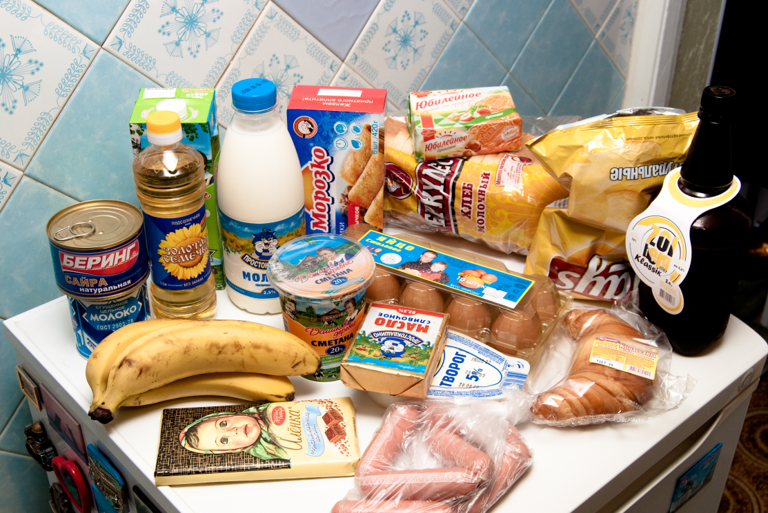
Figure 3 - Animal Biotechnology provides a number of products we use in everyday life.

Biotechnology can improve an animal’s impact on the environment. And biotechnology enhances ability to detect, treat and prevent diseases.
Just like other assisted reproduction techniques such as artificial insemination, embryo transfer and in vitro fertilization, livestock cloning improves animal breeding programs allowing farmers and ranchers to produce healthier offspring, and therefore producer healthier, safer and higher quality foods more consistently.
Livestock is becoming increasingly important to economic growth in developing countries and the application of biotechnology is largely dictated by commercial considerations and socio-economic goals. Using technology to support livestock production is an integral part of viable agriculture in multi-enterprise systems. Livestock are part of a fragile ecosystem and a rich source of animal biodiversity, as local species and breeds possess genes and traits of excellence. Molecular markers are increasingly being used to identify and select the particular genes that lead to these desirable traits and it is now possible to select superior germ plasm and disseminate it using artificial insemination, embryo transfer and other assisted reproductive technologies. These technologies have been used in the genetic improvement of livestock, particularly in cattle and buffaloes, and the economic returns are significant. However, morbidity and mortality among animals produced using assisted reproductive technologies lead to high economic losses, so the principal application of animal biotechnology at present is in the production of cheap and dependable diagnostic kits and vaccines.
Animal Biotechnology provides a new methods of reproduction and saving the Animals (see figure 4):
- Artificial insemination
- In vitro fertilization
- Cloning
- Cryobanking of sperm, eggs and embryos

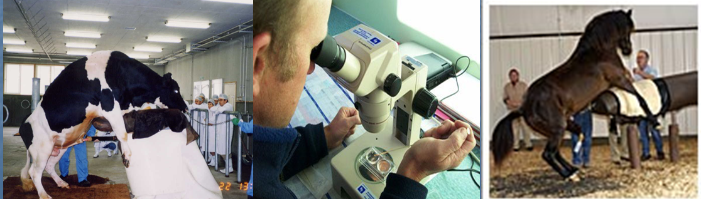Figure 4 – The basic methods of reproduction and saving animals

Animal Biotechnology to Improve Animal Health and Advance Human Health
For decades, farmers have been improving livestock herds through enhanced animal husbandry practices and more modern technologies, such as artificial insemination, embryo transfer, in vitro fertilization, genetic mapping and cloning.
Through biotechnology, farmers can enhance breeding, resulting in healthier herds.
Additionally, the animal health industry has developed treatments that can prevent and treat disease. New vaccines, diagnostic tests and practices can help farmers treat animal diseases, while reducing food borne pathogens at the farm level.
Animals have been used for years to produce medicines for humans. Animal made pharmaceuticals transform biotech animals into “factories” to produce therapeutic proteins in their milk, eggs, and blood, which can be used in the development of biopharmaceuticals. In addition, biotechnology can be used to produce human - compatible transplant organs, tissues and cells in pigs that can be vital to enhancing human health. So, Animal Biotechnology provides new technologies (see figure 5) for diagnosis and therapy of Animal and Human diseases.

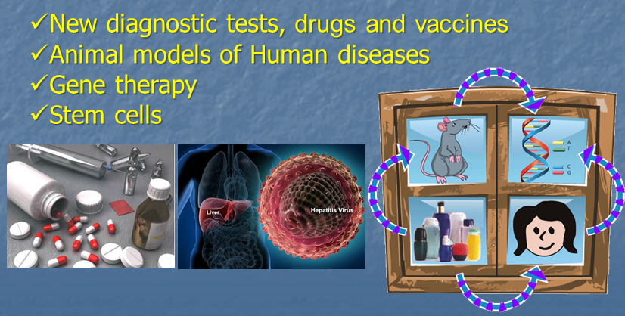
Figure 5 - New technologies for diagnosis and therapy of Animal and Human diseases
Biotechnology to Develop More Nutritious Food
Improved animal health conditions from vaccines, medicines and diagnostic tests result in safer foods for consumers. In addition, food quality may be improved by introducing desirable traits through introduction of new genes into farm livestock and poultry. In the future, meat, milk and egg products from animals can be nutritionally enriched with the usage of biotechnology.
Conservation of Environment and Animals
Biotechnology can help produce environmentally friendly animals, as well as conserve endangered species. Farm animals and their feeds have been improved through biotechnology to reduce animal wastes, minimizing the impact on the environment. Today’s reproductive and cloning techniques offer the possibility of preserving the genetics of endangered species. Genetic studies of endangered animals can also result in increased genetic diversity which can result in healthier populations of species.
Objects
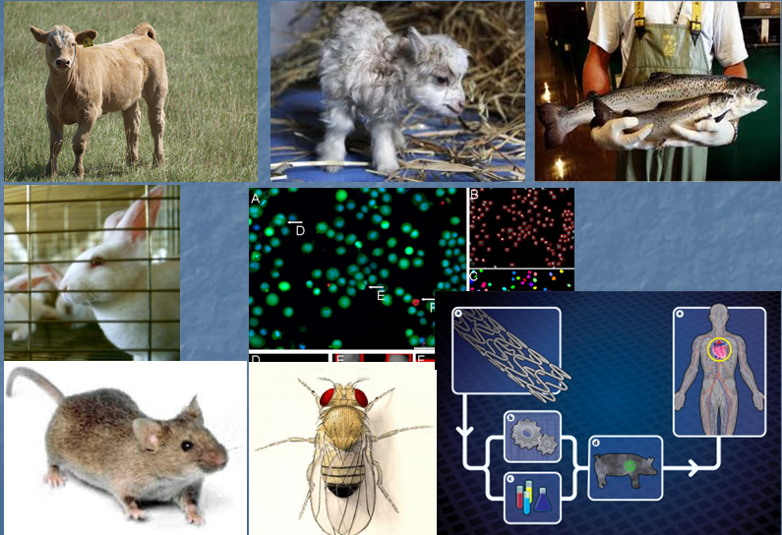
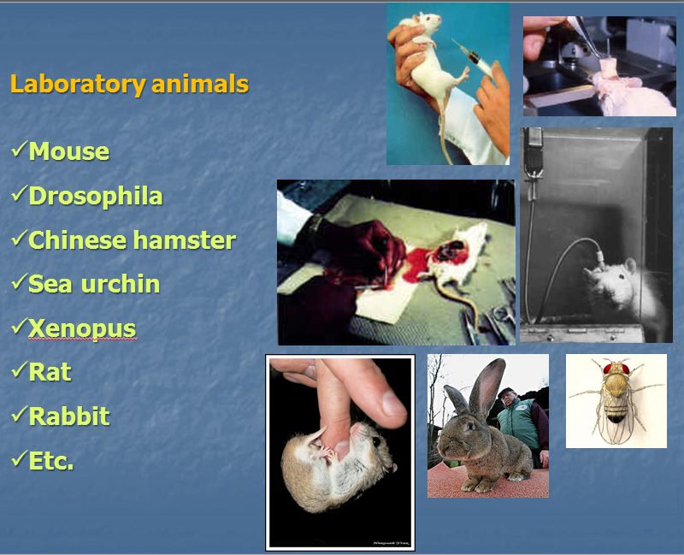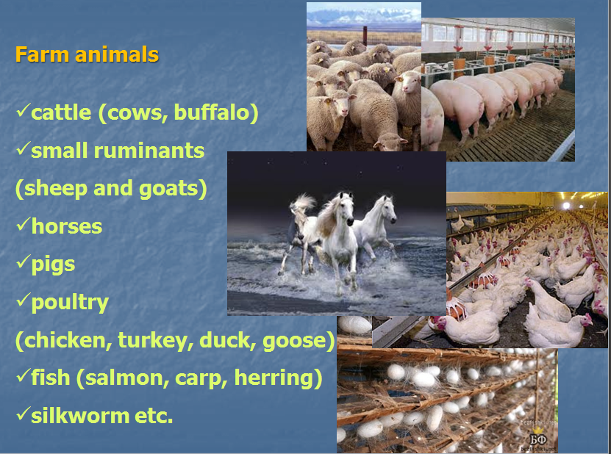
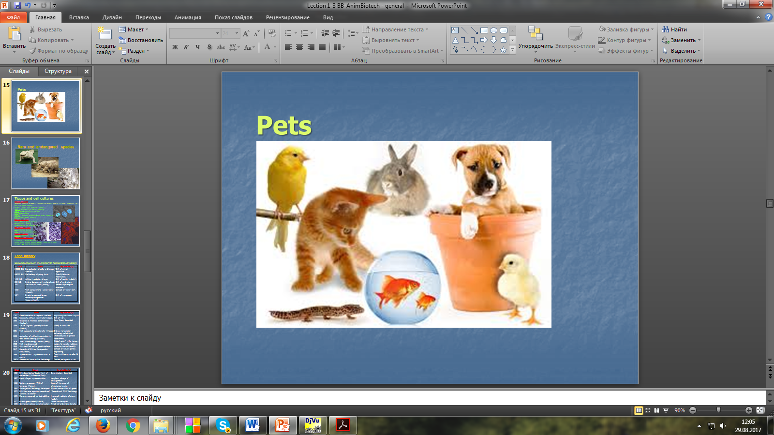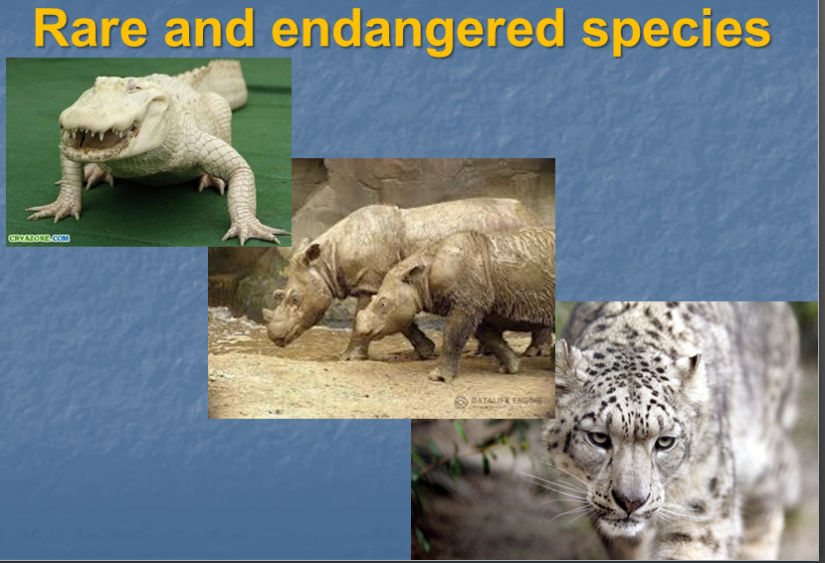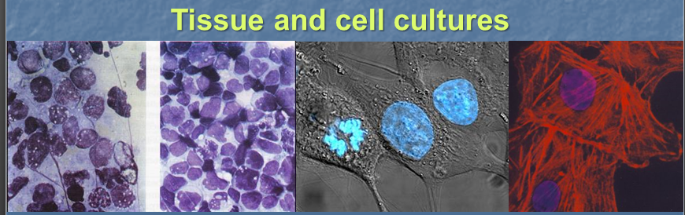
Figure 6 – Objects of Animal Biotechnology

All living animals and their cells can be an object of Animal Biotechnology (see figure 6). There are laboratory animals, farm animals, pets, rare and endangered species. Tissue and cultures also are the objects of Animal Biotechnology. Most applicable tissue and cell cultures are stored in the big scientific centers. For an example, National Cancer Institute’s has more than 60 Human cancer cell lines ((NCI60); ESTDAB database etc.). Among them there are HeLa (cervical cancer), DU145; Lncap, PC3 (prostate cancer), MCF-7, MDA-MB-438 (breast cancer), THP-1 (acute myeloid leukemia), U87 (glioblastoma), SHSY5Y (Human neuroblastoma cells, cloned from a myeloma, Saos-2 cells (bone cancer). In big biobanks there are Primate cell lines: Vero (African green monkey Chlorocebus, kidney epithelial cell line initiated in 1962), Rat tumor cell lines, GH3 (pituitary tumor), PC12 (pheochromocytoma), Mouse cell lines, MC3T3 (embryonic calyarium). Biotechnologists also use other species cell lines (Zebra fish ZF4 and AB9 cells, Madin-Darby canine kidney MDCK, epithelial cell line Xenopus A6, kidney epithelial cells etc.).
Animal models
There are 4 types of animal models, which we use animal biotechnology aims:
- Living animals
These animals are living and usually no threat to their wellbeing. Such animals may be known as a laboratory scientific animals (mouse, drosophila, Chinese hamster, sea urchin, xenopus, rat, rabbit etc.). Agricultures research often uses experimental groups of animals.
- Living animal tissues (cell cultures) or systems
Animal tissues can be cultured in a lab. This saves to use of animals as well as the expense of feeding, housing and cleaning up after the animals.
- Non-Living systems
Non-living systems includes using no living mechanical models which reflect animal activity. Very often these relate to skeletal movement and locomotion. Artificial replacement parts, such as hip joints can be studied using non-living systems.
- Computer and Mathematical approaches
Computer simulation with virtual reality and other applications help in biotechnology. Computer modeling may be done with a propose biotechnology practice before it is tested with animals.
Methodology
The methodology of Animal Biotechnology has long history (see table 1). We can believe that some of the first biotechnology in use includes traditional breeding techniques that date back to 5000 B.C.E. Such techniques include crossing diverse strains of animals (well known as hybridizing method) to produce greater genetic variety of animals. The offspring from these crosses then are bred selectively to produce the greatest number of desirable traits. For an example, female horses have been bred with male donkeys to produce mules, and male horses have been bred with female donkeys to produce hinnies, for use as work animals, for the past 3,000 years. This method continues to be used today.
The modern era of biotechnology began in 1953, when James Watson, American biochemist, and Francis Crick, British biophysicist, presented to world their double-helix model of DNA. That was followed by Swiss microbiologist Werner Arber’s discovery in the 1960s of special enzymes, called restriction enzymes (or restrictases), in bacteria. These enzymes cut the DNA strands of any organism at precise sites. In 1973, American geneticist Stanley Cohen and American biochemist Herbert Boyer removed a specific gene from one bacterium and inserted it into another bacterium strain using restrictases. That event marked the beginning of recombinant DNA technology, or genetic engineering. In 1977, genes from other organisms were transferred to bacteria, an achievement that led eventually to the first transfer of a human gene.

Table 1 - Some Milestones in the History of Animal Biotechnology
Date | Event | Implication(s)
3-9000 B.C. | Domestication of cattle and horses / livestock. | Birth of animal agriculture.
8-9000 B.C. | Orchiectomy of young bulls. | Growth/behavior modification.
1400 B.C. | Artificial incubation of eggs. | Birth of poultry 'industry'.
300 B.C. | Embryo development systematized. | Birth of embryology.
1651 | Circulation of blood (Harvey). | Modern Physiological principles.
1665 | Plant compartments called "cells" (Hooke). | Concept of "cells" born.
1674 | Simple lenses used to see microscopic organisms (Leeuwenhoek). | Birth of microscopy.
1760 | Genetic selection to improve livestock. | "Engineering" of livestock begins.
1780 | Successful artificial insemination (dogs). | Birth of "AI".
1856 | Existence of microbes demonstrated (Pasteur). | Germ theory described.
1859 | On the Origin of Species published (Darwin). | Theory of evolution.
1891 | First successful embryo transfer (Heape). | Embryo manipulation technology established.
1900 | Application of artificial insemination in food animal breeding (Ivanov). | Increased pace of genetic improvement.
1919 | Term "biotechnology" coined (Ereky). | 'Biotechnology' in the lexicon.
1935 | First virus discovered. | Vectors for genetic mutations.
1944 | DNA identified as the genetic material. | Molecular basis of heredity.
1947 | Elements of DNA are transposable (McClintock). | Concept of natural genetic engineering.
1949 | Cryoprotectants / cyropreservation of sperm. | Freezing/shipping gametes & cells.
1950's | Mammalian tissue culture technology. | Tissues/cells grown in Lab.
1953 | DNA described as 'double-helix' of nucleotides (Watson and Crick). | Gene structure described.
1957 | Liquid nitrogen cyropreservation | Long-term storage of cells/gametes.
1960 | Radioimmunoassay (RIA) of hormones (Yalow). | Assay of hormones at physiological levels.
1966 | Microinjection technology developed. | Physical manipulation of genes.
1973 | DNA from one organism 'recombined' with that of another. | "Recombinant DNA" technology.
1975 | Monensin approved as feed additive. | Improved metabolic efficiency (cattle).
1977 | Human gene cloned (Itakura). | Genes can be copied.
1978 | Commercial estrous synchronization (cattle). | Timed 'AI' and embryo transfer.
1980-81 | First transgenic mice (mice bearing foreign genes). | Mammalian genetic engineering.
1981 | Transfer of murine embryonic stem (ES) cells. | Totipotent ES cells aid transgenics.
1983 | Polymerase chain reaction (PCR) described (Mullis). | Rapid amplification, detection and cloning of genes.
1985 | First transgenic domestic animals produced (pig). | Genetic engineering of livestock.
1987 | Targeted gene disruption (gene 'knockout'). | Loss of gene function studies/therapies.
1989 | Targeted DNA integration and germ-line chimeras (mice). | Potential for tissue engineering and gametic transmission of transgenes.
1993 | Recombinantly produced growth hormone (rbGH / 'POSILAC') approved for dairy cows. | Pharmacologically enhanced milk production.
1993-95 | Functional nucleic acid vaccines introduced. | Engineering medicines.
1996 | Sheep cloned by somatic (body) cell transfer. | True mammalian cloning possible.
1998 | Human embryonic stem cells derived. | Multiple therapies for genetic and immunological disorders.
1999 | A diagnostic test allows quick identification of Bovine Spongicorm Encephalopathy (BSE, also known as “mad cow” disease) and Creutzfeldt-Jakob Disease (CJD) | Quick development of diagnostic tests for farm animal diseases
2001 | FDA approves Gleevec® (imatinib), a gene-targeted drug for patients with chronic myeloid leukemia. Gleevec is the first gene-targeted drug to receive FDA approval. | Pharmacogenetics and targeted therapy are fast developing.
2002 | The banteng, an endangered species, is cloned for the first time. | Endangered species cloning researches.
2003 | China grants the world’s first regulatory approval of a gene therapy product, Gendicine (Shenzhen SiBiono GenTech), which delivers the p53 gene as a therapy for squamous cell head and neck cancer. | Gene therapy products in clinics.
1984-2003 | The Human Genome Project (HGP) completes sequencing of the human genome. | The HGP can help us understand human and animal diseases. Commercial development of genomics research related to DNA based products.
2007 | FDA approves the H5N1 vaccine, the first vaccine approved for avian flu. | Developing of animal disease protecting vaccines.
2009 | FDA approves the first genetically engineered animal for production of a recombinant form of human antithrombin. | Animals modeling in pharming

Animal biotechnology in use today is based on the science of genetic engineering. Under the umbrella of genetic engineering exist other technologies, such as allophaens, transgenics and cloning, that also are used in animal biotechnology. 3 basic methodological approaches of Animal Biotechnology (xenotransplantation, cloning, and genetic engineering) nowadays are not exist independently. Pointed methodological approaches complement and enrich each other.
Figure 7 demonstrates the different genetic background of chimeras, clones, and transgenic organisms.

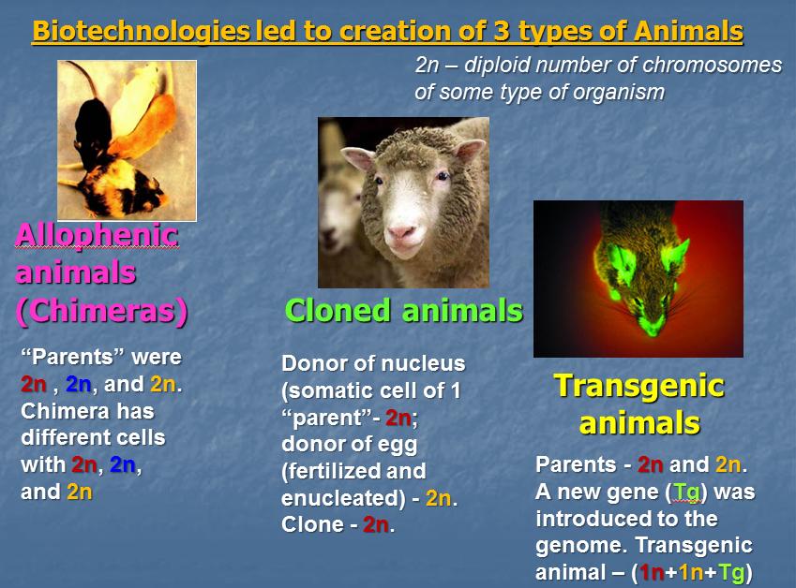
Figure 7 – The genetic background of 3 types of animals produced by biotechnology tools
Chimeras
The main methodological approach to get chimeras is transplantation of cells, tissues or organs from one individual to another. The special term – xenotransplantation means the transplantation of living cells, tissues or organs from one species to another. Transplanted cells, tissues or organs are called xenografts or xenotransplants. It is contrasted with allotransplantation when cells, tissues or organs are transplanted from other individual of same species. If two genetically identical individuals of the same species exchange by cells tissue or organs it will be termed as syngeneic transplantation. And Autotransplantation defines the transfer of one part of the body to another in the same individual.
Clones
Researches use reproductive cloning techniques to produce multiple copies of mammals that are nearly identical copies of other animals, including transgenic animals, genetically superior animals and animals that produce high quantities of milk or have some other desirable trait. To date, cattle, sheep, pigs, goats, horses, mules, cats, rats and mice have been cloned, beginning with the first cloned animal, a sheep named Dolly, in 1996.
The somatic cell nuclear transfer (SCNT) technology led to development of Reproductive cloning. Using SCNT scientists remove the nucleus from an egg cell (oocyte) and replace it by the nucleus from a donor adult somatic cell, which is any cell in the body except for an oocyte or sperm. For reproductive cloning, the embryo carrying the nuclei of somatic cell is implanted into a uterus of a surrogate female, where it can develop into a live being.
Transgenics
Transgenics are the transferal of a specific gene from one organism to another. The approach is also known as recombinant DNA technology. Gene splicing is used to introduce one or more genes of an organism into another organism. A transgenic animal is created once the second organism incorporates the new DNA into its own genetic material.
In gene splicing, DNA cannot be transferred directly from its original organism, the donor, to the recipient organism, or the host. Previously the donor DNA must be cut and pasted, or recombined, into a compatible fragment of DNA from a vector - an organism that can carry the donor DNA into the host organism. Often the host organism is a rapidly multiplying microorganism such as a harmless bacterium (E. coli, B. subtilis), which serves as a factory where the recombined DNA can be copied in large quantities. The subsequently produced protein then can be removed from the host and used as a genetically engineered product in humans, other animals, plants, bacteria or viruses. The donor DNA can be introduced directly into an organism by techniques such as injection through the cell walls of somatic cell or into the fertilized egg of an animal.
This transferring of genes alters the characteristics of the organism by changing its protein makeup. Proteins, including enzymes and hormones, perform many vital functions in organisms. Individual genes direct an animal’s characteristics through the production of proteins.
Other Technologies
In addition to the use of transgenics and cloning, scientists can use gene knock out technology to inactivate, or “knock out,” a specific gene. This technology is provided a possible source of replacement organs for humans. As we mentioned before the process of transplanting cells, tissues or organs from one species to another is referred as xenotransplantation. Currently, the pig is the major animal being considered as a viable organ donor to humans. Unfortunately, pig cells and human cells are not immunologically compatible. Pigs, like almost all mammals, have markers on their cells that enable the human immune system to recognize them as foreign and reject them. Genetic engineering is used to knock out the pig gene responsible for the protein that forms the marker to the pig cells.
Mail stones of applications
- Improving the animals
Transgenic animals with increased growth rates, enhanced lean muscle mass, enhanced resistance to disease or improved use of dietary phosphorous to lessen the environmental impacts of animal manure.
- Farming
Transgenic poultry, swine, goats and cattle that generate large quantities of human proteins in eggs, milk, blood or urine, using these products (enzymes, clotting factors, albumin and antibodies) as human pharmaceuticals.
- The use of animal organs in humans
Pigs currently are used to supply heart valves for insertion into humans, but they also are being considered as a potential solution to the severe shortage in human organs available for transplant procedures.
The Future of Animal Biotechnology
- The government agencies will more involve in the regulation of animal biotechnology
Likely will rule on pending policies and establish processes for the commercial uses of products created through the transgenic and cloning technologies
- The use of animal organs in human transplant operations.
- Inventions of new methods of in vitro fertilization (IVF) and preimplantation diagnostic (PGD)
- The widespread use of stem cells technologies in medicine

Related Issues
Positive:
- enhanced nutritional content of food for human consumption;
- a more abundant, cheaper and varied food supply;
- agricultural land-use savings;
- a decrease in the number of animals needed for the food supply;
- improved health of animals and humans;
- development of new, low-cost disease treatments for humans;
- and increased understanding of human disease.
Negative:
- potential effects of transgenic food products to Human;
- potential effects on the environment and the effects on animal welfare;
- a majority of the public is uncomfortable with genetic modifications to animals, cloning of animals and potentially Human, and also IVF technology.

Chapter 2. Biosafety and Bioethics issues in Animal Biotechnology

Before turn to ethical points of Animal Biotechnology we need in definitions.
Biosafety deals with prevention of large scale loss of biological integrity focusing both on ecology and human health. It is related to several fields such as ecology, agriculture, medicine, chemistry and ecobiology.
Bioethics is the philosophical study of the ethical controversies brought about by advances in biology and medicine. It is concerned with the ethical questions that arise in the relationships among life sciences, biotechnology, medicine, politics, law, philosophy and theology. It is concerned with the nature of life and death, the kind of life to be considered worth living, what constitutes murder, how people in very painful circumstances should be treated, what are the responsibilities of one human being to others, and other such living organisms.
What we expect from Animal Biotechnology?
There are some answers on this question. First of all, we should expect growing use and demand for agricultural animal biotechnology. Secondly, the development of animal biotechnology for biomedical purpose, for needs of Humans and companion animals. This includes the genetic selection, gene therapy, disease management. The government agencies will more involve in the regulation of animal biotechnology, likely will rule on pending policies and establish processes for the commercial uses of products created through the animal transgenic and cloning technologies, the use of animal organs in human transplant operations, inventions of new methods of in vitro fertilization (IVF) and preimplantation diagnostic (PGD), the widespread use of stem cells technologies in medicine, the new gene therapy protocols for inherited monogenic diseases, neuro-generative and cancer states, the invention of new gene therapy methods. Politics expect the potential negative effects of transgenic food products to Human, potential effects on the environment and the effects on animal welfare, a majority of the public is uncomfortable with genetic modifications to animals, cloning of animals and potentially Human, and also IVF technology.
There are some areas of ethical concern about Animal Biotechnology. First of all we should mention possible safety/risk, long/short–term effects, environmental impact, distributive justice. Is really biotechnology produced animal harmed? And who benefits from it?
In this regard we can note the most discussed problems (see figure 8):
- Designer babies
- Perfecting humans
- Human cloning
- Genetically modified (GM) food
- Reproductive tourism

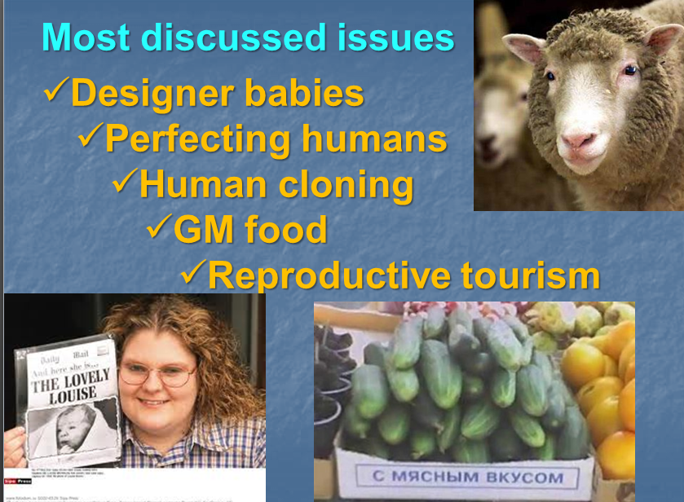
Figure 8 – Most discussed bioethical problems

The genetic engineering of animals has increased significantly in recent years. In connection with the widespread using of this technology there are many ethical issues arose, some of which relate to animal welfare - defined by the World Organization for Animal Health as “the state of the animal…how an animal is coping with the conditions in which it lives”. These issues need to be considered by all stakeholders, including veterinarians, to ensure that all parties are aware of the ethical issues at stake and can make a valid contribution to the current debate regarding the creation and use of genetically engineered animals. In addition, it is important to try to reflect societal values within scientific practice and emerging technology, especially publicly funded efforts that aim to provide societal benefits, but that may be deemed ethically contentious. Genetically engineered animals bring the extra challenges, and as a result of that, governing organizations have started to develop relevant policies, often calling for increased vigilance and monitoring of potential animal welfare impacts. Veterinarians can play an important role in carrying out such monitoring, especially in the research setting when new genetically engineered animal strains are being developed.
Several terms are used to describe genetically engineered animals: genetically modified, genetically altered, genetically manipulated, transgenic, and biotechnology-derived, amongst others. In the early stages of genetic engineering, the primary technology used was genetically transformation, transgenesis. These terms mean the transfer of genetic material from one organism to another. However, with advances in the field, new technology emerged that did not necessarily require transgenesis: recent applications allow for the creation of genetically engineered animals via the deletion of genes, or the manipulation of genes already present.
Human Genome projects achievements are broadly discussed in the world. We should point it. Benefits of HGP:
- Already the genes for many diseases (various cancers, Alzheimer’s disease, and polycystic kidney disease) have been identified.
- Genomic sequencing allows rapid and accurate diagnosis for individuals.
- Earlier detection of genetic predispositions to disease can be used for late onset of genetically-inherited diseases.
- Many gene therapy protocols are being tested
- Other advantages of the sequencing include genetic testing and screening, and its use in reproductive technologies for preimplantation diagnosis.
- We can make rational drug design, so that drugs can be designed to target the cause of the disease. The drugs can be designed for specific individuals, pharmacogenics, “custom drugs”, which will change the prescription of drugs.
- The risk assessment of health damage and risks caused by radiation exposure, including low-dose exposure, and assessment of health damage and risks caused by exposure to mutagenic chemicals and cancer causing toxins, to reduce the likelihood of heritable mutations.
- DNA fingerprinting methods was invented and databases were designed.
Since the beginning of the Human Genome Project, many ethical questions were raised. Recognizing that, the U.S. Department of Energy (DOE) and the National Institutes of Health (NIH) allocated 3–5% of their total expenditure on HGP for the Ethical, Legal, Social Implications (ELSI) arising out of the Genome Project. This represented the world’s largest bioethics program. The European Commission only started funding the HGP when it had set up an ELSI program. Since then there have been contemporary efforts going on to answer some of the bioethical challenges of the Human Genome Project.
Bioethics can be called as love of life. It is the concept. Bioethics could be viewed in descriptive, prescriptive and interactive ways. Interactive bioethics is discussion and debate between people and groups within society. Different sectors of society have been involved in the HGP, from ordinary people, patients, scientists, industry, governments, legal system, regional and international organizations, and the United Nations.
To control the bioethics issues many countries developed special documents.
So, the safety of GM foods in European Commission is controlled by Regulation EC No. 258/97, which had introduced a mandatory premarket safety assessment for all novel foods produced after May 1997. In USA: Food and Drug Administration (FDA) controls GM food safety and distribution. In GB: UK Consumers’ Association. In Kazakhstan the law about genetic engineering activity and GM products is still discussed.
- Due to multiple regulation documents and rules of GM food controlling we can mark common traits:
- Checking the source of any food is one among the primary duties of individual consumers.
- You should buy GM food only for yourself.
- The first use of GM food labeling was arisen from the collaboration of two government agencies, Health Canada and the Canadian Food Inspection Agency (CFIA).
- Different countries use different systems of labeling and control for GM food.
Reproductive technics also induce bioethical concern. Development in public attitudes in this field:
- Unnatural/Irreverent – genetic engineering, cloning, Frankenstein, Playing God, hubris
- Valuing of human life
- Speed of scientific developments – black run
- Further breaking link between sex and reproduction
- Perceived threat to “traditional family” and relationships
- Extension of practices for social reasons/convenience
- Addition of desirable characteristics
- Reproductive tourism
In this regard I would like mention the good, reasonable flexible system of control reproductive technics in UK (Committee of inquiry into human fertilization and embryology, Warnock Reports). Stem cells technologies development also regulated by this Committee.
Stem cells: what is permitted in UK:
- Adult stem cells (bone marrow)
- Fetal cells (cord blood)
- Embryonic stem cells (pre-implantation embryos)
- “spare” IVF embryos
- embryos created from donated gametes
- somatic cell nucleus transfer from donated oocytes
Techniques not currently permitted in the UK:
- Use of spermatids
- Fragment removal
- Ooplasmic transfer
- Selection of embryos for non-medical genetic traits
- Human reproductive cloning
It is very important that therapeutic cloning is permitted – cloning of modified (healthy) cells and then transfer to sick body. But reproductive cloning is not permitted.
Creation of the regulating documents in the field of animal biotechnology questions is not fast procedure and many points should be taken into account. There are: human rights, animal rights, authority, autonomy, ownership, justice, confidentiality and privacy, responsibility, scientists and social duty etc.
Very good example of regulation rules gives Good Laboratory Practice (GLP).
GOOD LABORATORY PRACTICE (GLP) PRINCIPLES
1. Test Facility Organization and Personnel Management’s responsibilities
Test facility management should ensure that the principles of good laboratory practice is complied with in the test facility.
2. At minimum it should
(a) ensure that qualified personnel, appropriate facilities, equipment, and materials are available;
(b) maintain a record of the qualifications, training, experience and job description for each professional and technical individual;
(c) ensure that personnel clearly understand the functions they are to perform and, where necessary, provide training for these functions;
(d) ensure that health and safety precautions are applied according to national and/or international regulations;
(e) ensure that appropriate standard operating procedures are established and followed;
(f) ensure that there is a Quality Assurance Program with designated personnel;
(g) where appropriate, agree to the study plan in conjunction with the sponsor;
(h) ensure that amendments to the study plan are agreed upon and documented;
(i) maintain copies of all study plans;
(j) maintain a historical file of all Standard Operating Procedures;
(k) for each study ensure that a sufficient number of personnel is available for its timely and proper conduct;
(l) for each study designate an individual with the appropriate qualifications, training, and experience as the Study Director before the study is initiated. If it is necessary to replace a Study Director during a study, this should be documented;
(m) ensure that an individual is identified as responsible for the management of the archives.

Another ethical question is intellectual property rights. For discussion I’ll give you some examples of special patent application in the field of biotechnology (examples from USA):
- The Harvard mouse was the first patented transgenic animal
- The polymerase chain reaction (PCR)
- Hepatitis B
- HIV protease inhibitors
- Primate embryonic stem cells

Patenting of living organisms
USA: Since 1984. Harvard University and the US Patent Office. Harvard applied for a patent on a genetically modified mouse. For this was the first time it was officially decreed that an animal could indeed be classed as an invention. Moreover, it was a mouse specifically engineered to have an increased probability of suffering malignant tumors — for use as a “model” for studying human cancers and carcinogens.
Europe: The question of patenting “animate matter” has given long term headaches to the European Patent Office in Munich, and in March 1995, it led to the first ever rejection by the European Parliament of a European Commission Directive. A new draft EC Directive on patenting is currently being discussed in the early committee stages of the European Parliament, and is again the subject of deep seated controversy between industry proponents and many diverse groups which include church groups, NGO’s, environmental and animal welfare organizations, and also many doctors, farmers and ethicists.
You cannot patent a mere discovery. It must have a non-obvious “inventive step”, and some specified practical application. Patent law was framed in an industrial context, and typically applied to objects, chemicals, designs and processes. Agriculture was seen as lying outside this realm. You could patent a mouse trap, but not a mouse. But, with the rise of biotechnology, a shift has occurred. Once it became possible to alter the genetic makeup of living things, researchers could genuinely claim an “inventive step” in the organism itself.
Oncomice, transgenic sheep, or whatever: should we be patenting our fellow creatures at all? If this is true, is this a shift in perception we should be counteracting?
Patenting the Human Genome—Losing Investments or Losing our Humanity?
Sections of the human genome are being identified by the thousand. Should these be patentable, if you could prove they weren’t just “discoveries”? Many US researchers with an eye to the main chance thought “yes”?
- If animals or our own genes are products of nature then we cannot claim invention.
- If they are nothing more than products – it can be patented.
- If they are both, - we need a new system of intellectual property involving living material.
Much depends on what we need to patent. We can patent only discovery not invention.
- Parts of the human genome
- Sequence itself
- Identification of human genes function etc.
The patent for such research is also the moral dimension. To patent parts of the human genome as such, even in the form of “copy genes”, would be ethically unacceptable to many in Europe. In response it is argued that patenting is the legal assessment of patent claims, and should not be confused with ethics. But now we have brought cancerous mice and human genetic material in the potential frame of intellectual property, ethics has moved to a much more central position.

Chapter 3. Basic technics in animal cell culture

Cell culture is the process by which prokaryotic, eukaryotic, plant or animal cells are grown under controlled conditions. But due to complexity of animals, as a highly specialized multicellular organisms, the culturing of cells derived from animal cells require the special conditions.
Animal cells are more difficult to culture than microorganisms and plant cells because they require many more nutrients and typically grow only when attached to specially coated surfaces. Rich media are required for culture of animal cell. Animal cell culturing demands the knowledge about molecular contents of natural medium for cells in the body and stimulating to growth factors. So, it was a long history of scientific events before animal cell culturing became a real methodological approach of animal biotechnology (see table 2). Animal cell culture was first successfully undertaken by Ross Harrison in 1907. But in 1885 Roux for the first time maintained embryonic chick cells in a cell culture. First development was the use of antibiotics which inhibits the growth of contaminants. Second was the use of trypsin to remove adherent cells to subculture further from the culture vessel. Third was the use of chemically defined culture medium.
Table 2 – Milestones in the history of animal cell culturing
Date | Who | Event
1878 | Claude Bernard | Proposed that physiological systems of an organism can be maintained in a living system after the death of an organism.
1885 | Roux | maintained embryonic chick cells in a saline culture.
1897 | Loeb | demonstrated the survival of cells isolated from blood and connective tissue in serum and plasma.
1903 | Jolly | observed cell division of salamander leucocytes in vitro.
1907 | Harrison  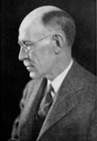 | Frog embryo nerve fiber outgrowth in vitro. (cultivated frog nerve cells in a lymph clot held by the 'hanging drop' method and observed the growth of nerve fibers in vitro)
1912 | Alexis Сarrel 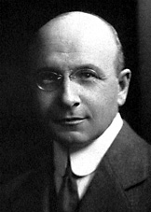 | Explants of chick connective tissue; heart muscle contractile for 2–3 months
1916 | Rous & Jones | Trypsinization and subculture of explants
1920s/30s | Carrel &  Ebeling, 1923 | Subculture of fibroblastic cell lines
1925–1926 | Strangeways & Fell | Differentiation in vitro in organ culture
1940s | Keilova, 1948; Cruikshank & Lowbury, 1952 | Introduction of the use of antibiotics in tissue culture (penicillin and streptomycin)
1943 | Earle | Establishment of the L-cell mouse fibroblast cell line; first continuous cell line
1949 | Enders  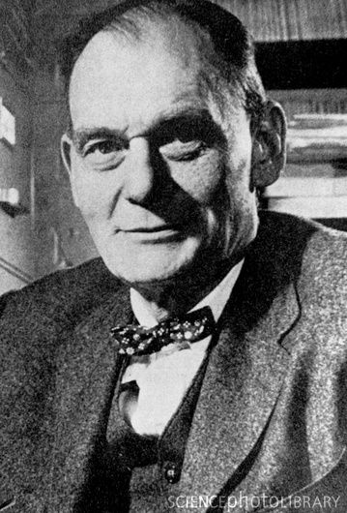 | Growth of virus in cell culture
1952 | Dulbecco  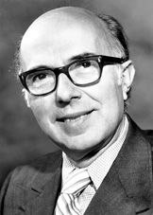 | Use of trypsin for generation of replicate subcultures  Virus plaque assay
1952 | Gey | Establishment the first human cell line, HeLa, from a cervical carcinoma
1955 | Eagle | Development of defined media
1959 | Puck & Marcus | Cloning of HeLa on a homologous feeder layer
1961 | Sorieul & Ephrussi | Cell fusion–somatic cell hybridization
1962 | Macpherson & Stoker | Establishment and transformation of BHK21
1964 | Klein Smith & Pierce | Pluripotency of embryonal stem cells
1965 | Ham | Serum-free cloning of Chinese hamster cells
1967 | Hoober & Cohen | Epidermal growth factor
1968 | Stoker et al. | Anchorage-independent cell proliferation
1969 | Metcalf | Colony formation in hematopoietic cells
1975 | Kohler & Milstein  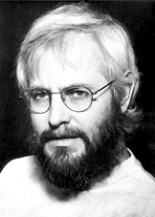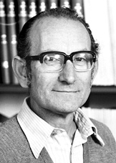 | Hybridomas—monoclonal antibodies
1976 | Illmensee & Mintz | Totipotency of embryonal stem cells
1976 | Hayashi & Sato | Growth factor-supplemented serum-free media
1977 | Nelson-Rees & Flandermeyer | Confirmation of HeLa cell cross-contamination of many cell lines

Areas where cell culture technology is currently playing a major role.
Model systems for:
- Studying basic cell biology, interactions between disease causing agents and cells, effects of drugs on cells, process and triggering of aging & nutritional studies
- Toxicity testing
- Study the effects of new drugs
- Cancer research
- Study the function of various chemicals, virus & radiation to convert normal cultured cells to cancerous cells
Cultivation of virus for vaccine production, also used to study there infectious cycle. Production of commercial proteins, large scale production of viruses for use in vaccine production e.g. polio, rabies, chicken pox, hepatitis B & measles. During the development the gene therapy method cells having a functional gene can be replaced to cells which are having non-functional gene.
Types of animal cells which can be cultured
Basing on morphology (shape and appearance) or on their functional characteristics animal cells, which able to exist in culture medium, are divided into three types:
- Epithelial like-attached to a substrate and appears flattened and polygonal in shape
- Lymphoblast like-cells do not attach remain in suspension with a spherical shape
- Fibroblast like-cells attached to an substrate appears elongated and bipolar

Figure 9 demonstrate the different morphology of animal cells.

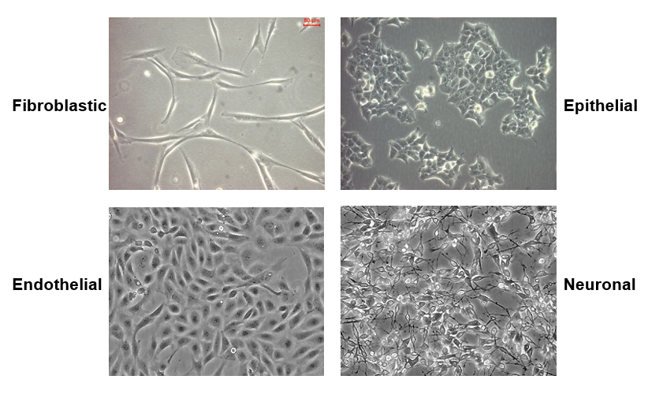
Figure 9 – Cell morphologies very depending on cell type.
Media
Nine amino acids, referred to as the essential amino acids, cannot be synthesized by adult vertebrate animals and thus must be obtained from their diet. Animal cells grown in culture also must be supplied with these nine amino acids: histidine, isoleucine, leucine, lysine, methionine, phenylalanine, threonine, tryptophan, and valine. In addition, most cultured animal cells require cysteine, glutamine, and tyrosine. In the intact animal, these three amino acids are synthesized by specialized cells. For example, liver cells produce tyrosine from phenylalanine, and both liver and kidney cells can produce glutamine. Animal cells whithin the organism and also in culture can synthesize the 8 remaining amino acids; thus these amino acids need not be present in the diet or culture medium. The other essential components of a medium for culturing animal cells are vitamins, which the cells cannot make at all or in adequate amounts; various salts, glucose, and serum, the noncellular part of the blood.
Serum is a mixture of hundreds of proteins. Serum contains various factors needed for proliferation of cells in culture. For example, serum contains insulin, a hormone required for growth of many cultured cells of vertebrates, and transferrin, an iron-transporting protein, which essential for incorporation of iron by cells in culture. Although many animal cells can grow in a serum-containing medium, such as Eagle’s medium, certain cell types require specific protein growth factors that are not present in serum. For instance, precursors of red blood cells require the hormone erythropoietin, and T lymphocytes of the immune system require interleukin 2 (IL-2). These factors bind to receptor proteins that span the plasma membrane, signaling the cells to increase in size and mass and undergo cell division. A few mammalian cell types can be grown in a completely defined, serum-free medium supplemented with trace minerals, specific protein growth factors, and other components.
The three basic classes of media, which differ in their requirement for supplementation with serum, are: basal media, reduced serum media, and serum free media.
Basal (Basic) Media):
- Basal Medium is a defined medium that contains essential and nonessential amino acids, vitamins, inorganic salts, organic compounds, and trace elements, but does not contain the Growth Supplements necessary for cell growth.
- Balanced salt solutions (BSS) e.g. phosphate-buffered saline (PBS)
- DMEM and RPMI 1640 (with or without glutamine)
Reduced-Serum Media:
- Reduced-serum media are basal media formulations enriched with nutrients and animal-derived factors, which reduce the amount of serum that is needed.
Serum-Free Media:
- Serum-free media (SFM) circumvents issues with using animal sera by replacing the serum with appropriate nutritional and hormonal formulations.
- Serum-free media formulations exist for many primary cultures and cell lines, including Chinese Hamster Ovary (CHO), hybridoma cell lines, VERO, MDCK, MDBK cell lines etc.
- One of the major advantages of using serum-free media is the ability to make the medium selective for specific cell types by choosing the appropriate combination of growth factors.

The choice of media depends on the type of cell being cultured. The components or reagents of suitable culture media include balanced salt solution, buffers and chemicals, cell dissociation reagents, and supplements. Balanced salt solutions can provide an environment that maintains the structural and physiological integrity, pH and osmotic pressure of cells in vitro. It maintains osmolarity, regulates membrane potential (Na⁺, K⁺, Ca²⁺) and provides ions for cell attachment and enzyme cofactors. Cell dissociation reagents are the cell detachment solutions of proteolytic and collagenolytic enzymes (Papain, powder; Trypsin 0.25% (1X), liquid; Trypsin 2.5% (10X), liquid; Dispase (Neutral Protease), powder; Elastase, powder; Hyaluronidase; Pepsin A, powder; Collagenase type 1,2,3,4; Trypsin Inhibitors)
Supplements include L-glutamine; Glutamax™; Non-essential amino acids (NEAA); Growth Factors and Hormones (e.g.: insulin); Vitamines (MEM Vitamin Solution); 2-Mercaptoethanol; Lipid Supplement; CHO Supplement. For avoiding of microbial contamination media is supplemented with antibiotics viz. penicillin, streptomycin etc. Prepared media is filtered and incubated at 4⁰C.
On the market there are many animal cell culture media: Minimum Essential Medium (MEM); GMEMm (Glasgow Minimum Essential Medium); EMEM (Eagle’s MEM); DMEM (Dulbecco’s Modified Eagle Medium); Medium 199; BME (Basal Medium Eagle); Ham's F-10 Medium; Ham's F-12 Medium; RPMI 1640 medium; Leibovitz L-15 medium; CMRL 1066; Dulbecco's Modified Eagle's Medium (DMEM-001); MCDB 131; McCoy's 5A. But commonly used Medium are GMEM, EMEM, DMEM etc.
Conditions
Within the tissues of intact animals, most cells of organism tightly contact and interact specifically with other cells via various cellular junctions. Also the cells contact with the extracellular matrix, a complex network of secreted proteins and carbohydrates that fills the spaces between cells. The extracellular matrix constituents are secreted by cells themselves. The matrix helps form the tissue binding the cells in tissues together. It also provides a lattice through which cells can move, particularly during the early stages of animal differentiation.
In various animal tissues the extracellular matrix consists of several common components: fibrous collagen proteins, hyaluronan (or hyaluronic acid), a large mucopolysaccharide, and covalently linked polysaccharides and proteins in the form of proteoglycans (mostly carbohydrate) and glycoproteins (mostly protein). However, the exact composition of the matrix in different tissues varies as a result the specialized function of a tissue. For example, in connective tissue the major protein of the extracellular matrix is a type of collagen that forms insoluble fibers with a very high tensile strength. Fibroblasts, the basic cell type in connective tissue, secrete this type of collagen as well as the other matrix components. Receptor proteins in the plasma membrane of cells bind various matrix elements, imparting strength and rigidity to tissues.
The ability of animal cells in vivo to interact with one another and with the surrounding extracellular matrix is mimicked in their growth in culture. In contrast to bacterial and yeast cells, which can be grown in suspension, most cultured animal cells require a surface (often agarizied) to grow on (see figure 10). Many types of cells can adhere to and grow on glass, or on specially treated plastics with negatively charged groups on the surface (e.g., SO₃²⁻). The cultured cells secrete collagens and other matrix components. These bind to the culture surface and function as a bridge between it and the cells. Cells cultured from single cells on a glass or a plastic dish form visible colonies in 10–14 days. Some tumor cells can be grown in suspension because of the tumor transformation of adhesion and motility behavior. This is a considerable experimental advantage because equivalent samples are easier to obtain from suspension cultures than from colonies grown in a dish.

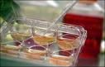
Figure 10 – Monolayer of cells, adherent cells

Once the available substrate surface is covered by cells (a confluent culture) growth slows and ceases. Cells to be kept in healthy and in growing state have to be sub-cultured or passaged. It’s the passage of cells when they reach to 80-90% confluence in flask/dishes/plates. Explantation techniques (see figure 11) depend on cell type and supporting culture cell equipment.

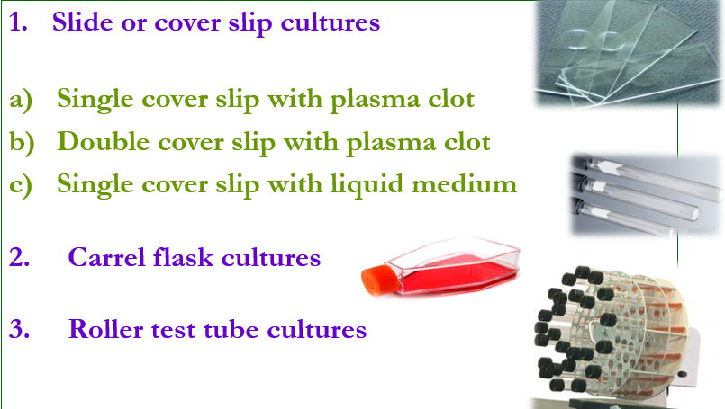
Figure 11 – Explantation techniques.

Adherent cells:
- Cells which are anchorage dependent
- Cells are washed with PBS (free of ca & mg) solution.
- Add enough trypsin/EDTA to cover the monolayer
- Incubate the plate at 37 C for 1-2 mins
- Tap the vessel from the sides to dislodge the cells
- Add complete medium to dissociate and dislodge the cells with the help of pipette which are remained to be adherent
- Add complete medium depends on the subculture requirement either to 75 cm or 175 cm flask
Suspension cells:
- Easier to passage as no need to detach them
- As the suspension cells reach to confluence
- Asceptically remove 1/3rd of medium
- Replaced with the same amount of pre-warmed medium
Cells are cultured as anchorage dependent or independent. Derived from normal tissues cell lines are considered as anchorage-dependent, they grow only on a suitable substrate, for an example, the tissue derived cells. Suspension cells are anchorage-independent, for an example, the blood cells. Transformed cell lines either grow as monolayer or as suspension.
Such enzymes as trypsin, dipase, collagenase in combination with EDTA breaks the cellular glue that attached the cells to the surface.
Basic environmental requirements for “happy” cells are controlled temperature, good substrate for cell attachment, appropriate culture medium and CO ₂-incubator that maintains the correct pH and osmolality.
The control of cell toxicity is very important for culturing of animal cells. Cytotoxicity causes inhibition of cell growth. Observed effect on the morphological alteration in the cell layer or cell shape. Characteristics of abnormal morphology is the giant cells, multinucleated cells, a granular bumpy appearance, vacuoles in the cytoplasm or nucleus. Cytotoxicity is determined by substituting materials such as medium, serum, supplements flasks etc.
Cell culture contaminants of two types:
- Chemical-difficult to detect caused by endotoxins, plasticizers, metal ions or traces of disinfectants that are invisible.
- Biological-cause visible effects on the culture they are mycoplasma, yeast, bacteria or fungus or also from cross-contamination of cells from other cell lines.
Biological contaminants compete for nutrients with host cells. Secreted acidic or alkaline by-products ceases the growth of the host cells. Degraded arginine & purine inhibits the synthesis of histone and nucleic acid. It also produces H₂O₂ which is directly toxic to cells.
In general indicators of contamination are turbid culture media, change in growth rates, abnormally high pH, poor attachment, multi-nucleated cells, graining cellular appearance, vacuolization, inclusion bodies and cell lysis. Yeast, bacteria & fungi usually shows visible effect on the culture (changes in medium turbidity or pH). Mycoplasma detected by direct DNA staining with intercalating fluorescent substances e.g. Hoechst 33258. Mycoplasma also detected by enzyme immunoassay by specific antisera or monoclonal abs or by PCR amplification of mycoplasmal RNA. The best and the oldest way to eliminate contamination is to discard the infected cell lines directly.
Basic aseptic conditions:
- If working on the bench use a Bunsen flame to heat the air surrounding the Bunsen.
- Swab all bottle tops and necks with 70% ethanol.
- Flame all bottle necks and pipette by passing very quickly through the hottest part of the flame.
- Avoiding placing caps and pipettes down on the bench; practice holding bottle tops with the little finger.
- Work either left to right or vice versa, so that all material goes to one side, once finished.
- Clean up spills immediately and always leave the work place neat and tidy.
Safety aspect in cell culture:
- Possibly keep cultures free of antibiotics in order to be able to recognize the contamination.
- Never use the same media bottle for different cell lines. If caps are dropped or bottles touched unconditionally touched, replace them with new ones.
- Necks of glass bottles prefer heat at least for 60 secs at a temperature of 200⁰C.
- Switch on the laminar flow cabinet 20 mins prior to start working.
- Cell cultures which are frequently used should be subcultered and stored as duplicate strains.
Rules for working with cell culture:
- Never use contaminated material within a sterile area.
- Use the correct sequence when working with more than one cell lines.
Figure 12 demonstrates how the animal cell culturing should be controlled.

Good Aseptic technique

Figure 12 - Control for culture contamination
Contamination Monitoring Program
Strategic use
of antibiotics
Strategic use
of the Cell Repository
Understanding the Nature of Contamination
Good Housekeeping by everyone

Basic equipment used in cell culture:
- Laminar cabinet: Vertical are preferable.
- Incubation facilities: Temperature of 25-30⁰C for insect and 37⁰C for mammalian cells, CO₂ 2-5% and 95% air at 99% relative humidity. To prevent cell death incubators set to cut out at approximately 38.5⁰C.
- Refrigerators: Liquid media kept at 4⁰C, enzymes (e.g. trypsin) and media components (e.g. glutamine & serum) at -20⁰C.
- Microscope: An inverted microscope with 10x to 100x magnification.
- Tissue culture ware: Culture plastic ware treated by polystyrene.
How to do tissue culture?
Tissue culture means in vitro cultivation of organs, tissues and cells at defined temperature using an incubator and supplemented by a medium containing cell nutrients and growth factors.
Different types of cells grown in vitro culture include connective tissue elements such as fibroblasts, skeletal tissue, cardiac, epithelial tissue (from liver, breast, skin, kidney) and many different types of tumor cells.
Tissue culture is used as a generic definition to include the in vitro cultivation of organs, tissues or cells. The ability to survive and grow tissues outside the body in an artificial environment is very important for preparing the tissue culture.
Tissue culture can be subdivided into three major categories: cell culture, organ culture, explant culture (see figure 13).

Figure 13 – The types of tissue culture

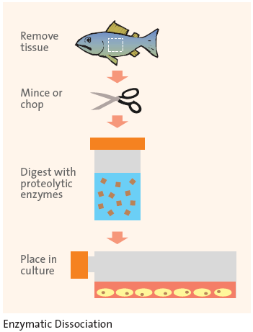
Figure 14 – The typical scheme for tissue culture
Figures 14 demonstrates the main steps on for preparing the tissue culture.

Organ culture
The entire embryos or organs are excised from the body and culture. Organ culture refers to a three-dimensional culture of tissue retaining some or all of the histological features of the tissue in vivo. (Histological structure maintained)
The tissue is cultured at the liquid–gas interface (on a grid or gel), which favors the retention of a spherical or three-dimensional shape.
Advantages:
- Normal physiological functions are maintained.
- Cells remain fully differentiated.
Disadvantages:
- The particular cells of interest may be very small in number in a piece of tissue so the response produced may be difficult to detect and quantify.
Interactions between epithelial and mesenchymal tissues constitute a central mechanism regulating the development of most embryonic organs. Studies on the nature of such interactions require the separation of the interacting tissues from each other and the follow-up of their advancing development in various types of recombined explants. The tissues can be either transplanted and their development followed in vivo, or they can be cultured as explants in vitro. Although the transplantation methods offer certain advantages, including physiological environment and the possibility for long-term follow-up, organ culture techniques are superior in many other aspects. The cultured tissues can be manipulated in multiple ways, and their development can be continuously monitored. The culture conditions are reproducible, and the composition of the medium is known exactly and it can be modified. Furthermore, the in vitro culture conditions allow analyses of the nature of the inductive signals.
Many types of organ culture systems have been used over the years for studies on embryonic organ development. The Trowell method (see figure 15) has been widely applied, and it has proven to be suitable for the analysis of the morphogenesis of many different organs. In this system, the explants are cultured in vitro at the medium/gas interface on thin membrane filters that are supported by a metal grid. We have used the Trowell technique as modified by Saxen.

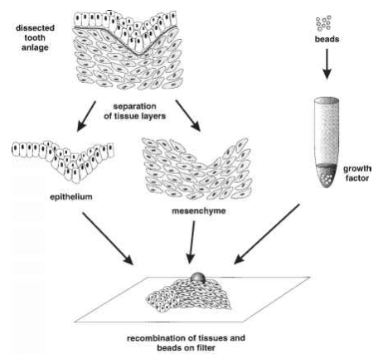
Figure 15 - Schematic representation of the Trowell method
(Methods in Molecular Biology, Vol. 97: Molecular Embryology: Methods and Protocols Edited by: P. T. Sharpe and I. Mason © Humana Press Inc., Totowa, NJ)

The most popular methods include the using of grid combining with growth on filter or agar media (see figure 16).
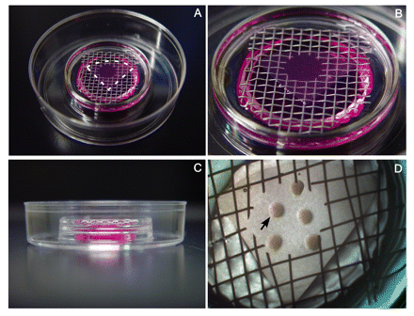
Figure 16 – Organ culture: using the agar (A, B, C) and filter (D) on the grid.

Organ culture techniques include:
1. Plasma clot method or Watch glass method
2. Organ Culture on Agar (Agar gel method)
- Raft method
- Grid method
3. Organ Culture in Liquid Media (using filter)
- Trowell method
Primary cell culture
The primary culture is a term for the culture derived from cells surgically or enzymatically removed from an organism and placed in suitable culture environment which attached and grow together.
A cell strain is a lineage of cells originating from the primary culture.
Normal animal tissues (skin, kidney, liver etc.) or whole intact embryos commonly are used to establish the primary cell cultures. To prepare tissue cells for culture (also for removing adherent cells from a culture dish for biochemical or molecular-genetic studies), trypsin or another protease is used to destroy the proteins in the junctions which normally interconnect cells. Most cell types were difficult, if not impossible, to culture for many years because they need in stimulating growth factors. The identification and preparation of various protein growth factors which can stimulate the replication of specific cell types, as well as other recent modifications in culture protocols, now permit scientists to grow various types of highly specialized cells.
However, many studies with vertebrate cells still are performed with those few cell types that grow most readily in culture. These are not cells of a defined type, rather, they represent whatever grows when a tissue or an embryo is placed in culture. The cell type that usually predominates in such kind of cultures is called a fibroblast because it secretes the types of proteins associated with fibroblasts in fibrous connective tissue of animals. Cultured fibroblasts have the morphology of tissue fibroblasts, but they retain the ability to differentiate into other cell types; thus they are not as differentiated as tissue fibroblasts.
Some studies are performed with primary cultures of epithelial cells. Basically, external and internal surfaces of tissues and organs are covered by a layer of epithelial cells known as an epithelium. These highly differentiated cells are polarized because the plasma membrane is organized into at least two discrete regions.
Certain cells cultured from blood, spleen, or bone marrow adhere poorly, if at all, to a culture dish but nonetheless grow well. In the body, such nonadherent cells are held in suspension (for an example, in the blood), or they are weakly adherent (for an example, in the bone marrow or spleen). Because these cells often come from immature stages of the development of differentiated blood cells, they are very useful for studying normal blood cell differentiation and the abnormal development of leukemia’s.
In cases when cells are removed from an embryo or an adult animal, most of the adherent ones grow continuously in culture for only a limited time period before they spontaneously cease the growing. Such a culture eventually dies out after many cell divisions, even if it is provided with fresh supplies of all the known nutrients that cells need to grow, including serum. For instance, when human fetal cells are explanted into cell culture, the majority of cells die within a relatively short time. “Fibroblasts,” although also destined to die, proliferate for a while and soon become the predominant cell type. They divide about 50 times before they cease growth. Starting with 106 cells, 50 cell divisions can produce 106×250, or more than 1000 cells, which is equivalent to the weight of more than 100 people. So, even though its lifetime is limited, a single primary culture, if carefully maintained, can be studied through many generations. Such a lineage of cells originating from one initial primary culture is called a cell strain.
The traits of primary cell culture:
- Primary cells have a restricted life span
- Primary culture contains a very heterogeneous population of cells
- Sub culturing of primary cells leads to the generation of cell lines
- Cell lines have limited life span. They passage several times before they become senescent.
- Cells such as macrophages and neurons do not divide in vitro conditions, so cannot be used as primary cultures.
Biologists often want to maintain cell cultures for many generations, more than 100 cell divisions because they want to clone individual cell type, or specially transformed single cell, modify cell behavior or select mutants. This opportunity is possible with cells derived from some tumors and with rare cells that arise spontaneously because they have undergone genetic changes that endow them with the ability to grow indefinitely. The genetic changes that allow these cells to grow indefinitely are due to oncogenic transformation. And such cells are oncogenically transformed and became immortalized. A culture of cells with an indefinite life span is called immortal, and such culture is called a cell line to distinguish it from an impermanent cell strain.
The ability of cultured cells to grow indefinitely or their possibility to be transformed varies depending on the animal species from which the cells were originated. For instance, normal chicken cells rarely are transformed and die out after only a few cell divisions, even tumor cells from chickens almost never exhibit immortality. Among human cells, only tumor cells immortalized and grow indefinitely. The HeLa cell, the first human cell type to be grown in culture, was originally obtained in 1952 from a malignant tumor (cervical carcinoma). This cell line exists more than 60 years and has been invaluable for research on human cells.
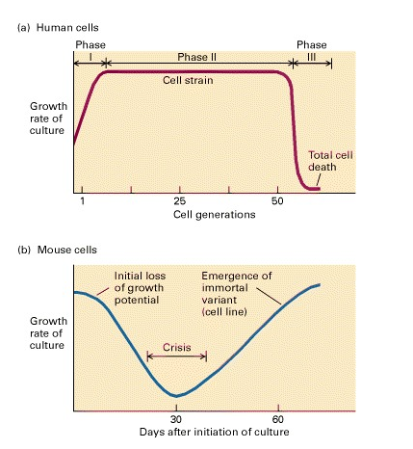
Figure 17 – Stages in the establishment of a cell culture
(Molecular Cell Biology. 4th edition. Lodish H, Berk A, Zipursky SL, et al. New York: W. H. Freeman; 2000)

In contrast to described human and chicken cells, cultures of embryonic adherent cells from rodents routinely give rise to cell lines. When adherent rodent cells are first explanted, they grow well, but after a number of serial replantings they lose potential to growth, and the culture goes into crisis (see figure 17). During this period most of the cells in culture die, but often a rapidly dividing variant (mutant) cell arises spontaneously and takes over the culture. A cell line derived from such a mutant variant will grow forever if it is provided with the necessary nutrients. Cells in spontaneously established rodent cell lines and in cell lines derived from tumors often have abnormal chromosomes or chromosomal rearrangements. In addition, their chromosome number usually is greater than in the normal cell from which they arose, and it continually expands and contracts in culture. Cells having an inappropriate number of chromosomes are said to be aneuploid and are obviously mutants.
Although most cell lines are undifferentiated, some of these can carry out many functional characteristics of the normal differentiated cells from which they are derived. One instance provided by certain hepatoma cell lines (HepG2) that synthesize most of the serum proteins produced by normal hepatocytes (the major cell type in the liver) from which they are derived. The HepG2 represented by highly differentiated hepatoma cells are commonly studied as models of normal hepatocytes. Cultured myoblasts, muscle precursor cells, are another example of transformed cells that continue to exhibit many functions of a specialized, differentiated cell. Transformed myoblasts that grown in culture can be induced to fuse and form myotubes. These resemble differentiated multinucleated muscle cells and synthesize many of specialized proteins associated with contraction. Certain lines of epithelial cells from different sources also have been cultured successfully. One such line, Madin-Darby canine kidney (MDCK) cells, can form a continuous sheet of polarized epithelial cells one cell thick that exhibits many of the properties of the normal canine kidney epithelium from which the cell line was derived. The MDCK line has proved valuable as a model for studying the functions of epithelial cells.
Continuous cell lines
Most cell lines grow for a limited number of generations after which they ceases. Cell lines which either occur spontaneously or induced virally or chemically transformed into Continuous cell lines.
There are characteristics of continuous cell lines:
- Cells are smaller, more rounded, less adherent with a higher nucleus/cytoplasm ratio.
- Cells able fast growth and have aneuploid chromosome number.
- Cells reduced serum and anchorage dependence and grow more in suspension conditions.
- Culture able grow up to higher cell density.
- Cells are different in phenotypes from donor tissue.
- Cells stop expressing tissue specific genes.
The figure 18 demonstrates the ability to growth of animal cells.

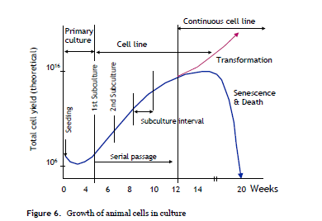
Figure 18 - Growth of animal cells in culture

The figure 19 was created to summarize your knowledge about types of cell lines in animal cell culturing.

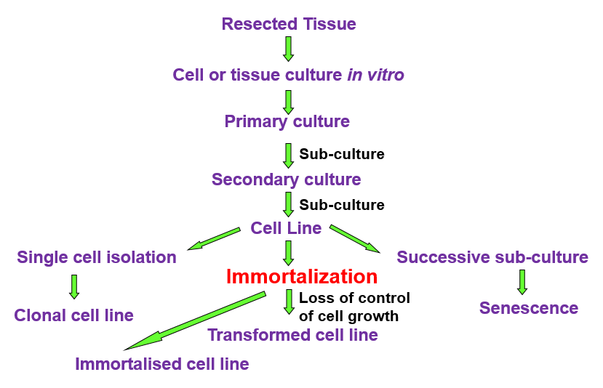
Figure 19 – Isolation of cell lines for in vitro culture.

Hybridoma or Interspecific Hybrids
Cultured animal cells infrequently undergo cell fusion spontaneously. However, the fusion rate increases greatly in the presence of certain viruses that have a lipoprotein envelope similar to the plasma membrane of animal cells. A mutant viral glycoprotein in the envelope promotes cell fusion. Cell fusion also can be promoted by chemicals - polyethylene glycol, which causes the plasma membranes of adjacent cells to adhere to each other and to fuse. As most fused animal cells undergo cell division, the nuclei eventually fuse, producing viable cells with a single nucleus (instead two) that contains chromosomes from both parents. The fusion of two cells that have genetically different origins led to formation of a hybrid cell called a heterokaryon.
Cultured cells from different mammals can be fused to produce interspecific hybrids, which have been widely used in genetics of somatic-cell. For instance, hybrids can be obtained from human cells and mutant mouse cells that lack an enzyme required for synthesis of a particular essential metabolite. As the human-mouse hybrid cells grow and divide, they gradually lose human chromosomes in random order, but retain the mouse chromosomes. In a medium supporting growth of both the human cells and mutant mouse cells, the hybrids eventually lose all human chromosomes. However, it is interesting fact that in a medium lacking the essential metabolite that the mouse cells cannot produce, the one human chromosome which contains the gene encoding the needed enzyme will be retained, because any hybrid cells that lose it following mitosis will die. All other human chromosomes eventually are lost.
Researchers have prepared various panels of hybrid cell lines using different mutant mouse cells and media in which they cannot grow. Each cell line in such panel contains either a single human chromosome or a small number of human chromosomes, and a full set of mouse chromosomes. Because each chromosome can be identified visually under a light microscope, such hybrid cells provide a means for assigning or “mapping,” individual genes in specific chromosomal sites. For instance, suppose a hybrid cell line is shown microscopically to contain a particular human chromosome. That hybrid cell line can then be tested biochemically or molecular genetically for the presence of various human enzymes or genes, exposed to specific antibodies to detect human surface antigens, or subjected to DNA hybridization and cloning techniques to locate particular human DNA sequences. The genes encoding a human protein or containing a human DNA sequence detected in such tests must be located on the particular human chromosome carried by the cell line being tested. Panels of hybrids between normal mouse and mutant hamster cells also have been established; in these hybrid cells, the majority of mouse chromosomes are lost, allowing mouse genes to be mapped to specific mouse chromosomes.

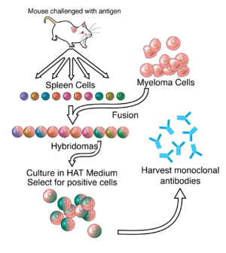
Figure 20 – The usage of hybridomas for monoclonal antibodies producing
(https://en.wikipedia.org/wiki/Hybridoma_technology)

The hybridomas are often used for monoclonal antibodies producing (see figure 20). For this purpose there some specialized media, which allow to select mutant and wild type variants (for an example HAT medium). But this question will be described further in regarding with animal cell markers.

Chapter 4. Stem cells technology
Diversity of Human Cells
Adult humans consist of more than 200 kinds of cells. They are nerve cells (neurons), muscle cells (myocytes), skin (epithelial) cells, blood cells (erythrocytes, monocytes, lymphocytes, etc.), bone cells (osteocytes), and cartilage cells (chondrocytes). There are cells essential for embryonic development but not incorporated into the body of the embryo, include the extra-embryonic tissues, placenta, and umbilical cord. All of these cells are generated from a single, totipotent cell, the zygote, or fertilized egg (see figure 21).
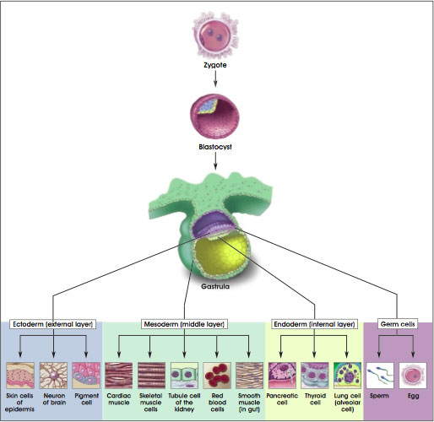
Figure 21 – The origin of Stem Cells
(https://www.researchgate.net/figure/8551939)

Stem cells are undifferentiated cells that can differentiate into specialized types of cells and can divide (through mitosis) to produce more stem cells. They are found in multicellular organisms. Mammals represent two broad types of stem cells: embryonic stem cells, which can be isolated from the inner cell mass of blastocysts, and adult stem cells, which are found in various tissues. The main function of stem cells and progenitor cells in adult organisms is a reparation of the body, replenishing adult tissues. Stem cells of developing embryo can differentiate into all the specialized cells - ectoderm, endoderm and mesoderm (induced pluripotent stem cells), but also maintain the normal homeostasis of regenerative organs, such as blood, skin, or intestinal tissues.
A stem cell is a "blank" cell/precursor cell that can give rise to multiple tissue types such as a skin, muscle, or nerve cell. Essentially a stem cells act as a building blocks of the body.
Features of Stem Cells:
- Stem Cells are very unique cells.
- Stem Cells able to develop into multiple cell types in the body.
- Stem Cells act as a repair system for the body.
- Stem Cells can theoretically divide without limit in a living organism in order to replenish various types of cells.
- When a stem cell undergoes the division, each new (daughter) cell has the potential to either remain a stem cell or become another (differentiated) type of cell with a more specialized function (for example, a muscle cell, a red blood cell, a brain cell, etc.).
Stem cells have three unique properties which allow it differ from other cells in the body:
- Stem cells are capable to divide and renew themselves for long periods.
- Stem cells are “unspecialized” and they can differentiate and give rise to specialized cell types.
- A stem cell fate is "uncommitted", until cell receives a signal to develop into a specialized cell.
Stem cells have the ability to divide asymmetrically. It means that one portion of the cell division becomes a differentiated cell while the other becomes another stem cell.
Stem cells are unspecialized. A stem cell does not have any tissue-specific structures that allow it to perform specialized functions of body organs. A precoursor stem cell in tissue cannot function as a neighboring cell in tissue, for example, to pump blood through the body like a heart muscle cell. Also it cannot carry molecules of oxygen through the bloodstream like a red blood cell and it cannot fire electrochemical signals to other cells that allow the body to move like a nerve cell.
Stem cells are capable to divide and renew themselves for long periods. Stem cells may undergo the mitosis divisions and replicate many times. The following divisions of cell called proliferation. In the laboratory the stem cells can proliferate for many months yielding millions of cells. So, stem cells are capable of long-term self-renewation.
Stem cells can differentiate and give rise to specialized cell types. The term differentiation means the process when unspecialized stem cells become specialized. Stem cell differentiation triggers by signals inside and outside cells. The internal signals are controlled by a own cell's genes. The external signals are the chemicals secreted by other cells, physical contact with neighboring cells, and certain molecules in the microenvironment.
Stem cells exist in both embryos and adults. Stem cells function in embryos to generate new organs and tissues. In adults, their function is replacing the cells during the natural course of cell turnover.
You should to know the distinguishing features of progenitor/precursor cells and stem cells (see figure 22). The figure demonstrate that stem cell is an undifferentiated cell which develops into a variety of specialized cell types. And the results of stem cell division are one additional stem cell and a specialized cell. For instance, a hematopoietic stem cell produces a second generation stem cell and a neuron. A progenitor cell (a precursor cell) is capable of undergoing cell division and can yield in two specialized cells. For example, a myeloid progenitor/precursor cell undergoing cell division yields to two specialized cells - a neutrophil and a red blood cell.
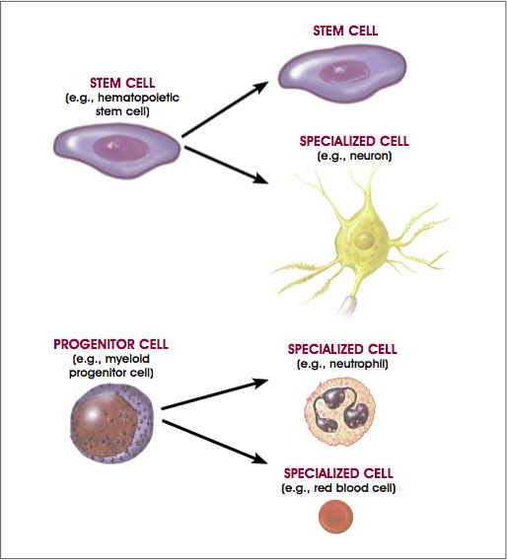
Figure 22 – Distinguishing features of progenitor/precursor cells and stem cells
(https://www.researchgate.net/figure/8551939)

Two main properties characterize the stem cells:
- Self-renewal - The ability to go through numerous cycles of cell division maintaining the undifferentiated state.
- Potency - The capacity to differentiate into specialized cell types. This requires stem cells to be either totipotent or pluripotent, that means have a possibility to give rise to any mature cell type. Sometimes multipotent or unipotent progenitor (precoursor) cells are referred to as stem cells. But it is a narrow application of this term as a result of the clinical usage a tissue progenitor cells for restoration of one or a limited cell types in this tissue. Real stem cell function should be regulated in a feedback mechanism.
Self-renewal
Two approaches exist to ensure that a stem cell population is maintained:
- Mechanism of obligatory asymmetric replication: a parent stem cell divides into one mother cell which is identical to the original stem cell, and another daughter cell which is differentiated.
- Mechanism of stochastic differentiation: when one parent stem cell develops into two differentiated daughter cells, another stem cell undergoes mitosis resulting two stem cells that identical to the original parent cell.
Potency definition
The term potency specifies the potential of differentiation of the stem cell, that means the potential to differentiate into different cell types.
Totipotent stem cells can differentiate into embryonic and extraembryonic cell types. Totipotent stem cells can create a complete, viable organism. This kind of cells is produced from the fusion of an egg and sperm cell. In animals, cells of early embryo produced by the first few divisions of the fertilized egg are also totipotent.
Pluripotent stem cells are the descendants of totipotent cells of early embryo and can differentiate into nearly all types of cells, i.e. cells derived from any of the three germ layers.
Multipotent stem cells can differentiate into a limited number of cell types, and only those of a closely related family of cells.
Oligopotent stem cells differentiate into only a few cell types, such as lymphoid or myeloid stem cells.
Unipotent cells can differentiate into only one cell type, their own, but have the property of self-renewal, that distinguishes them from non-stem cells (for example, progenitor cells, muscle stem cells).
The figure 23 demonstrates the types of stem cells taking into account the potency of cells.

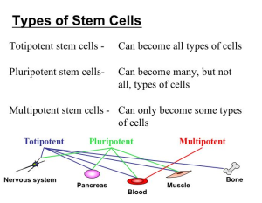
Figure 23 – Potency characterized types of stem cells

In Mammalians totipotent stem cells are the products only of first divisions of zygote. The fertilized egg is totipotent. The origin of word became from the Latin totus, meaning “entire”. It has the potential to generate all the cells and tissues that make up an embryo. It supports embryonic development in utero. Between different kinds of Mammalians there are some restriction of totipotency, which can differ. For an example, the stage of 8-celled embryo – in Human and Mouse, and for Cattle – the 16-celled embryo stage.
“Pluri” is derived from the Latin plures means several or many. Thus, pluripotent cells have the potential to differentiate to any type of cell. Pluripotent stem cells are descendants of the totipotent stem cells of the embryo. These cells develop about four days after fertilization. They can give rise into any cell type, except for totipotent stem cells and the placenta cells. Pluripotent, embryonic stem cells originate as inner cell mass (ICM) cells within a blastocyst (see figure 24). These cells cannot re-create a complete organism but differentiate to a large number of mature tissue types, for example, brain and muscle. These stem cells can give rise any tissue in the body, excluding a placenta. Only cells from an earlier stage of the embryo (before morula stage) are totipotent, able to give rise all tissues in the body and the extraembryonic placenta.

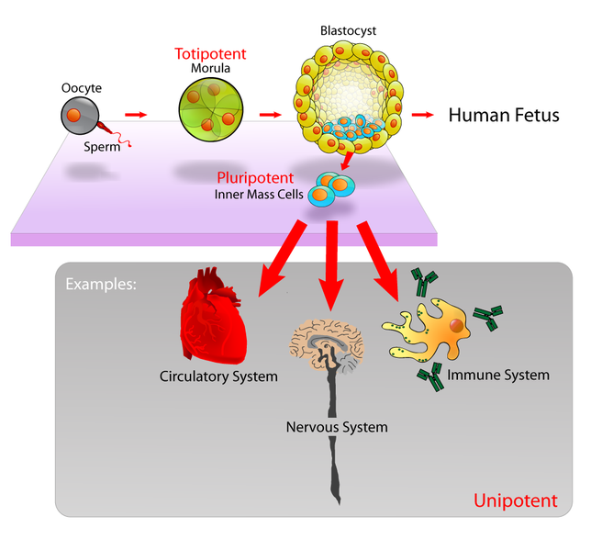
Figure 24 – The origin of pluripotent stem cells
(https://www.researchgate.net/figure/8551939)

As mentioned before, the multipotent stem cells (see figure 25) are descendants of pluripotent stem cells and antecedents of differentiated cells in particular tissues. For instance, hematopoietic stem cells, which were found primarily in the bone marrow, give rise to all of the cell types found in the blood, including red blood cells, white blood cells, and platelets.
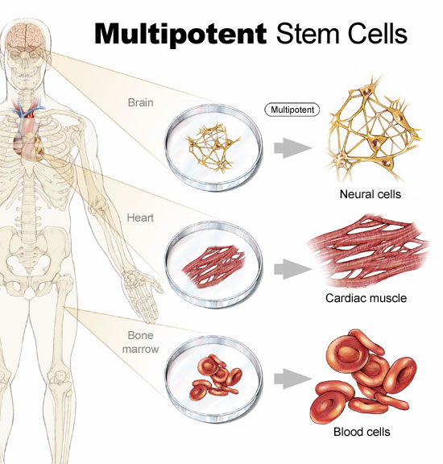
Figure 25 – The differentiation ways for multipotent stem cells
(https://www.researchgate.net/figure/8551939)

The figure 26 demonstrates the origin of Human stem cells taking into account the potency feature.

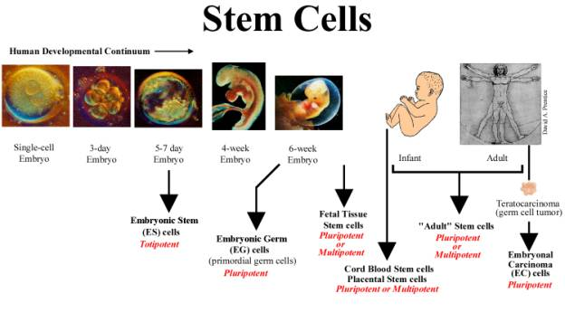
Figure 26 – Developmental stages and potency of Human stem cells
(http://www.celldiagram.net/frequently-asked-questions-on-stem-cells.html)

The figure 27 demonstrates the bone marrow stem cells differentiation potential.
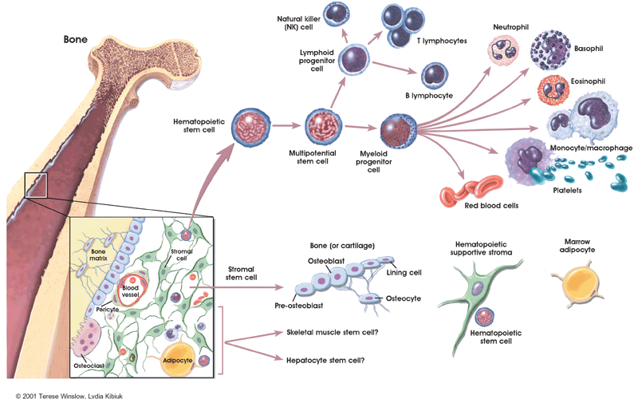

Figure 27 – Bone marrow stem cells differentiation potential.
(https://stemcells.nih.gov/info/basics/4.htm)

Unipotent stem cell are the of adult organisms. These cells are capable of differentiating along only one cell lineage. The word "Uni" is derived from the Latin word unus, which means one.
So, Progenitor cells are unipotent stem cells, which can produce only one specialized cell type. For instance, erythroid precoursour cells differentiate into only red blood cells.
Terminally differentiated cells represent the end of the long chain of cell divisions. These cells are permanently committed to specific functions, such as a liver cell or lung cell.
Stem cell сlasses
The class of animal stem cells depends on their potency. In animal there are 2 main stem cell types (see figure 28) that come from different places in the body or were formed at different times in live cycle: 1) embryonic styem cells (ESC) that exist only at the earliest stages of development, which differ at different animals due to their ontogenesis peculiarities; 2) various types of tissue-specific basal cells (or adult stem cells – ASC), which include the progenitor cells that appear during fetal development and remain in animal and human bodies throughout life. The new class of stem cells was recently developed by biotechnologists using reprogramming of potency of adults cells - induced pluripotent stem cells (iPSCc).

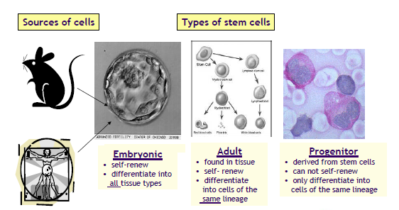
Figure 28 – Different types of stem cells

Embryonic Stem Cells (ESC)
Embryonic stem cells class includes 2 subtypes - embryonic stem cells and embryonic germ cells. ESC type presents stem cell colonies that are not differentiated.
Properties of Embryonic Stem Cells:
- Derived from the inner cell mass of the blastocyst.
- Capable to undergo an unlimited number of symmetrical divisions without differentiating. This property is called as long-term self-renewal.
- Exhibit and maintain a stable set of diploid number of chromosomes (karyotype).
- Pluripotent ES cells can give rise to differentiated cell types that are derived from all three primary germ layers of the embryo (endoderm, mesoderm, and ectoderm).
ESC first extracted in 1981from a Mouse embryo by Cf. G.R. Martin et al. Isolation of Human ESC first done by James Thomson’s team in 1998. hESC were isolated by transferring the inner cell mass of a 3-5 days old embryo onto a mouse fibroblast feeder layer.
If the embryonic stem cells are grown in culture under appropriate conditions, ESC can remain undifferentiated or unspecialized. But if cells are clump together, they can form embryoid bodies and begin differentiate spontaneously growing up into all types of differentiated cells as muscle cells, nerve cells, and many other cell types. Although spontaneous differentiation is a good sign that a culture of embryonic stem cells is healthy, the differentiated process is uncontrolled and therefore represents an inefficient strategy to produce cells of certain specific cell types.
Thus, to produce cultures of specific types of differentiated cells (for example heart muscle cells, blood cells, or nerve cells) the scientists try to control the differentiation of embryonic stem cells. The approach is to change the chemical composition of the culture medium, alter the surface of the culture dish, or modify the cells by inserting specific genes. The results of many experimentation is some basic protocols for the directed differentiation of embryonic stem cells into some specific cell types (see figure 29).

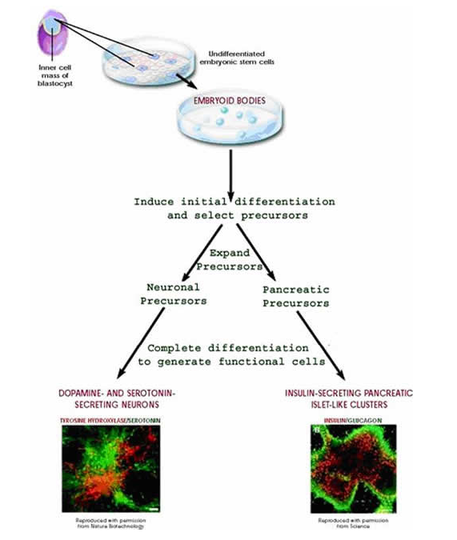
Figure 29 – Directed differentiation of mouse ESC (https://stemcells.nih.gov/info/basics/4.htm)

If scientists can reliably direct the differentiation of embryonic stem cells into specific cell types, they may be able to use the resulting, differentiated cells to treat certain diseases in the future. Diseases that might be treated by transplanting cells generated from human embryonic stem cells include diabetes, traumatic spinal cord injury, Duchenne's muscular dystrophy, heart disease, and vision and hearing loss.
Regarding Human there are two main sources of embryonic type stem cells: embryos and fetus. ESCs are obtained by harvesting living embryos which are generally 5-7 days old. The removal of embryonic stem cells invariably results in the destruction of the embryo. Another kind of stem cell, called an embryonic germ cell, can be obtained from either miscarriages or aborted fetuses.
Potential sources of stem cells are:
- fetal tissue that becomes available after an abortion
- excess embryos from assisted reproductive technologies such as commonly used in fertility clinics
- embryos created through in vitro fertilization specifically for research purpose, and
- embryos created asexually as a result of the transfer of a human somatic cell nucleus to an egg with its own nucleus removed.
- Other sources of stem cells are those from umbilical cord blood, and bone marrow.
- In addition, neural stem cells, haematopoetic stem cells and mesenchymal stem cells can be harvested from fetal blood and fetal tissue.
Advantages of Embryonic Stem Cell:
- Flexible - appear to have the potential to make any cell.
- Immortal - one embryonic stem cell line can potentially provide an endless supply of cells with defined characteristics.
- Availability - embryos from in vitro fertilization clinics.
Disadvantages of Embryonic Stem Cell:
- Difficult to differentiate uniformly and homogeneously into a target tissue.
- Immunogenic - embryonic stem cells from a random embryo donor are likely to be rejected after transplantation
- Tumorigenic - capable of forming tumors or promoting tumor formation.
- Destruction of developing human life.
Embryonic stem cells are easier to identify, isolate and harvest than adult stem cells. There are more of them. They grow more quickly and easily in the lab than adult stem cells. They can be more easily manipulated (they are more plastic).
Adult Stem Cells (ASC)
Animal or human adult stem cells are an undifferentiated cells or multipotent, which found among differentiated cells in a basal layer of tissue or organ. The adult stem cell can renew itself and can differentiate to yield some or all of the major specialized cell types of the tissue or organ. The main function of adult stem cells in an adult organism is to maintain and repair the tissue in which they are found. Biologists also use the term somatic stem cell instead of adult stem cell, where somatic refers to cells of the body as opposite to the germ cells (sperm or eggs). Unlike embryonic stem cells which presented in early embryo, the origin of adult stem cells in some mature tissues. But initially they arose from embryo and contain their multipotency in adult body.
Research on ASC led to surprising results. Biologists have found adult stem cells in many more tissues than they once thought possible. This finding has led researchers and clinicians to think whether adult stem cells could be used for transplantations. In fact, adult hematopoietic, or blood-forming, stem cells from bone marrow have been used in transplants for more than 40 years. Scientists now have evidence that stem cells exist in the brain and the heart, two locations where adult stem cells were not at first expected to be found. The development of protocols to control the adult stem cells differentiation in vitro conditions become the basis of transplantation-based therapies.
The history of research on ASC began more than 60 years ago. In early 1950s, it was revealed that the bone marrow contains at least two kinds of stem cells. The population, called hematopoietic stem cells, forms all the types of blood cells in the body. Another population, called bone marrow stromal stem cells were discovered a few years later. This population also called as mesenchymal stem cells or skeletal stem cells. These non-hematopoietic stem cells make up a small proportion of the stromal cell population in the bone marrow and can generate bone, cartilage, and fat cells which differentiate to blood and fibrous connective tissue.
In the 1960s researches studying rats discovered 2 regions in brain that contained dividing cells that ultimately become nerve cells. Before this discovery most scientists believed that the adult brain could not divide and generate new nerve cells. Only in the 1990s that researches agreed that the adult brain does contain stem cells that are capable to generate the three major cell types in brain: astrocytes and oligodendrocytes, which are non-neuronal cells, and neurons, or nerve cells.
So, ASC have been identified in many organs and tissues, including brain, bone marrow, peripheral blood, blood vessels, skeletal muscle, skin, teeth, heart, gut, liver, ovarian epithelium, and testis. They are thought to locate in a specific area of each tissue, which researched termed as a "stem cell niche". In many tissues, current evidence suggests that some types of ASC are pericytes, cells that compose the outermost layer of small blood vessels. Stem cells may remain quiescent, non-dividing, for long time periods until they are activated by a normal need for more cells to maintain tissues, or by disease or tissue induction.
As a rool, a very small number of stem cells present in any tissue. Once removed from the body, the capacity of ASC to divide is limited, making a generation of large quantities of stem cells is quite difficult. In many laboratories, researches are trying to find better ways to grow large quantities of ASC in vitro cell culture and to manipulate them for generation specific cell types and for disease treatment. Some instances of potential treatments include regenerating bone using cells derived from bone marrow stroma, developing insulin-producing cells for type 1 diabetes, and repairing damaged heart muscle following a heart attack with cardiac muscle cells.
In a living animal, ASC are available to divide for a long period until they will be needed, and can give rise to mature cell types that have characteristic shapes and specialized structures and functions of a particular tissue. The figure 30 represent an examples of differentiation pathways of ASC in vitro or in vivo (see figure 30).
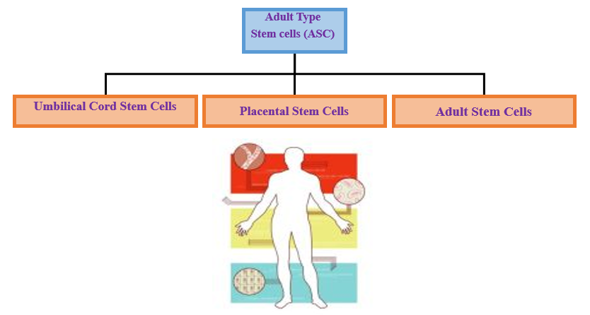
Figure 30 – Adult type of Stem cells (ASC)

All types of blood cells give rise from hematopoietic stem cells: red blood cells, B lymphocytes, T lymphocytes, natural killer cells, neutrophils, basophils, eosinophils, monocytes, and macrophages.
Mesenchymal stem cells present in many tissues of the body. Mesenchymal stem cells from bone marrow, specifically bone marrow stromal stem cells and skeletal stem cells, give rise to a variety of cell types: bone cells (osteoblasts and osteocytes), cartilage cells (chondrocytes), fat cells (adipocytes), and stromal cells which support blood formation. But it is not yet clear how similar or dissimilar mesenchymal cells derive from non-bone marrow sources.
Brain neural stem cells give rise to three major cell types: nerve cells (neurons) and two categories of non-neuronal cells—astrocytes and oligodendrocytes.
Lining the digestive tract epithelial stem cells occur in deep crypts give rise to several cell types: absorptive cells, goblet cells, Paneth cells, and enteroendocrine cells.
The epidermal stem cells represented by skin stem cells located in the basal layer of the epidermis and at the base of hair follicles give rise to keratinocytes, which migrate to the surface of the skin and form a protective layer. The follicular stem cells can give rise to both the hair follicle and to the epidermis.
Certain ASC types can differentiate into cell types seen in organs or tissues other than those expected from the cells' predicted lineage, for example, brain stem cells that differentiate into blood cells or blood-forming cells that differentiate into cardiac muscle cells, and so forth. This phenomenon was called transdifferentiation.
The examples of transdifferentiation have been observed in some vertebrate species, whether this phenomenon actually occurs in humans is still discussed. The observed instances in human may involve fusion of a donor cell with a recipient cell. Another possibility is that transplanted stem cells are secreting factors that encourage the recipient's own stem cells to begin the repair process. Even when transdifferentiation has been detected, only a very small percentage of cells undergo this process.
Among of transdifferentiation experiments variety, scientists have recently demonstrated that certain adult cell types can be "reprogrammed" into other cell types in vivo using a well-controlled process of genetic modification. This strategy is used as a way to reprogram available cells into other cell types that have been lost or damaged due to disease. For instance, one recent experiment in mice shows how pancreatic β-cells, the insulin-producing cells which are lost or damaged in diabetes, could possibly be created by reprogramming other pancreatic cells. By "re-starting" expression of three critical β-cell genes in differentiated adult pancreatic exocrine cells, researchers were able to create β cell-like cells that can secrete insulin. The reprogrammed cells were similar to β-cells in appearance, size, and shape. They expressed genes which characterize of β-beta cells, and they were able to partially restore blood sugar regulation whose own β-cells had been chemically destroyed. While the gene modification is not a real transdifferentiation process, but this method for reprogramming adult cells may be used as a model for directly reprogramming other adult cell types.
Sources of Human adult type stem cells (see figure 31):
- Umbilical Cords, Placentas and Amniotic Fluid - Adult type stem cells can be derived from various pregnancy-related tissues.
- Adult Tissues - In adults, stem cells are present within the bone marrow, liver, epidermis, retina, skeletal muscle, intestine, brain, dental pulp and elsewhere.
- Cadavers - Neural stem cells have been removed from specific areas in post-mortem human brains as late as 20 hours following death.
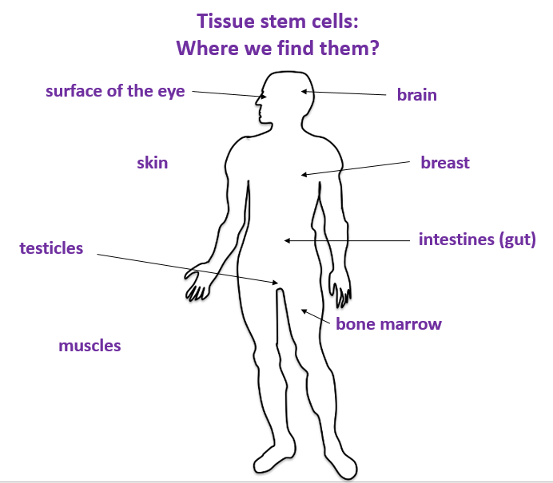
Figure 31 – Potential sources of ASCs

Differentiation pathways of ASCs:
- Neural stem cells in the brain give rise to its three major cell types: nerve cells (neurons) and two categories of non-neuronal cells — astrocytes and oligodendrocytes.
- Epithelial stem cells in the lining of the digestive tract occur in deep crypts and give rise to several cell types: absorptive cells, goblet cells, Paneth cells, and enteroendocrine cells.
- Skin stem cells occur in the basal layer of the epidermis and at the base of hair follicles.
- The epidermal stem cells give rise to keratinocytes, which migrate to the surface of the skin and form a protective layer.
- The follicular stem cells can give rise to both the hair follicle and to the epidermis
Despite of the big variety of differentiation ways of embryonic stem cells that due to their totipotency or multipotency, the adult stem cells preferable to embryonic stem cells because by following reasons: 1) adult stem cells are naturally exist in animal and human bodies, and they provide a natural repair mechanism for many specialized tissues; 2) they belong in the microenvironment of an adult body, while embryonic stem cells belong in the microenvironment of the early embryo, that’s why they tend to cause tumors and immune system reactions.
Advantages of Adult Stem Cell:
- Adult stem cells from bone marrow and umbilical cords appear to be as flexible as the embryonic type
- Somewhat specialized - inducement may be simpler.
- Not immunogenic - recipients who receive the products of their own stem cells will not experience immune rejection.
- Relative ease of procurement - some adult stem cells are easy to harvest (skin, muscle, marrow, fat)
- Non-tumorigenic - tend not to form tumors.
- No harm done to the donor.
Disadvantages of Adult stem cells:
- Limited quantity - can sometimes be difficult to obtain in large numbers.
- Finite - may not live as long as embryonic stem cells in culture.
- Less flexible - may be more difficult to reprogram to form other tissue types

Induced pluripotent Stem Cells (iPSC)
In addition to reprogramming cells to become a specific cell type, it is now possible to reprogram adult somatic cells to become like embryonic stem cells through the introduction of embryonic genes. The scientists term this kind of stem cells - induced pluripotent stem cells (iPSCs). Thus, a source of cells can be generated that are specific to the donor, thereby increasing the chance of compatibility if such cells were to be used for tissue regeneration. However, like embryonic stem cells, determination of the methods by which iPSCs can be completely and reproducibly committed to appropriate cell lineages is still under investigation.
iPSCs are adult cells that have been undergo the genetic modification and reprogrammed to an embryonic stem cell-like state by being forced to express genes and factors that important for maintaining the defining properties of embryonic stem cells. Although these cells meet the defining criteria for pluripotent stem cells, it is not known if iPSCs and embryonic stem cells differ in clinically significant ways. In 2006 the mouse iPSCs were first reported, and human iPSCs were first announced in late 2007. Mouse iPSCs demonstrate important peculiarities of pluripotent stem cells, including expressing stem cell markers, forming tumors containing cells from all three germ layers, and being able to contribute to many different tissues when injected into mouse embryos at a very early stage in development. Human iPSCs also express stem cell markers and are capable of generating cells characteristic of all three germ layers.
Although additional research is still needed, iPSCs are already useful tools for new drug development and modeling of diseases to understand the mechanisms. Scientists hope to use them in transplantation medicine. Viruses are currently used to introduce the reprogramming factors into adult cells, and this process must be carefully controlled and tested before the technique can lead to useful treatment for humans. In animal studies, the virus used to introduce the stem cell factors sometimes causes cancers. Researchers are currently investigating non-viral delivery strategies. In any case, this breakthrough discovery has created a powerful new way to "de-differentiate" cells whose developmental fates had been previously assumed to be determined. In addition, tissues derived from iPSCs will be a nearly identical match to the cell donor and thus probably avoid rejection by the immune system. The iPSC strategy creates pluripotent stem cells that, together with studies of other types of pluripotent stem cells, will help researchers learn how to reprogram cells to repair damaged tissues in the human body.
The iPSCs resemble ESCs in their properties and potential to differentiate into a range of adult cell types. Transgenic expression of only four transcription factors (c-Myc, Klf4, Oct4 and Sox2) is sufficient to reprogram these cells to a pluripotent state.
The schematic image of iPSC method is represented on figure 32.

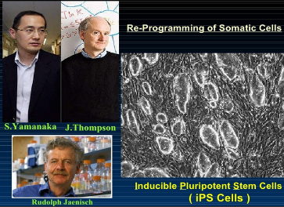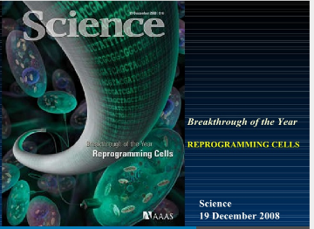
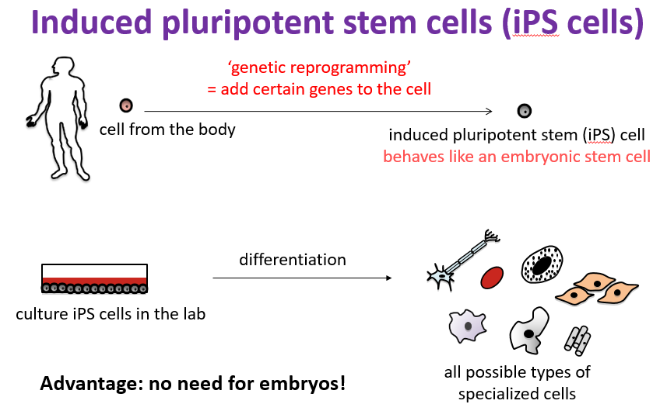
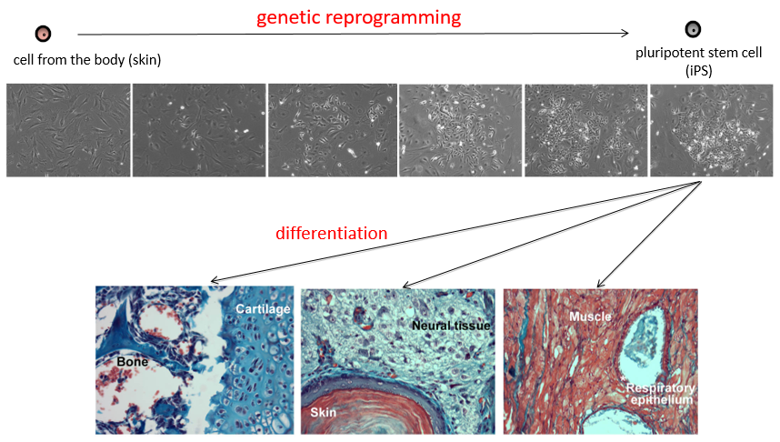

Figure 32 – The schematic image of iPSC method

iPSC is potential for studying human disease mechanisms, for getting basic biology knowledge, and drug screening. iPSC generated from patients with a variety of genetic disease (Park et al., 2008; Dimos et al., 2008): amyotrophic lateral sclerosis, Parkinson disease, Huntington disease, Alzheimer disease, Juvenile-onset, type 1 diabetes mellitus.
Besides iPSCs the Somatic Cell Nuclear Transfer (SCNT) method provides the potential alternative to stem cells. SCNT technology allow to transfer the nucleus from adult cell to enucleated egg and reprogram it. The table 3 shows comparison of these two alternatives to ESC.
Table 3 – Potential alternatives to ESC.
Somatic cell nuclear transfer (SCNT) | Induced pluripotent stem cells (iPSC)
The nucleus from adult cell is transferred to enucleated egg (the nucleus was removed) | Human cells are injected with genes that made them behave like human embryonic cells
Advantages over ESC:  - No embryo derived cells  - Well characterized system in mice  - No ethical restrictions  - Potential for generating stem cells from any individual | Advantages over ESC:  - No embryo derived cells  - Adult cells only  - No ethical restrictions  - Potential for generating stem cells from any individual
Challenges:  - Limited success in primates  - Human egg donation  - Labor intensive | Challenges:  - New technology (2007)  - The infection process makes the gene integrate randomly into the DNA. (Potential cancer in clinic applications)

Applications of stem cells
The figure 33 demonstrates the potential applications of stem cells in medicine.

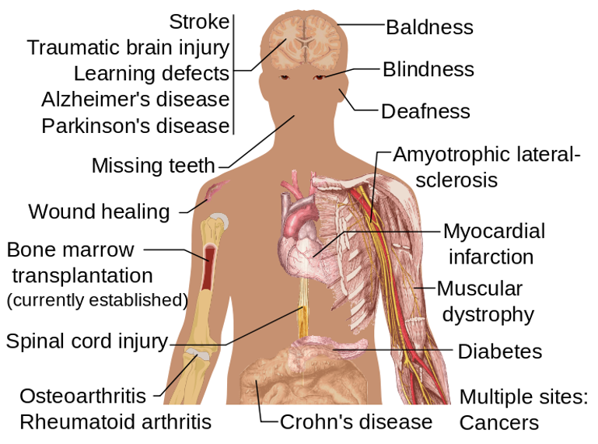
Figure 33 – Potential uses of Stem cells
(https://en.wikipedia.org/wiki/Stem_cell)

SCNT is applicable for therapeutic cloning. Biotechnologists first remove the nucleus from a normal egg cell of a healthy woman. Then they extract a nucleus from a somatic cell - that is, any body cell other than an egg or sperm - from a patient who needs an infusion of stem cells to treat a disease or injury, and insert the nucleus into the egg. The egg, which now contains the patient's genetic material, is allowed to divide and soon forms a blastocyst. Cells from the inner cell mass were isolated and used to develop new embryonic stem cell (ESC) lines. Figure 34 represents the possibility of SCNT for therapeutic cloning.
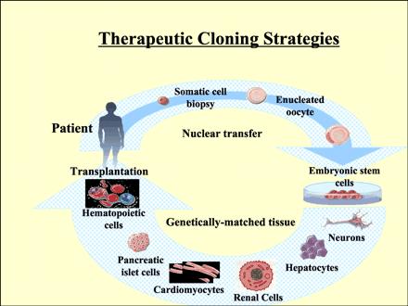
Figure 34 - Therapeutic cloning strategies
Therapeutic cloning was applicate for tissue repair. There are many examples with using the repair of human skin. Skin is readily cultured to provide replacement tissue for burns victims. Healthy skin cells from the patient can be grown rapidly in vitro to provide self-compatible skin grafts. At human skin cell divides one times in two days.
Stem cell transplantation (SCT) is the term now used in preference to bone marrow transplantation (BMT). When a patient's bone marrow fails to produce new blood cells, for whatever reason, he or she will develop anemia, be prone to frequent, persistent infections and may develop serious bleeding problems. In order to restore blood cell production a patient may be given healthy stem cells.
Cell therapy:
- Treatment of neural diseases such as Parkinson's disease, Huntington’s disease and Alzheimer's disease.
- Stem cells could be used to repair or replace damaged neurons.
- Repair of damaged organs such as the liver and pancreas.
- Treatments for AIDS.
Stem cells is very promising for cancer treatment:
- Intense chemotherapy damages a person’s bone marrow, where the stem cells for blood reside.
- Depleted of a fresh supply of blood cells, the patient is left vulnerable to infection, anemia and bleeding.
- These side effects of chemotherapy are often treated with a bone marrow transplant.
- “Transplanting bone marrow tissue into a chemo-cancer patient may involve hundreds of thousands or millions of cells – of which only two or three may be actual stem cells.
- It would be much more efficient if you could inject a thousand purified stem cells.
Is Stem Cell Research Ethical?
- Embryonic Stem Cells - always morally objectionable, because the human embryo must be destroyed in order to harvest its stem cells.
- Embryonic Germ Cells - morally objectionable when utilizing fetal tissue derived from elective abortions, but morally acceptable when utilizing material from spontaneous abortions (miscarriages) if the parents give informed consent.
- Umbilical Cord Stem Cells - morally acceptable, since the umbilical cord is no longer required once the delivery has been completed.
- Placentally-Derived Stem Cells - morally acceptable, since the afterbirth is no longer required after the delivery has been completed.
- Adult Stem Cells - morally acceptable.

Chapter 5. Reproductive technologies in Animal Biotechnology
Reproductive manipulations, including superovulation, semen collection, artificial insemination (AI), embryo collection, In Vitro fertilization (IVF) and embryo transfer (ET), are used in the production of both transgenic animals and animals produced by nuclear transfer (NT). Commercial livestock breeders also use many of these manipulations routinely. However, in spite of many experiments (Matthews, 1992; Moore and Mepham, 1995; Seamark, 1993), these procedures do raise animal welfare concerns, these generally are not specific to the production of genetically engineered animals. As recently shown by Van der Lende et al., 2000, only few of these procedures have received systematic study from the perspective of animal welfare.
Grandin (1993) demonstrated that handling and restraint can be distressful to farm animals, but are essential for almost all husbandry procedures, that include those involving reproductive manipulations. Certain reproductive manipulations, for example, the administration of injections to induce ovulation, can cause additional transient distress, as can electroejaculation.
Artificial insemination and embryo collection with fallowing embryo transfer present a range of animal welfare issues depending on the species used. These procedures in cattle can be accomplished with minimally invasive non-surgical procedures - the latter under epidural anesthesia. However, in sheep, goats, and pigs these manipulations involve surgical or invasive procedures, like a laparotomy or laparoscopy, and hence the potential for operative and postoperative pain. In poultry species the hen is killed in order to obtain early-stage embryos. In fish, eggs and milt might be hand-stripped in some species (causing handling discomfort), while in others the males or females must be killed to obtain eggs or sperm.
Farm animals might be subjected to these reproductive manipulations repeatedly during their lifetime because breeding livestock were valuable. As noticed by Eyestone (1994) this due to the problems involved in screening microinjected embryos prior to implantation to ensure that they actually are carrying the transgene of interest. Recipient cows might be a subject to transvaginal amniocentesis for genotyping. Nontransgenic fetuses or male fetuses are then aborted and the cows reused as recipients (Brink et al., 2000). While this limits the number of recipient animals used, it also raises welfare concerns over the repeated exposure of individual animals to procedures likely to cause pain and distress.
However, many scientists (Moore and Mepham, 1995; Seamark, 1993) belive that some reproductive manipulations are available for replacements or alternatives to known technics. For instance, a method has been devised for non-surgical embryo transfer in pigs, and ova for some purposes can be obtained from slaughterhouses, which eliminates the need for manipulation of live donor livestock females. The use of nuclear transfer to produce transgenic animals (Eyestone and Campbell, 1999) could eliminate the problem of repeated elective abortion and reuse of recipient animals, since cell populations with specific genotypes or phenotypes could be selected before embryo reconstruction.

Endocrine control of reproductive function in animals
Achievements in endocrinology and biology of animal reproduction significantly expanded the possibilities of regulating ща Animal reproductive function by biotechnological methods. The development of the Mammalian reproductive system and its functioning, especially in later stages of ontogenesis, largely depend on the gonadostimulating hormones of the anterior lobe of the pituitary gland.
In Mammalian adenohypophysis secretes 3 hormones which have stimulating and regulating action on reproductive system. There are follicle-stimulating hormone (FSH), luteinizing hormone (LH), and prolactin (PRL).
FSH, a glycoprotein operating in conjunction with LH, stimulates development of the graafian follicle, a small, egg-containing vesicle in the ovary of the female mammal; in the male, it promotes the development of the tubules of the testes and the differentiation of sperm. Though in the male the presence of FSH is necessary for the maturation of spermatozoa, additional FSH may not be required for months because testosterone can maintain this activity. In the female, however, there is a rhythmic, or cyclical, increase and decrease of FSH, which is essential for monthly ovulation.
LH is a glycoprotein and operates in conjunction with FSH. Following the release of the egg (ovulation) in the female, LH promotes the transformation of the graafian follicle into the corpus luteum, an endocrine gland that secretes progesterone. In the male, LH stimulates the development of the interstitial cells of the testes, which secrete testosterone, a male sex hormone. The production of LH is cyclical in nature (especially in the female).
The major action of PRL, which is a protein hormone, is to initiate and sustain lactation. In breast-feeding mammal females, tactile stimulation of the nipples and the breast by the suckling infant blocks the secretion of hypothalamic dopamine (which normally inhibits prolactin) into the hypophyseal-portal circulation of the pituitary gland. This results in a sharp rise in serum prolactin concentrations, followed by a prompt fall when feeding stops. High serum prolactin concentrations inhibit secretion of gonadotropin-releasing hormone (GnRH) from the hypothalamus, thereby decreasing the secretion of gonadotropins (LH and FSH), and may also inhibit the action of gonadotropins on the gonads. Thus, high serum prolactin concentrations during lactation reduce fertility, protecting lactating females from a premature pregnancy.
The figure 35 demonstrates estrous cycle in Mammalian regulating by hormones producing by adenohypophysis.
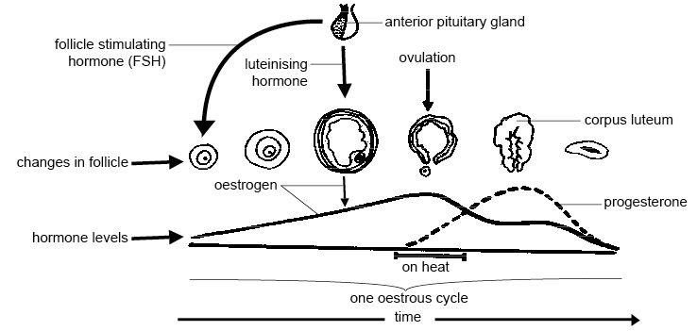
Figure 35 – The estrous cycle in Mammalian
(https://en.wikibooks.org/wiki/Anatomy_and_Physiology_of_Animals/Reproductive_System)

Estrous cycle:
- Reoccurs and repeat itself as long as female is not pregnant.
- Is controlled by hormones preparing the reproductive tract for ovulation and pregnancy
- Includes two phases:
- Follicular phase – short phase, period from regression of the corpus luteum (CL) to ovulation
- Luteal phase – long phase, period from ovulation to CL regression
- Reoccurs and repeat itself as long as female is not pregnant.
- Is controlled by hormones preparing the reproductive tract for ovulation and pregnancy
- Is categorized by frequency of occurrence throughout the year.
Phases of Estrous:
- Proestrus: ovary is about to release an egg
- Estrus: female receptivity
- Metestrus: uterus prepares for pregnancy fertilized egg attaches to uterus
- Diestrus: longest period of cycle inactive
- Estrous Cycles stop after conception, and begin soon after Parturition (birth)
Ovulation is a realize of egg cell from ovary. It occurs near the end of estrous period. Before ovulation egg cell is contained in follicle. During ovulation follicle breaks, releases the egg into the oviduct. If sperm is present, egg may become fertilized. After ovulation CL forms on ovary and releases progesterone. If egg is not fertilized, CL does not grow, allowing another follicle to grow and another estrous period to occur.
Functions of progesterone:
- Prepares uterus for implantation of the embryo.
- Stops other eggs from forming
- Maintains pregnant condition
- Develops mammary glands which produce milk to feed young after they are born.
Human, Horse, Cow are monoestral animals. Mice, Rat, Dog, Cat, Pig – polyestral animals. Ship, Goat - 1-2 estrous cycles.
Seasonably polyestrous – cycles occur only during certain times of the year. Long-day breeders (for an example, horses) – cycle when day length increases. Short-day breeders (for an example, ships) – cycle when day length decreases.
The figure 36 presents the scheme of hormone-controlling estrous cycle at horses.

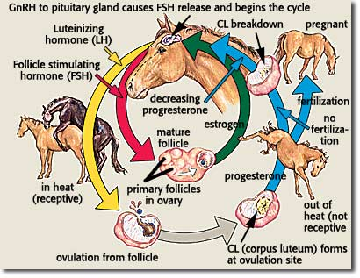
Figure 36 – Estrous cycle at horses
(https://www.pinterest.com/pin)
The cow is a non-seasonal polyestrous species. Which means a cow can multiple estrous cycles throughout the year. The ovarian changes during a typical 21-deay estrous cycle in which pregnancy does not occur. The development and regression of the corpus luteum and of the follicles are continuous processes (see figure 37).
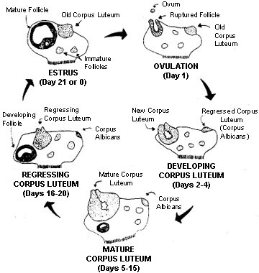
Figure 37 – Estrous cycle at cow
(http://www.cahe.nmsu.edu/pubs/_b/b-212.pdf)
Table 3 presents the longevity of estrous cycle at agricultural animals.
Animal | Age of puberty | Age of first service | Length of estrous cycle | Length of estrous period | Gestation period in days
Mare | 18 months | 24 months | 21 days | 5 days | 336
Sow | 6 months | 8-10 months | 21 days | 18 days | 114
Eve | 6-12 months (first fall) | First fall or second | 16 days | 2 days | 150
Cow | 6-18 months | 14 months | 21 days | 2 days | 283
Gyp | 6-12 months | 12 months | 6-12 months | 9 days | 63

Efficient and profitable reproductive performance of a dairy herd requires routine but conscientious heat detection and proper timing of artificial insemination. Failure to detect estrus (heat) is a major factor contributing to low fertility.
Methods of Heat Detection:
- Visual Appraisal
- Gomer Bulls
- Electronic device
- Ultrasound machine
- Marking harness (sheep and goats)
- Teaser Stallion
Common for agricultural animals symptoms of Estrous:
- Standing heat is the best indicator
- Restlessness
- Discharge from vulva
- Red, swollen vulva
- Mares with raise tail, and “winking”
Each kind of agricultural animal has own peculiarities which reflect on physiological signs and behavioral symptoms of estrous.

Chapter 6. Induction of superovulation
Superovulation plays an important role in the reproductive technologies programs: artificial insemination (AI), in vitro fertilization (IVF), embryo transfer (ET). It aims at inducing a high number of ovulations and a high yield of embryos of good quality. One of the more problematic aspects of the reproductive procedure is the variable response by the donor to superovulatory treatment and the percentage of embryos available for transfer from each donor. Despite much attention, little progress has been made during the last years, and the injection of exogenous gonadotrophins is still the only practical means of producing multiple ovulations from donor.
The earliest descriptions of superovulation date back to Smith and Engle in 1927, who used anterior pituitary preparations to induce a fourfold increase in the ovulation rates of rats and mice. A few years later, Cole and Hart in the USA demonstrated that the blood serum of pregnant mares would induce multiple ovulations in rats, establishing the basis for what was to become the most widely used gonadotrophin in the treatment of farm animals. Pregnant mare’s serum gonadotrophin (PMSG) is a glycoprotein found in the blood of the mare between days 40 and 130 of gestation and is unique among gonadotrophins in possessing both FSH and luteinizing hormone (LH) biological properties within the one molecule.
It is now known that PMSG is secreted by specialized trophoblastic cells that invade the mare’s endometrium between days 3 and 40 of gestation; for such reasons, the term equine chorionic gonadotrophin (eCG) rather than PMSG is preferred by many. The name notwithstanding, early research on superovulation in cattle and other farm animals invariably involved the use of PMSG. In the first decade of human in vitro fertilization (IVF), on the other hand, superovulation was usually by way of human menopausal gonadotrophin (hMG), countless thousands of healthy babies being born as testimony to the safety and efficacy of this urinary gonadotrophin.
Although, initially, relatively undefined preparations such as PMSG were used for superovulation in cattle and other farm ruminants, these were subsequently replaced by purified pituitary extracts from pigs, horses and sheep. One practical consequence of using pituitary preparations, because of their much shorter half-life, was the need to administer them by multiple injections rather than a single administration. Such variability in superovulatory response in cattle, which is reflected in buffaloes, sheep and goats, is known to be related to differences in the gonadotrophin preparation, total dose of FSH administered and duration and timing of treatment and the use of additional hormones in the superovulation regimen. There is evidence that pretreatment with recombinant bovine growth hormone (recombinant bovine somatotrophin (rBST)) or increased dietary intakes, which induce an increase in the population of small follicles, can significantly improve the response to standard superovulatory protocols; it is evident that ovarian status can be manipulated in various ways to improve superovulatory response (see figure 38).
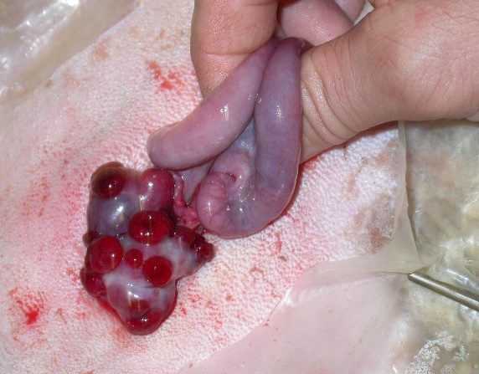
Figure 38 - Induced ovarian superovulation of ewes after gonadrotipin containing drug Folligon (Netherlands)
(kindly presented by Toishibekov E.M.)
Superovulation in cattle
The principle of superovulation in cattle is basically simple: to induce more ovulations than normal rate by giving a gonadotrophin stimulus (at critical moments of follicular development), followed by control of luteolysis, synchronous ovulation, high fertilization and early embryonic development rates. The majority of donor cows will give the best superovulatory response if superovulation treatment is established between days 8 and 14 of the cycle. Therefore, the donor cow must always be examined prior to treatment to detect any abnormality and to establish the presence of a normal, functional corpus luteum.
Although used widely in standardised protocols, superovulation is still not a well controlled technique. The superovulation treatments usually yield an average of 6 transferable embryos, but this technique continues to be associated with variable and unpredictable responses in ovulation rates and recovery of transferable embryos. Normally, no transferable embryos are recovered from about 20 percent of donors and only 1 to 3 transferable embryos are obtained from another 20 percent. An ideal response of 5 to 12 good quality embryos is obtained from about one third of the donors.
The preparations to induce superovulation include: equine chorionic gonadotrophin (eCG) derived from the serum of pregnant mares (usually called pregnant mare’s serum gonadotrophin, PMSG); extracts of domestic animal pituitaries, particularly those of the pig, of various degrees of purity and FSH to LH ratios; recombinant FSH; and gonadotrophins of pituitary origin extracted from human post-menopausal urine (human menopausal gonadotrophin, hMG).
The pregnant mare’s serum gonadotrophin (PMSG) is a glycoprotein that produces both FSH and LH biological effects. Due to its high content of carbohydrate side chains and sialic acid, PMSG has a very long half-life of about 5 days. Traditionally, a single dose of 1500 to 3000 IU of PMSG during the mid-luteal phase of the estrous cycle has been used to superovulated cows. A luteolytic dose of prostaglandin F2 or an analogue is administered 2 to 3 days later. The donor is expected to show heat signs 2 days after prostaglandin injection. The result is an interval of about 4 days between starting PMSG treatment and the onset of estrous.
The advantage of using PMSG for superovulation is its availability in large quantities for a low cost and that it can be used in countries where the import of certain porcine products is banned. PMSG can be also administered, as a single dose compared with the multiple injections normally required when using pituitary preparations.

Chapter 7. Collection of sperm, oocytes and early embryos
Collection of sperm, oocytes and early embryos is an important step in:
- Artificial insemination
- In Vitro Fertilization
- Cloning
- Embryo-engineering (Chimera getting)
- Transgenic technologies
- Biobanking

Collection of sperm
Semen collection refers to the process of obtaining semen from animals or male humans with the use of various methods, for the purposes of artificial insemination, or medical study (usually in fertility clinics). Semen can be collected via masturbation (e. g., from stallions and canids), prostate massage, artificial vagina, penile vibratory stimulation (vibroejaculation) and electroejaculation. Semen can be collected from endangered species for cryopreservation of genetic resources.
In animals, for example, bull semen can be collected by using an artificial vagina (AV), electro-ejaculator, or by massaging the ampule of the bull by hand. AV is the most desired use. The AV is made up of a piece of heavy rubber hose about 5 cm (2.0 in) in diameter and up a 46 cm or more (in only some cases less) in length. A small screw cap attachment is fitted or drilled preferably in the middle of the housing. A piece of latex or silicone rubber (usually rough inside, but in some cases smooth) then is put through the hose and pulled up at both ends. Another latex or silicone cone shaped attachment is placed on one end of the AV a held by a rubber band. On the end of the cone a glass or plastic centrifuge tube is attached usually 15ml size). Through the cap attachment water usually around 54°C is filled until the AV is 1/2 full, temperature may vary from bull to bull. This water is between the inside rubber and the inside hose wall of the AV. A small amount of K-Y jelly or Vaseline is placed just inside on the unconed end and then it is smeared with a pipette or greasing stick. Finally, in most cases and AV jacket is tied or attached onto the cone end to cover the cone and tube. This will help prevent cold shock to the semen by keeping the cone and tube warm. The collector then goes cautiously to the side of the bull when he is in mount, directs the bull's penis inside the AV by grabbing the sheath directly behind the extended penis never touching the penis itself. The bull then ejaculates after his penis slides through the AV. The bull should be ejaculating through the AV into the cone of the AV so there is very little chance of temperature shock to the semen. after the bull has dismounted the AV should be held in the upright position so the semen runs into the tube onto the end of the cone. Then the tube is detached and placed upright in a water bath of about 29-32°C.
A bull is generally brought to a collection area where there are gates or other protection areas set up. In most cases of Dairy Bulls, the bull has a halter or rope inserted into his nose ring. This is so he can be led and his handler can be a safe distance away, yet have some control over the animal. In the collection area there usually is a stall or stanchion where a mount animal is tied in. A mount animal can be a steer, a cow, or even another bull. Some bulls can be rather aggressive and have no problems or issues mounting another animal. Others are rather passive and may show little or no interest in mounting. Different scenarios are used to try to entice him to mount. Such scenarios may include a different breed of steer, a different bull, or even a cow. Sometimes a bull may be wary of the individual who is approaching him to collect. In which cases a blindfold may have to be put over his eye in that side. The bull mounts and semen is able to be collected as the bull doesn't worry about what is going on.
In human:
Shortly before or after the oocyte collection the male partner will be asked to give a sperm sample. Sexual abstinence of 3-4 days should be exercised. Collected about 60-90 minutes prior to fertilization. Sperm liquefied, centrifuged, suspended in culture medium, and incubated for 30-60 mins at 37⁰C. The most active sperms are located in the surface of the medium. Sperm may be obtained from the testicle, epididymis, or vas deferens from men whose semen is void of sperm either due to an obstruction or lack of production.
The figure 39 represents semen collection example.

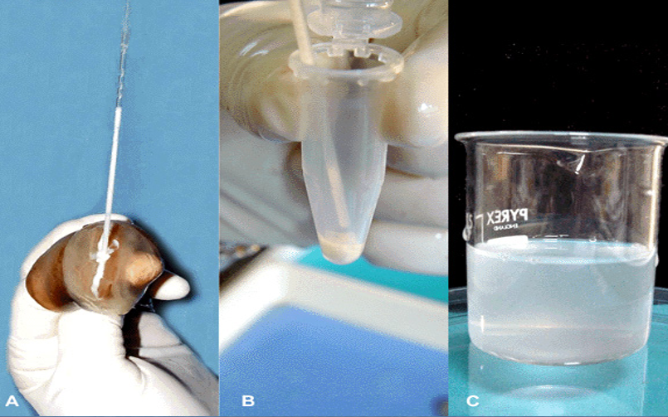
Figure 39 - Procedure of collection (A), centrifugation (B) and suspension (C) of sperms in culture medium
Sperm also can be collected from testicles with assisted surgical methods: percutaneous epididymal sperm aspiration (PESA) and microsurgical epididymal sperm aspiration (MESA) (see figure 40).
A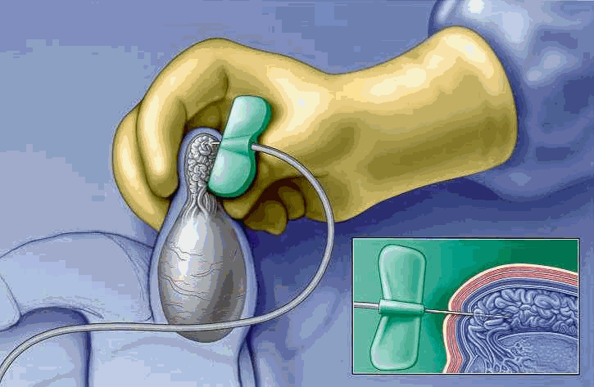 B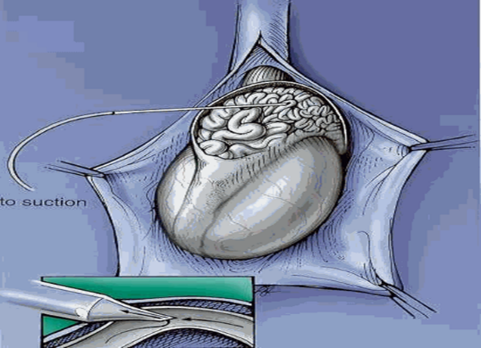
A – PESA; B - MESA
Figure 40 - Surgical sperm retrieval
Sperm quality control is required procedure. It includes analysis of sperm count, sperm morphology and motility (see figure 41). The types of morphological abnormalities of sperm presented in a figure 42. Many computer programs development for morphological analysis and motility assessment (see figure 43).
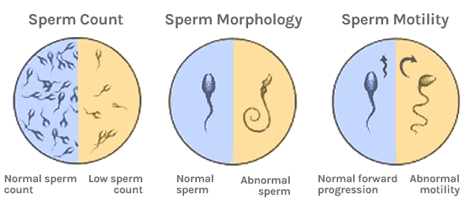
Figure 41 – Sperm quality control

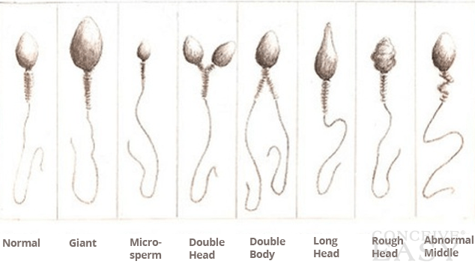
Figure 42 – Morphological sperm abnormalities

A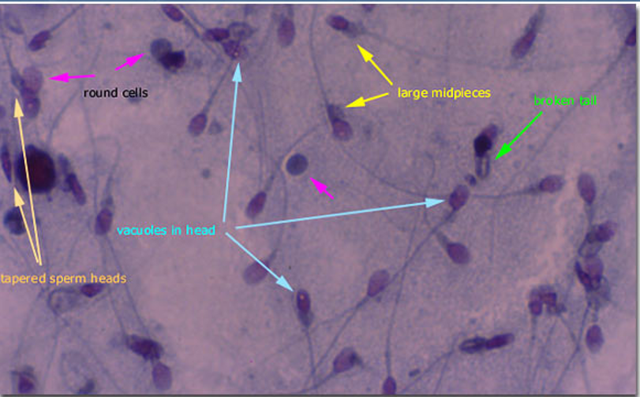 B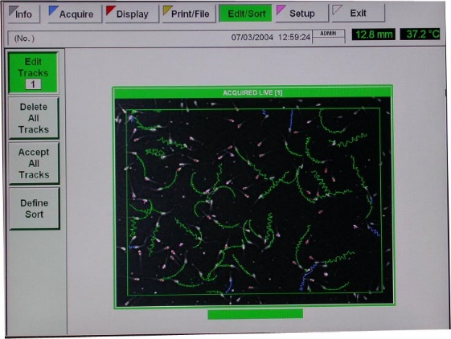
- Computer morphological analysis; B- Individual sperm movement tracks
Figure 43 – Computer analysis of sperm quality
(Kindly presented by Toishibekov E.M.)

Collection of oocytes and embryos
Initial IVP (in vitro embryo production) was used oocytes from slaughterhouse ovaries. During early experimentation this approach worked well when large numbers of immature eggs (oocytes) were needed to develop procedures. In the 1980s, it was proposed that the IVP application in animals would likely be used in rare exotic animals and in genetically valuable seedstock. Early attempts to retrieve oocytes from potential donor cattle included the surgical and less invasive laparoscopic procedures/ But there was a limit to how many procedures could be performed without causing injury. On this stage, there was essentially no safe, repeatable method of harvesting the oocytes from live farm animals.
Then in the late 1980s, a method was developed in humans for retrieving oocytes using ultrasonography to visualize the ovary while a needle was guided transvaginally into the follicle. The oocyte could be aspirated from the follicle and subjected to in vitro maturation, fertilization and then to culture procedures. These efforts paved the way for the new reproductive technology now available for farm animals. Currently, TUGA, the transvaginal ultrasound-guided oocyte aspiration, also known as ovum pick-up (OPU) in human medicine, is now used in cows, goats, mares and more recently in pigs and exotic hoof stock species.
The problem with the larger farm animals is that their gestation periods are considered to be long in comparison with those of dogs (62 days) and cats (63 days) and that the animals are out of embryo production during their gestation. Cows have 9.5-month and mares have 11-month pregnancies. But both are known to continue follicle wave development during early to mid-gestation. Another goal has been to take advantage of these developing ovarian follicles and attempt to produce IVF-derived offspring from oocytes harvested from females during pregnancy.
The ongoing pregnancies affecting from oocyte aspiration procedure were the main concern of biotechnologists. But soon this oocyte aspiration approach proved not to be a problem, and pregnant donors were found to consistently produce more oocytes per collection than similar nonpregnant, cyclic females. The first offspring produced from oocytes collected by transvaginal ultrasound-guided aspiration from pregnant donor animals resulted from cows and horses.
Ultrasound-guided follicle aspiration also has been used successfully in other kinds of animals, with modifications made primarily to account for anatomical differences of the donor animals. The aspiration technique has been used successfully to harvest oocytes from adult pigs, as long as rectal manipulation of the ovaries was possible within the donor females. Also transvaginal ultrasound-guided oocyte aspiration has also been used successfully to harvest oocytes in llamas.
However, there is still much to be studied in the use of assisted reproductive technologies to maximize reproductive potential in genetically valuable animals. Repeatable oocyte retrieval methods are being fine-tuned, it is likely that these procedures will become routinely used to obtain oocytes for further gamete and embryo research and also by seedstock producers for in vitro embryo production from farm animals in the commercial way.
Transvaginal ultrasound-guided oocyte aspiration is now used to harvest valuable oocytes from minor farm animal breeds, from domestic females representing rare bloodlines, clinically infertile females and cows too old to become pregnant. Research continues to find applications for this technology, including harvesting oocytes from injured females, young prepubertal heifers and early postpartum beef cows for in vitro embryo production. There are some plans to use ultrasound-guided oocyte aspiration to obtain oocytes for in vitro embryo production to help preserve germplasm of endangered exotic species.
Another way to obtain female germ line cells is using of abattoir materials for collecting oocytes and embryos, which also is popular for farmers and researchers.
Although superovulation remains the chosen method of producing high-quality bovine embryos for most commercial embryo transfer (ET) purposes, cost may well make this prohibitive for many research programs. On the other hand, abattoir materials form an inexpensive and readily available source of oocytes for research in embryo production and for use in cloning and the production of transgenic animals. In the production of cattle embryos from slaughterhouse ovaries, it was necessary to develop methods that permit the recovery of several good-quality oocytes per ovary; the number actually recovered will vary with different collection procedures (see figure 44).
A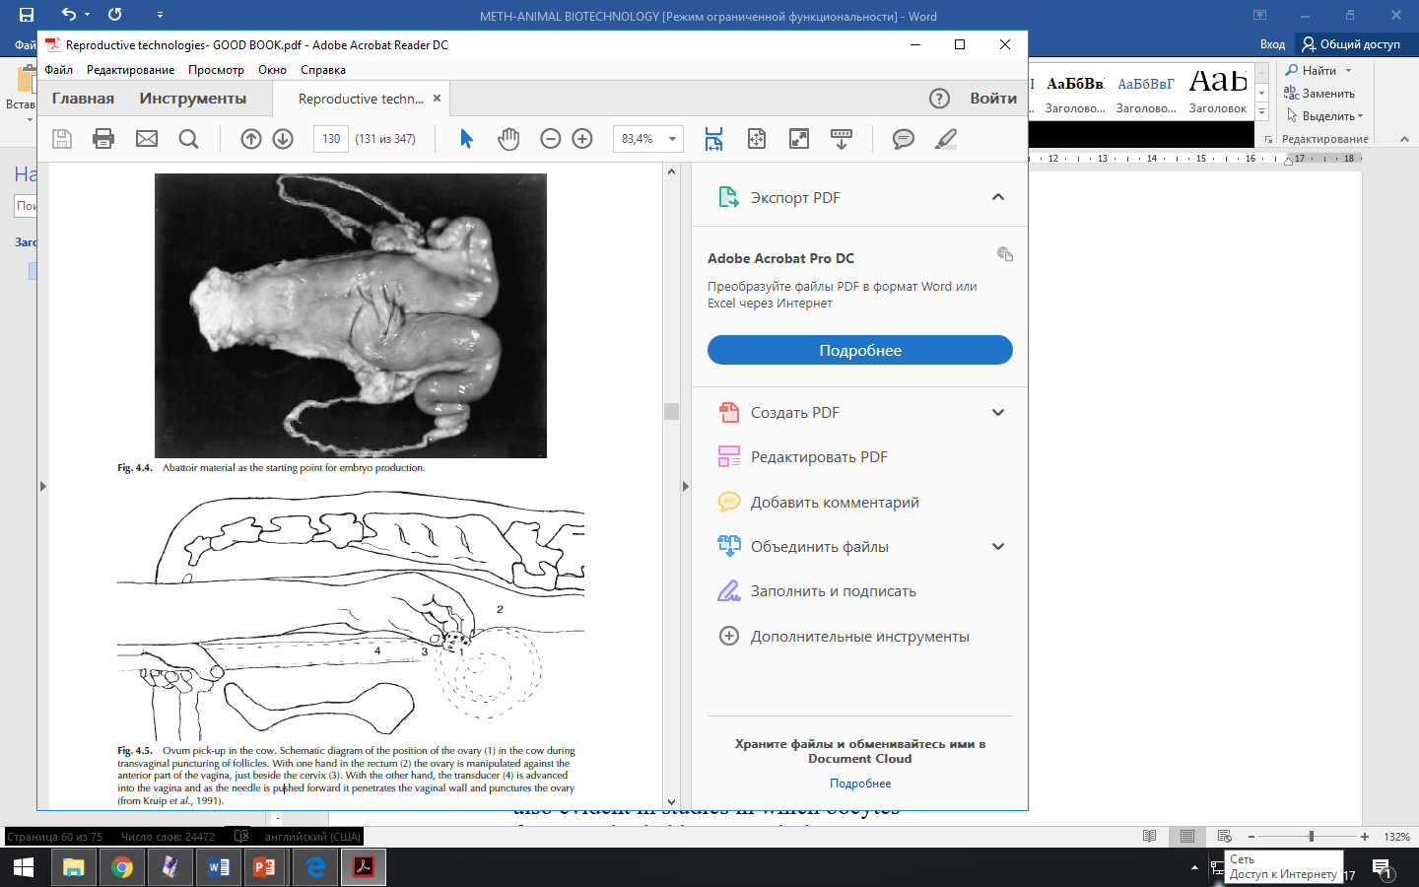B
A – abbatoir material uses for embryo collection; B – Ovum pickup in the cow
Figure 44 – Different methods of embryos and oocytes collections in cow

An alternative approach to oocyte collection from slaughterhouse ovaries is ovum pick-up (OPU) technique that allows collect eggs from live donor females (figure 43B). Biotechnologists have developed OPU devices that are practical and economical for routine use in oocyte retrieval, without causing negative effects on ovarian structure and subsequent ovarian function. As it was shown by Lopes et al. (2003), although donor cows used for OPU vary considerably in their yield of oocytes, there is an evidence that a certain oocyte number may be characteristic of each donor animal and determined by its genetic constitution. In using OPU, a scanner with an intravaginal sector probe and a guided needle is employed; the needle is connected to a test-tube and to a vacuum pump to aspirate the follicular fluid and the oocyte contained within it. Using an ultrasound scanner with good resolution, it is possible to envisage ovarian follicles down to 2-3 mm in size; the recovery procedure can be carried out on the farm with the donor sedated and confined in a crush. It is possible to collect oocytes not only from cyclic heifers and cows but even from animals in the early months of pregnancy, from those in the early post-partum period and from prepubertal heifers.
After collection of oocytes, they should be maintained in media such as Dulbecco’s phosphate buffered saline (PBS) or tissue culture medium (TCM)-199 (HEPES-buffered). It is clear that oocytes are extremely sensitive to temperature shock, making it important to monitor temperature carefully during the collection procedure. As proposed by Merton et al. (2003), the follicle-stimulating hormone (FSH) pre-stimulation of donors prior to OPU is available to improve cattle embryo production efficiency, much better than other methods. In the Czech Republic, Cech et al. (2003) also demonstrated that pre-stimulation of dairy cows with FSH increased the number of oocytes recovered by OPU in the first trimester of pregnancy.
Equipment, methods and practical applications of OPU are described by Christie et al. (2002), who also drew attention to the benefits and associated problems of this new technology. OPU/IVF can produce more embryos over a given period of time than conventional superovulation and embryo recovery, but the in vitro-derived embryos have proved to be significantly less viable than in vivo counterparts. There is also result in a higher incidence of abortion, perinatal mortality and fetal and placental abnormalities and a tendency to increased birth weights among IVP embryos. None the less, a large majority of IVF pregnancies do result in normal healthy calves and the technique provides a valuable new means of producing additional offspring from donors unable to produce calves by any other means
In human oocytes collected during IVF program:
- Collected from females desirable of having baby.
- Cannot be collected from females with non-functional ovaries.
- Can be collected during a natural or induced menstrual cycle.
- Time for this is determined by monitoring rise in the level of Luteinizing Hormone(LH) in urine or blood.
At human ovulation may be stimulated by administration of Clomiphene or Human menopausal Gonadotropin (hMG). Follicle development may be arrested at the optimum stage by administering Human chorionic gonadotropin (hCG) so that ova are not released (see figure 45). Recovery of oocytes can be done most conveniently by a laparoscopic instrument that allows the visualization of ovary through a monitor, aspiration (suction) of the follicular fluid containing the oocytes and the necessary surgical manipulation of ovary using sensors, laparoscopic scissors and an aspirating apparatus inserted into the abdomen of the female via a suitable tube (see figure 46).
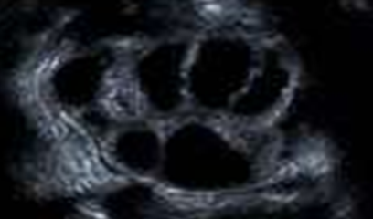
Figure 45 - Ovarian follicles, stimulated by ovulation medications, visible on ultrasound. The dark, circular areas are the follicles.

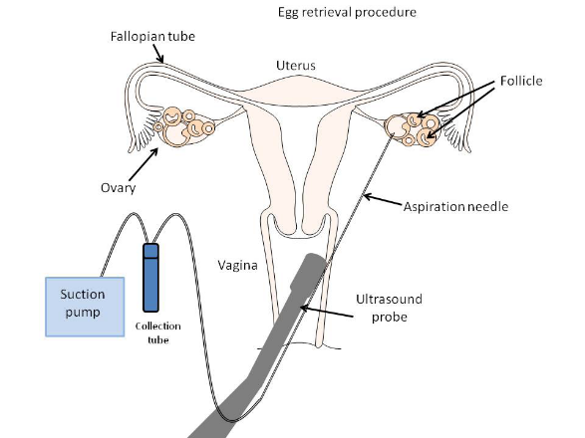
Figure 46 - The eggs are aspirated (removed) from the follicles through the needle connected to a suction device.
From practice it is known, that usually around 10-15 oocytes are aspirated. The eggs are prepared and stripped from the surrounding cells. After the eggs are retrieved, they are examined in the laboratory for maturity and quality. Mature eggs are placed in an IVF culture medium and transferred to an incubator to await fertilization by the sperms.
Oocytes are identified by microscopic examination of the follicular fluid aspirated during laparoscopy, and are incubated for 10-15 hours depending upon the expected time of maturation. Following mediums maybe used for serving the purpose: modification of Ham’s F10 medium; Earl’s solution; modified Whitten’s medium; Whittingham’s T6 medium.
Evaluation and maturation of the oocyte, selection criteria
The methods of selection of the cumulus–oocyte complexes (COCs) are usually based on parameters such as the morphology of the cumulus, the combined morphology of the cumulus and of the ooplasm, the size of the follicle and the oocyte and the level of follicular atresia. COCs with a compact and complete cumulus mass and a uniform appearance seem to present a higher developmental ability. Many reports have proposed classification schemes based on the compactness and number of layers of cumulus cells surrounding the oocyte and on the appearance of the oocyte itself. Oocytes with the highest developmental competence are expected to possess an even, smooth, finely granulated cytoplasm, surrounded by fewer than three compact layers of cumulus cells. There are those suggesting the need to revise the criteria employed for selecting oocytes. Data reported by Vassena et al. (2003) suggest that oocytes collected during the static or regressing phases of the follicular wave are preferable to those collected from follicles in the growing phase; it appears that the effects of early follicular atresia are beneficial to oocyte competence, although the reasons for this phenomenon are still unclear. Results reported by Alm and Torner (2003) showed that the staining of bovine COCs with brilliant cresyl blue before IVM could be used to increase the number of developmentally competent oocytes and to act as a marker of oocyte quality for techniques such as cloning. Brilliant cresyl blue stain determines the intracellular activity of glucose-6-phosphate dehydrogenase (G6PD), which is known to play a critical role in cell growth.
The quality control and evaluation are necessary steps in collecting of oocytes and embryos.
Table 4. Criteria used in evaluating cattle embryos (Lonergan, 1992).
Developmental stage | Identifying features
Morula | Individual blastomeres are difficult to discern from one another. The cellular mass of the embryos occupies most of the perivitelline space
Compact morula | Individual blastomeres have coalesced, forming a compact mass. The embryo mass occupies 60-70% of the perivitelline space
Early blastocyst | This is an embryo that has formed a fluid cavity or blastocoel and has the general appearance of a signed ring. The embryo occupies 70-80% of the perivitelline space. Visual differentiation between trophoblast and inner cell mass may be possible at this stage of development.
Blastocyst or midblastocyst | Pronounced differentiation of the outer trophoblast layer and the darker, more compact inner cell mass is evident. The blastocoel is highly prominent, with the embryo occupying most of the perivitelline space
Expanded blastocyst | Overall diameter of the embryo dramatically increases (1.2-1.5 times), with a concurrent thinning of the zona pellucida to approximately one-third of its original thickness
Hatched blastocyst | Embryos can be undergoing the process of hatching or may have completely shed the zona pellucida
Hatched expanded blastocyst | A re-expanded embryo with a large blastocoel and round, very fragile appearance or, in later stages, an elongated shape
Figure 47 presents eve oocytes and embryos, which were successful in quality control.
A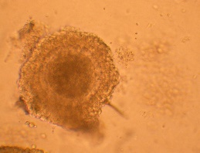B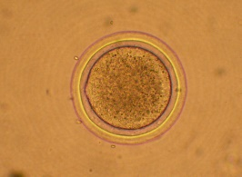 С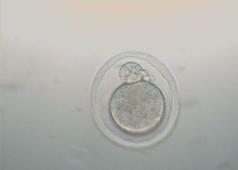 D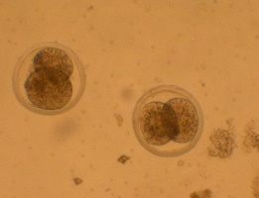
E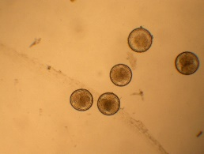 F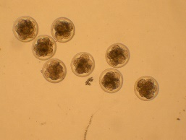 G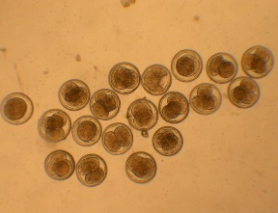 H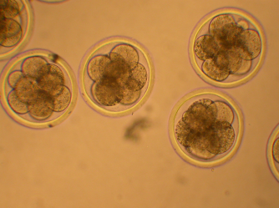
A - eve oocyte surrounded by cumulus cells; B - oocyte after cultivation in vitro; C - sheep zygote; D – 2-celled embryos; E -2- and 4-celled embryos; F - 8-celled embryos and early morulas; G - embryos from one ewes-donor (№ 01424) of Kazakh Arkharomerinos;
Figure 47 – Quality control selection of sheep oocytes and embryos
(Kindly presented by Toishibekov E.M.)

Chapter 8. Artificial insemination
Artificial insemination (AI) is used in animals ranging all the way from the honeybee to the elephant. Some of the milestone events in the development of AI technology are detailed in Table 5. The earliest reference to any form of AI is in 13th-century Arabic scriptures featuring the horse. The first systematic exploitation of this technology was also in horses, with the work of the Russian physiologist Ivanov at a government stud farm more than a century ago.

Table 5. Milestones of AI technology
(I.R. Gordon 2004. Reproductive Technologies in Farm Animals)
Date | Event | Researcher(s)
1677 | Discovery of sperm by the use of magnitying lens | Anton van Leeuwenhoek
1780 | Artificial insemination of a dog bitch and the subsequent birth of pups 62 days later | Spallanzani
1803 | Freezing of stallion sperm in the sbow and motility recovered after warming | Spallanzani
1890 | AI in horses first attempted in France | Repiquet
1899 | Started work on horse AI at Moscow State University | Ivanov
1912 | Demonstrated AI in horses, achieved results comparable to those obtained by natural service. Achieved success in cattle and sheep AI and trained hundreds of inseminators | Ivanov
1914 | Start of work in Italy which led to artificial vagina for semen collection in the dog | Amantea
1920s and 1930s | Development in Russia of artificial vaginas for use in bulls, stallions and rams, development a simple dilluents | Milovanov
1936 | Shipment of ram semen from cambridge in the UK to Poland, birth a lamb after AI | Arthur Walton
1937 | Development in Denmark of the rectovaginal method of AI in cattle | Varios Danish workers
1941 | Development of egg-yolk citrate semen diluent for cattle | Glenn Salisbury
1946 | Antibiotics (penicillin and streptomycin) used to control pathogenic microorhganisms in semen used for AI | Almquist
1949 | Method of freezing sperm of several species discovered | Chris Polge
1952 | First calf born (Frostly I) after use of frozen-thawed bull semen in Cambridge | Chris Polge and Tim Rowson
1960 | Liquid nitrogen became the refrigerant of choice for preserving bull semen. Most countries used 100% frozen bull semen | Many researchers in various countries

Without doubt, AI has been the most important reproductive technology applied during the 20th century to cattle; unlike technologies such as embryo transfer, which in the cow calls for considerable expertise on the farm and in the laboratory to be successful, AI is relatively cheap and simple to apply. Some reliable authorities estimate that the contribution made by AI to improved dairy production worldwide since the Second World War was equal to the combined contributions of better health, husbandry and nutrition; the technique was to greatly accelerate genetic selection, most notably with dairy cattle.
Current world statistics for AI in cattle stand at 232 million doses of semen produced as a frozen product and 11.6 million as liquid (Vishwanath, 2003). Fresh rather than frozen semen is primarily restricted to New Zealand, with limited amounts used in Africa, Australia, France, Germany and Eastern Europe.
Insemination procedure
In the 1940s, vaginal or shallow cervical insemination in cattle, performed with the aid of a vaginal speculum, was replaced by deep cervical or intrauterine insemination, involving the technique of cervical fixation per rectum; this method proved more efficient and was rapidly adopted as standard by the cattle AI industry (see figure 48). Based on the assumption that the deposition of semen nearer to the site of fertilization (ampulla of the oviduct), the next logical step in cattle AI was to attempt deep AI; however, when this was done, it was found to have little effect on the success of AI.

Figure 48 – Rectovaginal method of cow insemination (Hammond et al., 1983)

Deep intracornual deposition of semen in cattle was first proposed in the late 1950s to increase the efficiency of AI, to reduce the required number of sperm per insemination dose and to enhance the use of sperm from genetically superior bulls that were in demand.
More recent times have seen a resurgence in interest in deep inseminations. A study in Estonia reported by Kurykin et al. (2003), for example, showed that with deep intracornual insemination of PG-synchronized heifers at a fixed time (80–82 h) after the second of two PG injections, a sperm dose of 2 million sperm was as efficient as a dose of 40 million. It should benoted that intracornual AI requires greater care on the part of the inseminator because of the risk of perforating the uterine wall due to the tonicity of the uterus at oestrus and the danger of rupturing the ovulatory follicle while palpating the ovaries per rectum to determine the probable site of ovulation.
Although there is ample evidence showing that a single laparoscopic insemination in sheep with frozen–thawed semen can result in acceptable conception rates, its use in commercial practice is limited by its expense and even more so by animal welfare considerations. Among the alternative insemination procedures studied is that of transcervical AI, which involves the passage of an instrument through the cervix and into the uterus; unfortunately, this technique, quite apart from not being possible with all sheep, has serious welfare implications because of the manipulations of ewe and cervix involved.
Despite the long history of AI and its successful application to cattle breeding programmes, there are still areas of semen technology in which improvements can be made. Rejection of ejaculates, due to low motility, before or after freezing, is still common in AI centres; some bulls that apparently present a normal sperm picture and have an acceptable NRR of 60–70% may still yield ejaculates of which more than 50% are unsuitable for use.
Factors influencing the sex ratio
Sex is determined in farm mammals by the sex chromosome content of the sperm produced; females are produced by gametes containing an X-chromosome and males by sperm carrying the Y-chromosome. The sex ratio in a litter of piglets at birth (the socalled secondary sex ratio) is determined by the primary sex ratio in the litter (the sex ratio immediately after fertilization) and eventual selective prenatal mortality. In several farm and other mammals, variation has occasionally been reported in the sex ratio of offspring, which is apparently influenced by genetic and environmental factors.
The way in which chromosomes segregate at meiosis in the testes ensures that sperm carrying X- and Y-chromosomes are produced in equal numbers. There are, however, several interesting aspects to the actual ratio of males to females that are born under some conditions; it may not always be a matter of equal numbers of each sex. It now seems probable that, in species living in socially structured herds or flocks, females in good body condition or of high social rank produce more male than female offspring; increased dietary energy appears to be the factor that skews the sex ratio in favour of males. In deer, the suggestion is that male fetuses may be more vulnerable than females to the mother’s nutritional stress (arising from high population densities or other causes of food deprivation) because of faster male growth rates in utero; male fetuses require more nutrients and so may well be more adversely affected by food restrictions.
Others who have speculated on the cause of sex ratio skewing suggest that one sex may signal its presence to the mother more strongly; alternatively, the uterine tract environment may favour embryos of one sex more than the other (Roberts et al., 2002). It is known that expanded female cattle blastocysts produce about twice asmuch interferon (IFN) as male blastocysts. It is also evident from various studies that male embryos have a greater ability to survive in a glucose-rich medium; the uterine glucose environment may be greater in well-fed cows, thereby providing male embryos with a survival advantage.
The higher production of IFN by female blastocysts may be a factor in their survival in a glucose-rich uterine environment. Data presented by Roberts et al. (2003) emphasize the high sensitivity of embryos, particularly females, to glucose; one possible explanation is that female embryos are compromised because of the presence of two transcriptionally active X-chromosomes, which causes imbalance in glucose metabolism.
The semen-sorting technology currently applied commercially by Cogent in the UK is based on work at the American Beltsville Agricultural Research Center. It has been recognized for some time that the X-chromosome is larger and carries more DNA than the smaller Y-chromosome. In domestic livestock the DNA difference between X- and Y-bearing sperm varies from 3.5% to 4.2%. The first calves born from semen sexed by the Beltsville technique were produced by IVF. Clearly, far fewer sperm are required for fertilization when IVF is employed, although the techniques require modification to take account of the reduced motility and viability of sorted sperm (Zhang et al., 2003). According to Galli et al. (2003c), the use of sexed semen for IVF would increase if an efficient intracytoplasmic sperm injection (ICSI) procedure could be employed.
Although there is a genuine interest among many cattle farmers in semen sexing, not all researchers and commercial concerns have expressed enthusiasm about sexing bull sperm by flow-cytometry; there are those taking the view that the high cost and lower pregnancy rates associated with flow-cytometry sorting make the approach impracticable for widespread use. For such reasons, some commercial concerns have supported work which seeks to detect sex-specific differences in sperm surface antigenicity in cattle. One approach by a Canadian biotechnology company was based on the assumption that bull and boar sperm have sex-specific proteins on their surface and that these can be separated using appropriate antibodies. Under this scenario, addition of male antibody would permit X-chromosome sperm to be filtered out, without causing cell membrane damage, enabling the sperm to be used fresh (pigs) or frozen (bull) in the normal way. Although some Canadian researchers expressed optimism about developing a viable immunological sperm-sexing procedure, elsewhere researchers have shown reservations on the possibility of identifying membrane proteins specific to X- or Y-bearing sperm. In Brazil, Matta et al. (2001) reported testing a monoclonal antibody against a malespecific protein for sexing semen, claiming that there was a cytolytic effect on male gametes and no effect on female cells; they reported almost80%of female embryos after IVF. It is probably wise never to say that the seemingly impossible cannot happen.

Chapter 9. In vitro fertilization
There are many reasons for interest in embryos that can be produced in the laboratory, rather than recovered from the living animal. Progress in cellular and molecular embryology in farm animals has been difficult in the past due to the limited availability of suitable experimental material at an acceptable cost. Although oocytes and embryos can come from superovulated donor animals, this is likely to be expensive and not always free from animal welfare concerns. For such reasons, in vitro production (IVP) techniques, particularly those based on ovaries recovered after the donor’s demise, have received much attention in the past 10–15 years (Galli and Lazzari, 2003). Europe has been at the forefront of applying such technologies.
In the commercial cattle embryo transfer (ET) industry, in vitro embryo production is now an alternative to conventional means of obtaining embryos for transfer, using immature oocytes collected from the ovaries by ovum pick-up (OPU) of donor cattle of differing ages and physiological states. Reliable methods are now available for the maturation and fertilization of bovine oocytes in vitro; culture methods, although still imperfect, enable embryos to be grown to the stage at which they are suitable for transfer or cryopreservation. In vitro embryo production involves three steps, which have been developed to the greatest extent in cattle: oocyte in vitro maturation (IVM), in vitro fertilization (IVF) and embryo culture (IVC (in vitro culture)).
During the recent decade, IVP of bovine embryos has become a routine research tool in many laboratories; on the farm, the method is employed in commercial cattle breeding programmes in several countries. Statistics gathered for 25 European countries in the year 2003 showed more than 8000 in vitro-produced (IVP) embryos for commercial use, oocytes being collected either by aspiration from abattoir ovaries or by OPU from live donors.
Although commercial uptake of such embryo-based biotechnology in cattle remains limited in the context of overall cattle ET activity, on the research front the ability of laboratories to generate large numbers of embryos is likely to have a considerable impact on the accumulation of biological knowledge on factors influencing early embryonic development in this species. In due course, marked improvements in embryo production technology can be expected, which will help to improve the efficiency of cattle production. OPU is a very flexible procedure which does not interfere with the productive and reproductive career of donors, yet allow the production of more embryos than conventional superovulation.
None the less, IVP of cattle embryos remains technically demanding and requires specific laboratory expertise and equipment to ensure the production of high-quality embryos.
The term in vitro means in glass or in artificial conditions, and IVF refers to the fact that fertilization of egg by sperm had occurred not in uterus but outside the uterus at artificially maintained optimum condition. In recent years the IVF technology has revolutionized the field of animal biotechnology because of production of more and more animals as compared to animal production through normal course. For example, an animal produces about 4-5 offsprings in her life through normal reproduction, whereas through IVF technology the same can produce 50-80 offsprings in her life. Therefore, the IVF technology holds a great promise because a large number of animals may be produced and gene pool of animal population can also be improved.
The IVF technology is very useful. It involves the procedure: taking out the eggs from ovaries of female donor; in vitro maturation of egg cultures kept in an incubator; fertilization of the eggs in test tubes by semen obtained from superior male; and implantation of seven days old embryos in reproductive tract of other recipient female which acts as foster mother or surrogate mothers. These are used only to serve as animal incubator and to deliver offspring after normal gestation period. The surrogate mothers do not contribute anything in terms of genetic makeup since the same comes from the egg of donor mother and semen from artificial insemination.
Steps in IVF:
- Initial evaluation
- Suppression of natural hormonal cycle
- Ovarian stimulation
- Collection of oocytes
- Collection of sperms
- In vitro fertilization of oocytes
- Embryo transfer

The maturation of eggs is very important point of IVF technology and depend on many physiologically and technically factors. The table 6 presents milestones in development the optimum conditions for animal egg maturation.
Table 6. History of understanding the oocyte maturation
(I.R. Gordon 2004. Reproductive Technologies in Farm Animals)
Date | Event | Researcher(s)
1935 | Observation of spontaneous resumption of meiosis in rabbit oocytes | Pincus & Enzmann
1939 | Observation of resumption of meiosis in human follicular oocytes | Pincus & Saunders
1955 | Detailed study of maturation of rabbit oocytes | Chang
1962-1965 | Nuclear maturation in vitro achieved in several mammalian species | Edwards
1968 | Chronology of nuclear maturation in cattle oocytes | Sreenan
1977 | Appreciation of importance of cytoplasmic and nuclear maturation | Thibault et al.
1978 | Less than 1% of ruminant oocytes attained developmental competence after artificial maturation | Moor & Warnes
1984 | Crucial support of follicle cells in maturation of sheep oocytes | Stiugmiller & Moor

The immature oocytes are incubated in vitro so that they can be mature. However, immature oocytes should be taken out from follicles because they cannot mature in it but degenerate. Therefore, full potential of superovulation and all the oocytes can be utilized by IVF technology. Moreover, metabolic and hormonal requirement for oocytes during IVM should be found out so that the present rate of maturation (20%) could be improved. In majority of cases ovarian follicles never reach maturity and degenerate due to unknown causes. Possibly there may be genetic defects associated with them.
Certain preliminaries must occur before sperm are in a position to effect fertilization. In embryo production, one of the first steps is the selection of sperm for use in IVF. A common practice is to select frozen–thawed sperm on the basis of a Percoll separation method.
Mammalian sperm must undergo epididymal maturation, capacitation and the AR to be able to fertilize the oocyte. Studying epididymal sperm maturation in pigs, Burkin and Miller (2000) concluded that porcine sperm develop zona pellucida binding sites on the acrosomal ridge while they reside in the corpus region of the epididymis, thereby gaining the ability to fertilize oocytes. Studies reported by workers in Japan indicate that an increasing percentage of goat sperm acquire the potential to undergo the AR and fuse with the oocyte plasma membrane during transit through the caput epididymidis.
During capacitation, several biochemical modifications occur in the sperm’s surface membrane; such changes are essential in permitting sperm–oocyte binding and the AR. During the AR, hydrolytic enzymes are released by exocytosis to enable the sperm to penetrate the zona pellucida.
In Hungary, Somfai et al. (2002) showed that sperm with a higher viability and acrosome integrity could be obtained by Percoll separation than by a ‘swim-up’ method. Sperm capacitation is the biochemical modification sperm must undergo within the female tract before the cell can bind to the zona pellucida and undergo the acrosome reaction (AR). Capacitation is possible in vitro in the absence of reproductive-tract fluids and several compounds are known to induce in vitro capacitation (Table 7); the most common of these is the glycosaminoglycan (GAG) heparin. Although there are anecdotal reports from commercial clinics suggesting that heparin may not be needed for capacitation of frozen–thawed bull sperm prepared for IVF by centrifugation through Percoll, this is not supported by Mendes et al. (2003); they showed that heparin improved cleavage rates and embryo production in vitro, even when sperm were centrifuged through Percoll. The same workers found the commercial preparation Puresperm to be a useful alternative to Percoll when separating cryopreserved bull sperm for IVF.

Table 7. Artificial capacitation of bovine sperm in vitro
(I.R. Gordon 2004. Reproductive Technologies in Farm Animals)
Date | Method | Researcher(s)
1982 | High-ionic-strenth (HIS) medium | Brackett et al.
1983 | Bovine follicle fluid | Fukui et al.
1984 | Standard-ionic-strength medium | Iritani et al.
1984 | Heparin | Parrish et al.
1985 | Ionophore A23187 | Hanada
1986 | Liposomes | Graham et al.
1988 | Percoll gradient/hypotaurine | Utsumi et al.
1988 | Caffeine | Niwa et al.
1989 | TEST yolk | Ijaz & Hunter
1989 | Oviductal cell monolayer | Guyader et al.

IVF of unfertilized eggs is carried out in small droplets (or microdroplets) of culture medium. Each microdroplet comprises of about 10 oocytes. The culture medium should be supplemented with penicillamine, hypotaurin, and epinephrine because they facilitate penetration of sperms into oocytes. Moreover, one dose of sperm is given that consists of about one million sperms per one ml of medium. Thus, in vitro fertilized embryo should be maintained at in vitro conditions for a few days before it develop into blastocyst stage. For sheep and goats, it takes about seven days, for cattle needs eight days. Many farm biotechnology laboratories are known where about 60 per cent IVF embryos of cattle were successfully cultured to blastocyst stage.
The term delivery from cultured embryo is very low due to occurrence of high loss during first two months of pregnancy. This may be due to abortion of fetuses arising from the presence of genetic defects. It should be noted that before birth about 80 per cent genes play a key role in differentiation and development of fetuses. The oocytes which are forced to mature in vitro occasionally affects some defects. Sometimes environmental mutagenesis occurs in eggs, sperms or embryos. Artificial culture media should be improved because oxygen may have toxic effect. Therefore, gas atmosphere should be carefully controlled. Read and Smith proved this in 1996.
The other most successful method of IVM is to place the fertilized zygotes into agar (so that it may wrap around it) and implant them in oviduct of synchronized sheep or rabbit where the environment for early development of embryo is perfect. For early bovine embryo the oviduct of rabbit and sheep has been used as in vitro culture system. Hundreds of cattle eggs can be put into oviduct of a sheep and many of these are recovered after a week. A good quality of embryo at the late morula or blastocyst stage of development with a yield of about 40 per cent or more has been recorded by Lu et al. (1987).
Brackett et al. (1982) reported the birth of first IVF calf after getting success in fertilizing the eggs recovered from ovulated cow. Thereafter, hundreds of IVF calves have been born in Japan, India, U.K., etc.
The general standard scheme of IVF in cattle is presented in figure 49.

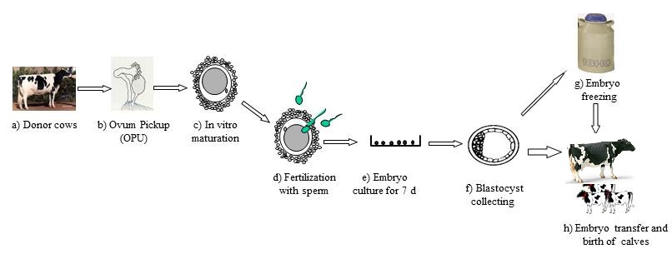
Figure 49 – IVF in cattle

ICSI
Intracytoplasmatic injection of spermatozoids (ICSI) is a quite new method, invented for human in the case of male infertility, but now it used for animals too. For various reasons, there may be a need to explore novel means of achieving fertilization. Some of the possible approaches are illustrated in figure 50.
Figure 50 – Four approaches for micro-assisted fertilization. SUZI – subzonal spern injection.
(I.R. Gordon 2004. Reproductive Technologies in Farm Animals)

As a result of poor IVF results, often with only 15–30% of oocytes being fertilized, ICSI has been employed in dealing with horse oocytes. Various workers have shown that ICSI is capable of increasing fertilization rates compared with IVF, and several foals have been born from IVM horse oocytes fertilized by sperm injection. In Italy, studies have demonstrated that a blastocyst rate of about 30% can be achieved after ICSI of IVM equine oocytes.
According to Squires et al. (2003), the ICSI technique provides the possibility of obtaining pregnancies from stallions that may have low sperm numbers or poor semen quality. Although ICSI is the method of choice for fertilizing horse oocytes in vitro, the reasons for this are not well understood and embryo development rates have remained low. For such reasons, a study undertaken by Tremoleda et al. (2003) in The Netherlands sought to characterize the nuclear and cellular events occurring in horse oocytes during fertilization after sperm injection; it was concluded that, until conventional IVF becomes more reliable, ICSI probably remains the best way to produce equine embryos, to perform fundamental research into the cellular and molecular events of fertilization, to investigate infertility and to understand the cellular basis of early pregnancy failure in horses.
ISCI has proved to be a valuable addition to the technology of assisted reproduction, especially in humans and, to a more limited extent, in horses. The technique also provides an opportunity for research into cell-cycle control and the mechanisms involved in sperm-induced oocyte activation. The same sperm injection technique also has relevance as a sperm vector system for transgenic animal production and with freeze-dried sperm for which the maintenance of motility is not required.

Other fertilization approaches in animal artificial reproduction
Gamete intra-Fallopian tube transfer (GIFT) has been used in horses to deal with stallions having low sperm numbers or in situations in which frozen semen is in limited supply or sexed semen is being employed. In the GIFT technique, oocytes and sperm are transferred to the mare’s oviduct. Results from studies by Squires et al. (2003), who inseminated fresh semen into the oviduct, showed an 82% pregnancy rate compared with an 8% rate with the use of frozen–thawed sperm; the authors note that further work is required to determine why pregnancy rates are depressed when using cooled or frozen semen compared with fresh semen for GIFT transfer. When techniques such as GIFT are used in the horse, the culture and subsequent transfer of donor oocytes may pose additional risks for disease transmission; although the zona pellucida provides pathogen protection, the cumulus cells surrounding the oocyte, which are inevitably transferred with the gamete, could harbour intracellular viral pathogens.

IVF in human
Assisted reproduction technologies are treatments or procedures that include the handling of human eggs and sperm or embryos for the purpose of establishing a pregnancy. For understanding the techniques, you will need in some special definitions. Infertility is inability to conceive after 1 year of properly timed unprotected intercourse. Fecundity rate, a likelihood of achieving pregnancy in a given month in a couple with normal fertility is approximately 20% per month. Cumulative pregnancy rate after 12 months is 93%.
In order to get pregnant under normal conditions:
- Healthy sperms Sperm retrieval procedures
- Sperm ascent Artificial insemination
- An ovum ovulation induction and oocyte retrieval.
- Fertilization ICSI
- Cell division.
- Implantation Assisted hatching
Used at human methods of artificial inseminations include: intravaginal insemination; intracervical insemination; intrauterine insemination; intratubal insemination.
The first successful IVF case was in 1978 when a British woman delivered a baby called Louise Brown in 28 of July 1978 in Oldam in England by cesarean section (see figure 51). It had taken nearly a century of research to achieve that.

Figure 51 – The first IVF child
IVF Indications:
- Women with blocked fallopian tubes (Tubal Factor)
- Ovulation problems (Diminished ovarian reserve; Endometriosis; Advancing age; Third party reproduction)
- Seminal problems for the man: sperm transport, motility… (Severe male factor)
- Unexplained infertility cases.
- Presence of seminal antibodies in the woman’s body

Current methods of IVF in human include:
- Precycle Work-up
- Ovarian Stimulation
- Egg Retrieval
- Embryo Transfer
- PGD
- Laboratory Handling

Ovarian stimulation is first step controlled by vaginal ultrasound which allows monitor the number and size of the follicles and adjust the dose of the injections accordingly. HCG Hormone injection is given for final maturation of the eggs. Oocytes (eggs) retrieval is done 34-37 hours after taking the HCG injection. The fluid collected from the follicles in special tubes is examined by the embryologist and the eggs are isolated. The semen sample is taken in the same day and the eggs fertilized either using the conventional IVF or ICSI.
Suppression drugs prevent spontaneous ovulation is also an important step in an IVF cycle because that natural ovulation should not occur - if the eggs leave the ovary, the doctor will not be able to retrieve them.
Ovarian stimulation is used to produce multiple mature follicles, rather than the single egg normally developed each month. Produces many good follicles to be Fertilized. Multiple eggs are stimulated because some eggs will not fertilize or develop normally after fertilization. Regular monitoring by ultrasound scan is done. Generally, eight to 14 days of stimulation is required.
Used medications are presented in the figure 52.
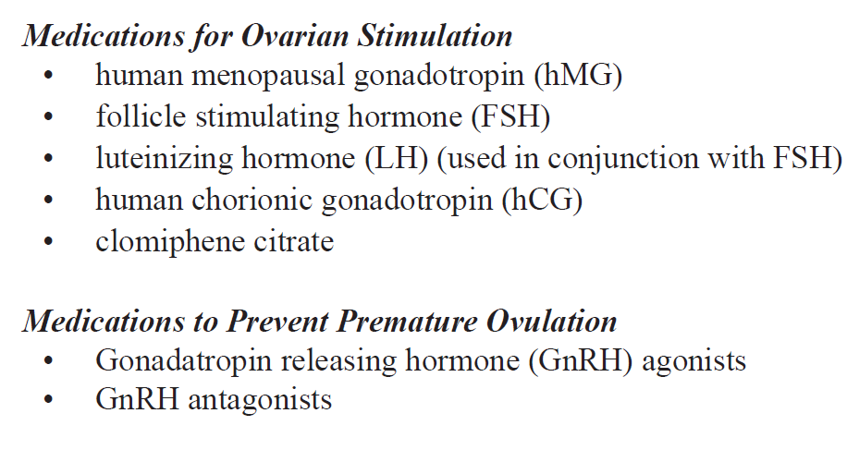
Figure 52 – Medications used to superovulation treatment in human
Possible side effects of ovarian stimulation:
- Discomfort, bruising or swelling at injection site
- Rash
- Allergic sensitivity
- Headache
- Mood swings
- Abdominal discomfort and bloating
- Chance of multiple pregnancies
- Ovarian Hyperstimulation Syndrome (OHSS)
Ovarian hyperstimulation can result in enlargement of the ovaries with leakage of fluid into the abdomen and rarely into the lungs. Most cases are mild, but a small proportion are severe and fatal. Treatment of OHSS depends on the severity of the hyperstimulation. Mild OHSS can be treated conservatively.
Oocyte retrive is done by using the vaginal ultrasound, Transabdominal ultrasound or laparascope, under general or local anaesthetic.
Eggs mixed with thousands of sperms in a special dish. Special incubators simulating natural conditions with 5% of CO₂ is used. The fertilization is observed in the laboratory microscope. After fertilization is assured and cell division observed the embryos (usually 3) are returned to the woman’s uterus through the cervix using a special catheter (done from 2-5 days). Luteal phase support also is needed.
Before implantation of embryos the genetic screening procedure is required (see figure 53).
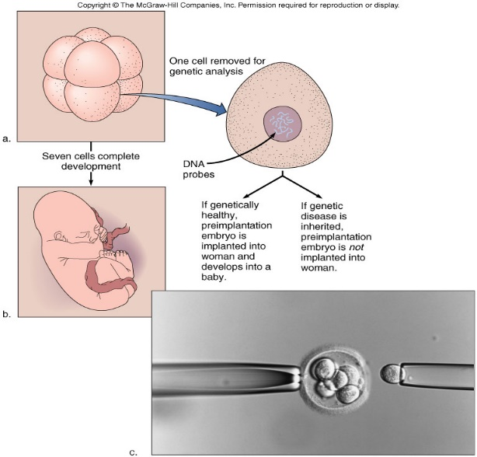
Figure 53 – IVF genetic screening

Transfer embryos is recommended at blastocyst stage. Culture fertilized ova and early embryos with cells that normally surround the oocyte, so they can provide growth factors. Screen early embryos for chromosome abnormalities and implant only those with normal karyotypes.
ICSI indications:
- Moderate to severe male factor:
- Severe problems in the seminal fluid as in severe deficiency in number or motility of the sperms or both.
- Epididymal or testicular sperm: In cases when there are no sperms in the seminal fluid but there are in testicles (absent duct). In these cases the sperms are taken from either the epididymis or the testes (PESA, TESA).
  - History of failed fertilization with IVF
  - Antisperm antibodies
  - Low egg number
Percutaneous Epididymal Sperm Aspiration (PESA) indicates in following cases: absence of the vas deferens; past infections which result in obstruction; cases who had vasectomy and surgical reversal failed. Testicular Sperm Aspiration (TESA) can be donу by aspiration using a needle or surgical extraction (еtaking a very small piece from the testes). Absence of sperms in the epididymis and absent or obstructed epididymis are the indications for TESA.
Applying ICSI at human the egg is injected with a single sperm, taken from the husband’s sperm (after preparation in the lab). A special needle is used to go through the wall of the egg and the sperm is introduced into the cytoplasm of the egg (see figure 54).
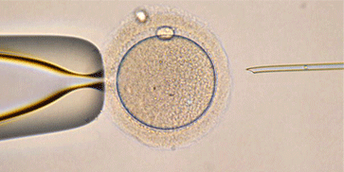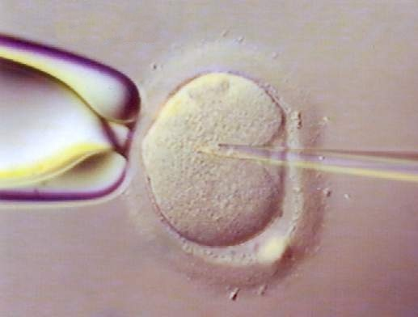
Figure 54 – ICSI at human

Damage to the oocyte (meiotic spindle)

ICSI concerns with override natural safeguards that serve to prevent fertilization by abnormal sperm; transmission of paternal genetic abnormalities (Sex chromosomal abnormalities, Y chromosome microdeletions); karyotyping and Y chromosome deletion analysis should be offered to all men with severe male factor infertility who are undergoing ICSI.
The fertilization is observed later and after the division occur, the embryos are transferred into the woman’s uterus.
If repeated implantation failure in special cases when the wall of the embryo is thick the assisted hatching is recommended (see figure 55).
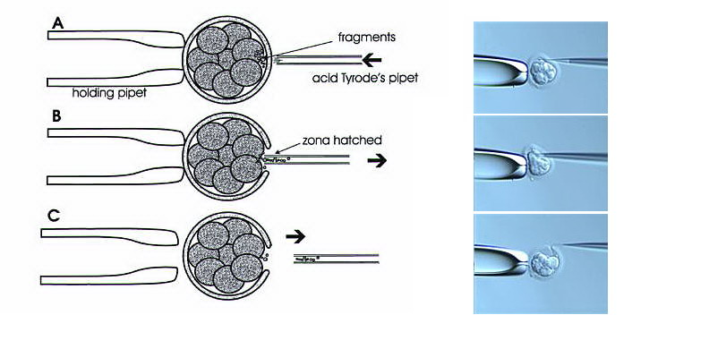
Figure 55 – Assisted hatching in human
Various protocols have been described. There are partial zona dissection; acid tyrode’s assisted hatching; laser-assisted hatching; zona pellucida thinning. A small hole is made in the wall of the Embryo using either a needle, and special chemical or laser beam.
Conventional methods of GIFT and ZIFT are still actual in assisted reproductive technologies in human. GIFT involves laparoscopically placing mature eggs into the healthy fallopian tube along with washed sperm. In the case of ZlFT, the zygotes are placed directly into the fallopian tubes via laparoscopy or transcervical fallopian tube catherization.
Since the day in 1978 when Louise Brown was born in England (Henig, 2003), human IVF has led to the birth of an estimated 1 million and more babies worldwide.
At that time, media attention verged on the hysterical, with reports suggesting that testtube babies were “the biggest threat since the atom bomb”. Although such predictions turned out to be quite wrong, there are those, some with the benefit of hindsight, who have introduced a strong note of caution about applying human-assisted reproduction techniques without a solid body of research evidence in support. It is now recognized that the unregulated nature of human IVF failed to put appropriate emphasis on follow-up studies on the children born after IVF.
There are those who have commented that techniques with such an impact on human welfare should have been under government-sponsored regulation from the start so that appropriate follow-up information would be guaranteed. In the USA, for example, the National Institute of Child Health and Human Development never funded human IVF research in any form.
There are those, such as Winston (2003) in the UK, who draw attention to worrying aspects of more recent advances, such as intracytoplasmic sperm injection (ICSI). In this context, there is an obvious need for those engaged in the animal field to share their experiences with those in the human field.

Chapter 10. Embryo transfer
The first embryo transfer (ET) dates back to Walter Heape more than a century ago in England. Many years were to pass before this novel form of reproductive technology was to reach the farm; when it did, it was predominantly in the breeding of cattle.
Tim Rowson and associates in Cambridge, working with sheep in the mid-1950s, showed the usefulness of ET as a research tool. The technique provided the means for testing in sheep the relative importance of genetic and environmental factors for the developing sheep embryo. Although the birth of the first calf by ET occurred in the USA (Betteridge et al., 2000) in the early months of 1950, it was to be a further two decades before Rowson’s work in Cambridge led to commercial application of ET technology.
The ET is a technique that increases both the commercial production and the genetic potential in livestock. The embryo transfer technique provides a rapid rate of improvement of animal genetic quality offering access to the highest-quality genetics at a lower cost than purchasing a live animal. Techniques inducing superovulation are used in conjunction with ET to expedite the propagation of animals with genetic selection for desirable traits.
The considerable variation in superovulatory response as well as the fact that the percentage of the superovulated donors do not produce transferable embryos, are the major limiting factors to the routine application of ET techniques.
The main purpose of embryo transfer (ET) in domestic animals is to spread the genetic quality of livestock production for desirable traits. Although the basic procedures employed in ET are now well established, there is considerable scope for improvement of ET technology in various areas.
The main point in ET is a donor-recipient synchrony.
Over the years, much evidence has accumulated on the importance of synchrony between donor and recipient in terms of their cycle stage. Exact synchrony should be the aim, but recipients out of phase by ± 1 day are generally regarded as acceptable, although some reduction in pregnancy rate is to be expected; cattle that are out of synchrony by as much as 2 days would not normally be used because of the reduced pregnancy rates. Some workers have looked at ways of making synchrony as exact as possible. In Arkansas, for example, the of an electronic estrous detection system to continuously monitor cattle permitted more precise timing of ET and resulted in improved pregnancy rates; Rorie et al. (2002) reported data suggesting that continuous monitoring of embryo donors and recipients and selection of recipients with synchrony of ±12 h could improve pregnancy rates (see Table 8).

Table 8 - Embryo-recipient synchrony and pregnancy rates (Rorie et al., 2002)
Estrous synchrony category (h) | Number of embryo transfers | Pregnancy rate (Mean±sem)
-12 to -24 | 37 | 51.4±8.2
0 to -12 | 67 | 58.2±6.1
0 | 9 | 66.7±16.6
0 to +12 | 78 | 61.5±5.6
+12 to +24 | 37 | 48.6±8.2
0 to ±12 | 126 | 62.7±4.4
±12 to ±24 | 102 | 50.0±4.9

Work in Ireland in the mid-1970s and elsewhere showed that it is possible to establish pregnancies by a non-surgical procedure involving the use of the standard Cassou inseminating instrument. The cow embryo is loaded, held in a small volume of medium (for example, phosphate-buffered saline (PBS) supplemented with 15% bovine serum), into a plastic straw (usually 0.25 ml capacity). At transfer, the straw is inserted into the inseminating instrument (“gun”) in the usual way and the same procedure followed as for AI, the main difference being that the embryo is deposited around the mid-horn position (ipsilateral horn); before carrying out the transfer, the recipient animal is given an epidural anaesthetic and tranquillizer.
During the past quarter-century, several variants of the standard transfer instrument have been marketed, with appropriate modifications to ensure that the embryo is deposited safely in the uterus.
Pregnancy rates in mares after non-surgical ET are usually lower than for surgical transfer and are highly dependent upon operator experience and expertise to pass the sterile transfer pipette through the closed diestrous cervix. Cambridge workers have reported a new transfer method which obviates the need for such operator skill; they reported an 85% pregnancy rate, a marked improvement on rates previously achieved (50–55%) using the conventional transfer method (Wilsher and Allen, 2003). It was concluded that the new technique is manipulatively uncomplicated, simple to perform and remarkably successful. Maiden heifers are usually preferred as recipients in conventional cattle ET operations; quite apart from being free of problems arising from previous pregnancies, such animals are likely to cost less and be easier to acquire than cows. However, in terms of ease of transfer, the parous cow has a definite advantage; various studies have shown that 10% or so of heifer recipients may be difficult, if not impossible, to use for cervical transfers. Certain categories of maiden heifers as recipients may also pose very real welfare problems. In the UK, for example, the use of beef-type heifers as recipients for embryos from large dairy breeds (for example, Holstein–Friesian) and doublemuscled beef breeds has occasionally resulted in a proportion requiring surgery to deliver the fetus. Clearly, it is undesirable for unsuitable embryos to be transferred to recipients; legislation has been enacted in several countries to prohibit transfer of embryos likely to produce large calves.
The importance of minimizing stress in recipient animals is rightly emphasized in various reports. Any routine treatment (e.g. antiparasitic) should take place at least 3 weeks prior to transfer; changes in the feeding regimen should be prohibited for 3-4 weeks before and after transfer. Recipients should be located where they can be easily and quietly handled on the day of transfer. Several authors stress the need for ET teams to examine their procedures to reduce stress and improve the welfare of all animals involved in their activities. Ibuprofen is a non-steroidal anti-inflammatory drug (NSAID) which has a number of beneficial actions in addition to its analgesic and antipyretic effects. There is evidence that substances that inhibit cyclo-oxygenase enzyme isoforms may improve IVF outcome in humans; treatment may take the form of a daily dose of 100 mg aspirin. It is also known that ibuprofen improves pregnancy rates in recipient cattle after ET and may be a useful, effective and safe adjunct to assisted reproduction in cattle (Elli et al., 2001).
Practical applications of embryo transfer:
- Gender preselection
- Genetic preservation of endangered breeds
- Interspecific embryo transfer
- As a research tool

Chapter 11. Cryopreservation of animal cells and tissues
Cryo-preservation or cryo-conservation is a process where organelles, cells, tissues, extracellular matrix, organs or any other biological constructs susceptible to damage caused by unregulated chemical kinetics are preserved by cooling to very low temperatures (typically −80°C using solid carbon dioxide or −196 °C using liquid nitrogen).
One of the most important early theoreticians of cryopreservation was James Lovelock (born 1919) known for Gaia theory. He suggested that damage to red blood cells during freezing was due to osmotic stress. During the early 1950s, Lovelock had also suggested that increasing salt concentrations in a cell as it dehydrates to lose water to the external ice might cause damage to the cell. Cryopreservation of tissue during recent times began with the freezing of fowl sperm, which during 1957 was cryopreserved by a team of scientists in the UK directed by Christopher Polge. The process was applied to humans during the 1950s with pregnancies obtained after insemination of frozen sperm. However, the rapid immersion of the samples in liquid nitrogen did not, for certain of these samples – such as types of embryos, bone marrow and stem cells – produce the necessary viability to make them usable after thawing. Increased understanding of the mechanism of freezing injury to cells emphasised the importance of controlled or slow cooling to obtain maximum survival on thawing of the living cells. A controlled-rate cooling process, allowing biological samples to equilibrate to optimal physical parameters osmotically in a cryoprotectant (a form of anti-freeze) before cooling in a predetermined, controlled way proved necessary. The ability of cryoprotectants, in the early cases glycerol, to protect cells from freezing injury was discovered accidentally. Freezing injury has two aspects: direct damage from the ice crystals and secondary damage caused by the increase in concentration of solutes as progressively more ice is formed. During 1963, Peter Mazur, at Oak Ridge National Laboratory in the U.S., demonstrated that lethal intracellular freezing could be avoided if cooling was slow enough to permit sufficient water to leave the cell during progressive freezing of the extracellular fluid. That rate differs between cells of differing size and water permeability: a typical cooling rate around 1 °C/minute is appropriate for many mammalian cells after treatment with cryoprotectants such as glycerol or dimethyl sulphoxide, but the rate is not a universal optimum.
Cryopreservation is based on the ability of certain small molecules to enter cells and prevent dehydration and formation of intracellular ice crystals, which can cause cell death and destruction of cell organelles during the freezing process. At low enough temperatures, any enzymatic or chemical activity which might cause damage to the biological material in question is effectively stopped. Cryopreservation methods seek to reach low temperatures without causing additional damage caused by the formation of ice during freezing. Traditional cryopreservation has relied on coating the material to be frozen with a class of molecules termed cryoprotectants. Two common cryoprotective agents are dimethyl sulfoxide (DMSO) and glycerol. Glycerol is used primarily for cryoprotection of red blood cells, and DMSO is used for protection of most other cells and tissues. A sugar called trehalose, which occurs in organisms capable of surviving extreme dehydration, is used for freeze-drying methods of cryopreservation. Trehalose stabilizes cell membranes, and it is particularly useful for the preservation of sperm, stem cells, and blood cells.
The side effects of cryoprotectants:
- True chemical toxicity
- (Baxter and Lathe, 1971; Fahy, 1986).
- In vitrification methods very high concentrations of these compounds are necessary to achieve and maintain a vitreous state.
- The precise nature of the toxic effects of CPA remains, to a large degree, uncertain.
- Cryoprotectants have been shown to alter cytoskeletal components in mammalian oocytes, particularly the filamentous actin network and meiotic spindle (Johnson and Pickering, 1987;Vincent et al., 1990;Vincent and Johnson, 1992)
New methods are constantly being investigated due to the inherent toxicity of many cryoprotectants. By default it should be considered that cryopreservation alters or compromises the structure and function of cells unless it is proven otherwise for a particular cell population.
Most systems of cellular cryopreservation use a controlled-rate freezer. This freezing system delivers liquid nitrogen into a closed chamber into which the cell suspension is placed. Careful monitoring of the rate of freezing helps to prevent rapid cellular dehydration and ice-crystal formation. In general, the cells are taken from room temperature to approximately −90 °C (−130 °F) in a controlled-rate freezer. The frozen cell suspension is then transferred into a liquid-nitrogen freezer maintained at extremely cold temperatures with nitrogen in either the vapour or the liquid phase. Cryopreservation based on freeze-drying does not require use of liquid-nitrogen freezers.
Cryoconservation of animal genetic resources is the process in which animal genetic material is collected and stored with the intention of conservation of the breed.
Vitrification
For successful commercial application, a simple process that permits direct embryo transfer and gives high pregnancy rates is what is required. The most significant steps in the cryopreservation of cattle embryos in recent years include the ability to freeze and transfer embryos in straws without dilution and the development of the open pulled straw (OPS) method for efficient vitrification of embryos and oocytes. In vitrification, ice-crystal formation is prevented by using high concentrations of cryoprotectants and high cooling and warming rates.
Although vitrification as a method of cryopreserving embryos appeared on the scene in the mid-1980s as an alternative to the traditional slow freezing of cattle embryos, its suggested advantages (simplicity, cost, speed) had little impact on commercial ET operations and its application remained largely confined to research studies.
Vitrification is an ultra-rapid cooling technique based on direct contact between the vitrification solution, containing cryoprotectant agents, and liquid nitrogen. The protocols for vitrification are simple, allowing cells and tissue to be placed directly into the cryoprotectants and then plunged directly into liquid nitrogen. It may be noted that the literature of cryopreservation technology makes a distinction between ‘thawing’ as applied to embryos and oocytes preserved by conventional freezing, and ‘warming’, which is the term used in bringing embryos back to ambient temperature after vitrification. In human-assisted reproduction, vitrification protocols are starting to be employed, with several births reported using protocols that have been successfully applied to bovine oocytes and embryos (Liebermann et al., 2002). Milestones in the application of vitrification to various mammalian species are detailed in Table 9.

Table 9 - Milestones in vitrification of embryos
Date | Species | Researcher(s)
1985 | Mouse | Rall & Fahy
1986 | Cow | Massip et al.
1986 | Hamster | Critser et al.
1988 | Rat | Kono et al.
1989 | Rabbit | Smorag et al.
1990 | Sheep/goat | Scieve et al.
1994 | Horse | Hochi et al.
1998 | Pig | Kobayashi et al.

Vitrification has the attraction of avoiding the need for expensive equipment, as required in a conventional cryopreservation program. In physical terms, vitrification is a process of solidification in which crystalline ice does not separate and there is no concentration of solutes, as in conventional freezing; there is an abrupt increase in the viscosity of the holding medium, producing a glasslike solid. Very high cooling rates are employed but initial exposure to the vitrifying solution is at refrigerator temperature and very brief or avoid adverse effects from cryoprotectant toxicity. Warming rate is also rapid to avoid crystal formation as the temperature returns to normal. Using the standard French ministraw as an embryo container, vitrification enabled a maximum cooling rate of about 2000°C/min. Vajta’s OPS method, on the other hand, permits much higher cooling and warming rates (> 20,000°C/min); the method involves loading the cattle embryos into a straw previously heat-pulled to half the diameter and thickness of the wall.
In the freezing of embryos, the methods originally used by Whittingham and others with mice were found to be entirely unsuccessful with pigs; the three approaches taken towards the cryopreservation of the pig embryo are shown in Fig. 3.6. It early became evident that pig morulae are extremely sensitive to cooling below 15°C and it eventually became clear that this sensitivity to cooling and freezing was the result of their high lipid content; it also became clear that pig embryos at the expanded and hatched blastocyst stages have a higher tolerance to cooling than early blastocysts or morulae.

Cryopreservation and freezerying of sperm
Cryopreserved sperm is successfully used for AI and IVF. Although millions of sperm are normally used to inseminate the different farm animal species, in all cases, only a minute fraction of these sperm reach the site of fertilization. There are those who believe that the differences among species in the ability of their sperm to survive freeze–thawing is related to their tolerance of osmotic stress. It is critically important that the osmotic behavior of sperm be determined and that cryopreservation protocols are adjusted to make it possible for sperm with appropriate motility and survival ability to be inseminated. It is likely that future research will continue to be concerned with semen storage.
Although it has been known for many years that mouse sperm do not freeze well, it now appears that an alternative approach to long-term storage in this species may lie in freeze-drying. The production of mouse pups from freeze-dried sperm has recently been reported by Japanese researchers; they used low temperature and pressures to remove water from the sperm and stored them at 4°C for periods of up to 3 months. In reconstituting the gametes, it was simply a matter of adding water, removing the sperm heads and injecting them into mouse oocytes; of 57 oocytes injected, 54 survived and 49 began development in vitro. The transfer of 46 embryos to the uterus of recipient mice resulted in the birth of 14 normal young. Freeze-dried mouse sperm are motionless and are not fertile in the conventional sense; however, ICSI can enable them to achieve fertilization. In farm animals, a study by Keskintepe et al. (2002) was the first to report the production of apparently normal cattle blastocysts after the injection of frozen–thawed bull sperm that were selected, freeze-dried and stored at 4°C until use. Other work in the USA working with pigs, has demonstrated that cytologically dead boar sperm, which had been freeze-dried, were capable of fertilizing oocytes by way of ICSI and of delivering exogenous genetic material for the production of transgenic pig embryos.
Although freeze-thawing does produce damage to the cells with loss of up to 50% of pre-freeze motility, since large numbers of cells are available, successful fertilization can be achieved even with low cryosurvival rates.
Effects of cryopreservation of sperm:
- Sperm membranes have an unusual lipid composition
- Reduction in temperature alters the membrane lipid organization and modifies the kinetics or intra-membrane proteins, leading to lowered permeability and loss of fluidity.
- Loss of fluidity led to poor sperm survival
- Frozen/thawed sperm behave in a similar way to capacitated sperm, which may lead to a shortened lifespan within the female tract; therefore the timing of insemination is important when using frozen sperm samples.
- Difference in sperm cryosurvival rates between normal semen and semen with abnormal parameters
Methods to improve:
- Sperm preparation in order to remove immotile and damaged sperm prior to freezing may help to select a population of sperm with a better chance of survival.
- Use of stimulants such as pentoxifylline may also improve survival after thawing

Freezing embryos
The freezing of mammalian embryos was first shown to be possible in 1971, when David Whittingham and colleagues in London obtained live mice pups after the transfer of frozen–thawed embryos that had been frozen using either glycerol or dimethyl sulphoxide (DMSO). Some milestones in the freezing of mammalian embryos are detailed in Table 10.
Table 10 - First young born after transfer of frozen-thawed embryos
Date | Species | Researcher(s)
1971 | Mouse | Whittingham et al.
1973 | Cow | Wilmut &Rowson
1974 | Rabbit | Bank & Maurer
1974 | Sheep | Wiladsen
1975 | Rat | Whittingham
1976 | Goat | Bilton & More
1982 | Horse | Yamomoto et al.
1984 | Human | Zeilmaker et al.
1985 | Hamster | Ridha & Dukelow
1988 | Cat | Dresser et al.
1989 | Pig | Hayashi et al.
1989 | Rhesus monkey | Wolf et al.

It is believed that sperm and embryos are capable of remaining viable at a temperature of −196°C (liquid nitrogen) for perhaps 1000 years or more, the only source of damage at such a temperature being direct ionization from background radiation. For normal purposes, however, there is little need to think in terms of storage for other than a few months or years. Many studies have shown that the usual length of cryopreservation of cattle embryos in liquid nitrogen does not affect their viability after thawing.
Cambridge workers were at the forefront in developing effective techniques for the freezing of cattle embryos, the work of Chris Polge, Ian Wilmut and Steen Willadsen being particularly valuable. It was found that slow freezing (0.3°C/min) of cattle embryos to low subzero temperatures (−80°C) required slow thawing; slow freezing of embryos to relatively high subzero temperatures (−25°C to −35°C), on the other hand, required rapid thawing (360°C/min).
Such findings, initially described by Willadsen in the freezing of sheep embryos, subsequently formed the basis of the cryopreservation technique that was to be widely adopted in commercial practice; since the late 1970s, the method has been the standard technique in freezing the embryos of many species, including human embryos.
The first calf born after transfer of a frozen embryo in the early 1970s at Cambridge (Frosty II) did much to stimulate such research. In the course of the next three decades, countless thousands of cattle embryos were frozen and thawed for transfer in countries around the world. In cattle, as in other domestic species and humans, the study of cryobiology as it relates to embryo preservation is one of the most intensively researched area of embryo biotechnology.
Numerous protocols of cryopreservation were to be proposed (conventional slow freezing, ultra-rapid freezing and vitrification), each methodology with its advantages and disadvantages.
Disease control is an important consideration in the export and import of embryos and recent years have seen moves to minimize or abandon altogether the use of animal proteins (serum or bovine serum albumin (BSA)) in the medium employed in bovine embryo freezing. A study reported by George et al. (2002) substituted plant protein (wheat peptones) for BSA, the workers finding that the substitution did not affect blastocyst survival and quality.
During recent years, ethylene glycol has been effectively employed as a cryoprotectant for bovine embryo preservation. The molecular weight of this agent (62.1) is lower than that of glycerol (92.1), propylene glycol (76.1) and DMSO (78.1) and it seems possible that its beneficial effect is partly due to its high permeability; the fact that it permeates the embryo rapidly also eliminates the need for the stepwise dilution of the cryoprotectant at the time of thawing. In a survey of the cattle ET industry in North America, workers reported the growing popularity of ethylene glycol and direct embryo transfers, recording that, in 1997, 55.4% of frozen–thawed embryos transferred in the USA and 87.6% of those in Canada were frozen using the agent. In France, workers have recently reported studies with 2134 transfers in which ethylene glycol was compared with a glycerol–sucrose combination; they recorded an improved success rate with ethylene glycol (55.4% vs. 47.2%). Further information on the use of ethylene glycol in the freezing of cattle embryos in the USA is provided by Hasler (2002).
Embryos can be frozen successfully by slow and ultrarapid freezing. Timing of pronucleate freezing is crucial, and the process must be initiated while the pronuclei are still distinctly apparent, no later than 20–22 hours after insemination. 2 to 8 cell embryos should be of good quality, grade 1 or 2, with less than 20% cytoplasmic fragments. Uneven blastomeres and a high degree of fragmentation jeopardize survival potential; embryos with damage after thawing may still be viable and result in pregnancies, but their prognosis for implantation is reduced.

Cryopreservation of oocytes
The first report on successful freezing of a mammalian oocyte was the work of David Whittingham in London in the late 1970s with mice; it was shown to be possible to obtain live offspring after IVF of mouse oocytes frozen with dimethyl sulphoxide (DMSO) and stored in liquid nitrogen. Despite such success, the history of oocyte freezing during the past quarter-century has revealed difficult problems; certainly, in terms of applications in human assisted reproduction, current cryopreservation protocols are regarded as far from optimal (Van der Elst, 2003).
Several workers have reported on their efforts to develop effective vitrification techniques for the cryopreservation of bovine oocytes. In Nottingham, for example, Mavrides and Morroll (2002) suggest that the cryo-loop vitrification technique followed by ICSI could be effective. The cryo-loop is a technique where a thin nylon loop is used to suspend a film of cryoprotectant containing the oocytes before they are immersed in liquid nitrogen. Using bovine oocytes, the Nottingham workers reported a survival rate of 90.5% in comparison with a slow-freezing technique (54.4%).
Mammalian oocytes are particularly susceptible to freeze-thaw damage due to their size and complexity. They must not only survive thawing, but also preserve their potential for fertilization and development.
Cryopreserving of tissues
Some have attempted to preserve oocytes by vitrifying ovarian tissues. A study by Al-Aghbari and Menino (2002), for example, reported that sheep oocytes could be successfully cryopreserved by vitrification of ovarian tissues; they subsequently exhibited IVM rates similar to those of vitrified and non-vitrified oocytes.
An important application of cryopreservation is in the freezing and storage of hematopoietic stem cells, which are found in the bone marrow and peripheral blood. In autologous bone-marrow rescue, hematopoietic stem cells are collected from a patient’s bone marrow prior to treatment with high-dose chemotherapy. Following treatment, the patient’s cryopreserved cells are thawed and infused back into the body. This procedure is necessary, since high-dose chemotherapy is extremely toxic to the bone marrow. The ability to cryopreserve hematopoietic stem cells has greatly enhanced the outcome for the treatment of certain lymphomas and solid tumour malignancies. In the case of patients with leukemia, their blood cells are cancerous and cannot be used for autologous bone-marrow rescue. As a result, these patients rely on cryopreserved blood collected from the umbilical cords of newborn infants or on cryopreserved hematopoietic stem cells obtained from donors. Since the late 1990s it has been recognized that hematopoietic stem cells and mesenchymal stem cells (derived from embryonic connective tissue) are capable of differentiating into skeletal and cardiac muscle tissues, nerve tissue, and bone. Today there is intense interest in the growth of these cells in tissue culture systems, as well as in the cryopreservation of these cells for future therapy for a wide variety of disorders, including disorders of the nervous and muscle systems and diseases of the liver and heart.

Chapter 12. Chimeras. Xenotransplantation.
Chimera or allophenic animal is the animal consisting of different genotype cells which originated more than one zygotes (see figure 56). Different cell populations can be combined in one organism during any stage of development.
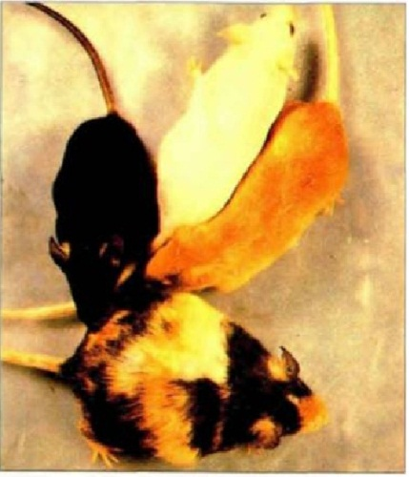
Figure 56 – Chimeric mouse born from 3 “parents”
(S. F. Gilbert et al., Developmental Biology, 11th edition, 2016)
In biological research, chimeras are artificially produced by selectively transplanting embryonic cells from one organism onto the embryo of another, and allowing the resultant blastocyst to develop. Chimeras are not hybrids, which form from the fusion of gametes from two species that form a single zygote with a combined genetic makeup.
An animal chimera is a single organism that is composed of two or more different populations of genetically distinct cells that originated from different zygotes involved in sexual reproduction. If the different cells have emerged from the same zygote, the organism is called a mosaic. Chimeras are formed from at least four parent cells (two fertilized eggs or early embryos fused together). Each population of cells keeps its own character and the resulting organism is a mixture of tissues.
As with cloning, the process of creating and implanting a chimera is imprecise, with the majority of embryos spontaneously terminating. Successes, however, have led to major advancements in the field of embryology, as creating chimeras of one species with different physical traits, such as color, has allowed researchers to trace the differentiation of embryonic cells through the formation of organ systems in the adult individual.
The first known primate chimeras are the rhesus monkey twins, Roku and Hex, with each having six genomes. They were created by mixing cells from totipotent four cell blastocysts; although the cells never fused they worked together to form organs. It was discovered that one of these primates, Roku, was a sexual chimera; as four percent of Roku's blood cells contained two x chromosomes.
A major milestone in chimera experimentation occurred in 1984, when a chimeric geep was produced by combining embryos from a goat and a sheep, and survived to adulthood. The creation of the "geep" revealed several complexities to chimera development. In implanting a goat embryo for gestation in a sheep, the sheep's immune system would reject the developing goat embryo, whereas a "geep" embryo, sharing markers of immunity with both sheep and goats, was able to survive implantation in either of its parent species.
In 2003, researchers at the Shanghai Second Medical University in China reported that they had successfully fused human skin cells and rabbit ova to create the first human chimeric embryos. The embryos were allowed to develop for several days in a laboratory setting, then destroyed to harvest the resulting stem cells. In 2007, scientists at the University of Nevada School of Medicine created a sheep whose blood contained 15% human cells and 85% sheep cells.
Chimeric mice are important animals in biological research, as they allow the investigation of a variety of biological questions in an animal that has two distinct genetic pools within it. These include insights into such problems as the tissue specific requirements of a gene, cell lineage, and cell potential. The general methods for creating chimeric mice can be summarized either by injection or aggregation of embryonic cells from different origins. The first chimeric mouse was made in the 1960s by Beatrice Mintz, he used the aggregation of eight-cell-stage embryos. Richard Gardner and Ralph Brinster developed the method of injection cells into blastocysts to create chimeric mice with germ lines fully derived from injected embryonic stem cells (ES cells). Chimeras can be derived from mouse embryos that have not yet implanted in the uterus as well as from implanted embryos. ES cells from the inner cell mass of an implanted blastocyst can contribute to all cell lineages of a mouse including the germ line. ES cells are a useful tool in chimeras because genes can be mutated in them through the use of homologous recombination, thus allowing gene targeting. Since this discovery occurred in 1999, ES cells have become a key tool in the generation of specific chimeric mice for many purpose.
The ability to make mouse chimeras comes from an understanding of early mouse development. Different parts of the mouse embryo retain the ability to give rise to a variety of cell lineages between the stages of fertilization of the egg and the implantation of a blastocyst into the uterus. Once the embryo has reached the blastocyst stage, it is composed of several parts, mainly the trophectoderm, the inner cell mass, and the primitive endoderm. Each of these parts of the blastocyst gives rise to different parts of the embryo. The inner cell mass gives rise to the embryo proper, while the trophectoderm and primitive endoderm give rise to extra embryonic structures that support growth of the embryo. From two- to eight-cell-stage embryos are competent for making chimeras, since at these stages of development, the cells in the embryos are totipotent, and not yet committed to give rise to any particular cell lineage. They could give rise to the inner cell mass or the trophectoderm. In the case where two diploid eight-cell-stage embryos are used to make a chimera, chimerism can be later found in the epiblast, primitive, endoderm and trophectoderm of the mouse blastocyst.
It is possible to dissect the embryo at other stages so as to accordingly give rise to one lineage of cells from an embryo selectively and not the other. For example, subsets of blastomeres can be used to give rise to chimera with specified cell lineage from one embryo. The Inner Cell Mass of a diploid blastocyst for example can be used to make a chimera with another blastocyst of eight-cell diploid embryo. The cells taken from the inner cell mass will give rise to the primitive endoderm and to the epiblast in the chimera mouse. ES cell contributions to chimeras have been developed from this knowledge. ES cells can be used in combination with eight-cell-and two-cell-stage embryos to make chimeras and exclusively give rise to the embryo proper. Embryos that are to be used in chimeras can further be genetically altered in order to specifically contribute to only one part of chimera. An example is the chimera built off of ES cells and tetraploid embryos, tetraploid embryos which are artificially made by electrofusion of two two-cell diploid embryos. The tetraploid embryo will exclusively give rise to the trophectoderm and primitive endoderm in the chimera.
Methods of creating chimeras (see figure 57):
- Embryonic aggregation chimeras
- Injection of embryonic cells to blastocyst
- Therato-carcinomas (for example, the introducton of embryonic cells to the adult)
- Xenotransplantation (transplantations of cells, tissue, organs from one adult to another)
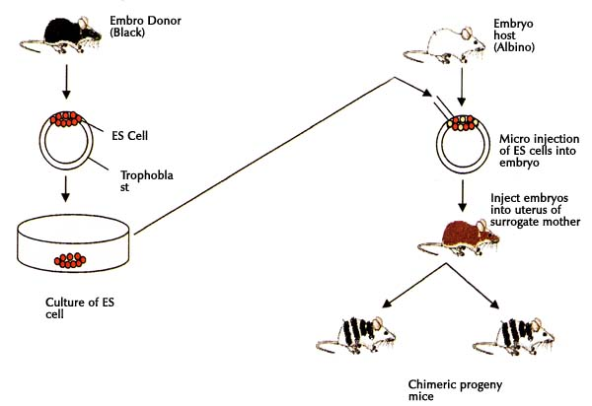
Figure 57 – Injection method of creating chimeras

Steps in creating chimerical mouse:
- Isolation of eggs from donors with different genotypes;
- Embryos should be cultivated on standard culture media (base-buffered saline, STC and lactate, glucose, albumin) to stage of 8 blastomeres;
- 8-cells morula aggregation (aggregation method), and cultivation in vitro to the blastocyst stage;
- chimeric embryo should be implanted into the uterus of female recipient
Animal chimeras are produced by the merger of multiple fertilized eggs or fusing of stem cells. There are a variety of combinations that can give rise to a successful chimera mouse and - according to the goal of the experiment - an appropriate cell and embryo combination can be picked. They are generally but not limited to diploid embryo and ES cells, diploid embryo and diploid embryo, ES cell and tetraploid embryo, diploid embryo and tetraploid embryo, ES cells and ES cells. The combination of embryonic stem cell and diploid embryo is a common technique used for the making of chimeric mice, since gene targeting can be done in the embryonic stem cell. These kinds of chimeras can be made through either aggregation of stem cells and the diploid embryo or injection of the stem cells into the diploid embryo.
For gene targeting to make a chimera the embryonic stem cells are used by the following procedure: 1) a construct for homologous recombination for the gene targeted will be introduced into cultured mouse embryonic stem cells from the donor mouse, by way of electroporation; 2) cells positive for the recombination event will have antibiotic resistance, provided by the insertion cassette used in the gene targeting; and be able to be positively selected for. ES cells with the correct targeted gene are then injected into a diploid host mouse blastocyst. These injected blastocysts are then implanted into a pseudo pregnant female surrogate mouse which will bring the embryos to term and give birth to a mouse whose germline is derived from the donor mouse's ES cells. This same procedure can be achieved through aggregation of ES cells and diploid embryos, diploid embryos are cultured in aggregation plates in wells where single embryos can fit, to these wells ES cells are added the aggregates are cultured until a single embryo is formed and has progressed to the blastocyst stage, and can then be transferred to the surrogate mouse.
Xenotransplantation is the transplantation of living cells, tissues or organs from one species to another. Such cells, tissues or organs are called xenografts or xenotransplants. It is contrasted with allotransplantation (from other individual of same species), Syngeneic transplantation (Grafts transplanted between two genetically identical individuals of the same species) and Autotransplantation (from one part of the body to another in the same person).
The first serious attempts at xenotransplantation (then called heterotransplantation) appeared in the scientific literature in 1905, when slices of rabbit kidney were transplanted into a child with renal insufficiency. In the first two decades of the 20th century, several subsequent efforts attempts to use organs from lambs, pigs and primates were published.
Scientific interest in xenotransplantation declined when the immunological basis of the organ rejection process was described. The next waves of studies on the topic came with the discovery of immunosuppressive drugs. Even more studies followed Dr. Joseph Murray's first successful kidney transplantation in 1954 and scientists, facing the ethical questions of organ donation for the first time, accelerated their effort in looking for alternatives to human organs.
In 1963, doctors at Tulane University attempted chimpanzee-to-human kidney transplantations in six people who were near death; after this and several subsequent unsuccessful attempts to use primates as organ donors and the development of a working cadaver organ procuring program, interest in xenotransplantation for kidney failure dissipated.
An American infant girl known as "Baby Fae" with hypoplastic left heart syndrome was the first infant recipient of a xenotransplantation, when she received a baboon heart in 1984. The procedure was performed by Leonard L. Bailey at Loma Linda University Medical Center in Loma Linda, California. Fae died 21 days later due to a humoral-based graft rejection thought to be caused mainly by an ABO blood type mismatch, considered unavoidable due to the rarity of type O baboons. The graft was meant to be temporary, but unfortunately a suitable allograft replacement could not be found in time.
Xenotransplantation of human tumor cells into immunocompromised mice is a research technique frequently used in oncology research. It is used to predict the sensitivity of the transplanted tumor to various cancer treatments.
Human organs have been transplanted into animals as a powerful research technique for studying human biology without harming human patients. This technique has also been proposed as an alternative source of human organs for future transplantation into human patients. For example, researchers from the Ganogen Research Institute transplanted human fetal kidneys into rats which demonstrated life supporting function and growth.
Xenotransplantation differs from other uses of genetically engineered animals in that it has the potential to create something entirely new—permanent human–animal chimeras—in which cells of distantly-related species survive and function for long periods of time in the most intimate contact possible. Given its potential for alleviating human diseases due to irreversible tissue or organ failure (see table 11), and given the acute shortage of human organs for transplant, there are very active research programs underway, in both commercial and academic laboratories, to overcome the significant immunologic and physiologic barriers, and thereby to bring xenotransplantation into standard medical practice.

Table 11 – Application of xenotransplantation in medical practice
(https://www.ncbi.nlm.nih.gov/books/NBK207578/table/ttt00004/?report=objectonly)
Indication | Transplant | Status
Organ Failure | Pig heart, kidney, liver, etc. | No successful experience
Acute liver failure | Extracorporeal perfusion | Some trials have been performed.
Diabetes | Pancreatic islets (or cells) | Some trials have been performed.
Parkinson's disease, Huntington's Disease, Focal epilepsy, Stroke | Neural tissue | Some trials have been performed.
Burn, Skin injury | Skin autograft  (co-cultured with mouse cells) | Successful trials have been performed.

At present, the only animal under serious consideration as a xenotransplant donor is the pig. For regulatory purposes, human cells cultured ex vivo with the cells of any other animal, such as mouse cell lines, also are considered to be xenotransplants (DHHS, 2001); co-cultivation with mouse cell lines has been used in the preparation of some cultured skin grafts as well as human stem cell lines; Thomson et al., 1998). While nonhuman primates, such as the baboon, would seem to have physiologic and immunogenetic advantages such as the lack of a hyper-acute immune response, their scarcity as well as the difficulty of clearing them of adventitious infectious agents (as well as ethical concerns) render them impractical for further consideration.
The field of xenotransplantation covers a great spectrum of procedures, ranging from implantation of single cells to treat Parkinson's disease and tissues, such as pancreatic islets, to treat diabetes; extracorporeal use of intact organs, such as perfusion of patient blood through pig livers to provide short-term support in cases of liver failure; to transplantation of whole organs—heart, kidney, liver, and so on. While whole-organ xenotransplantation remains far in the future, development of the simpler modalities is underway, and hundreds of human subjects have received porcine cells or tissues as part of clinical trials in the United States, Russia, Israel, and many European countries (Paradis et al., 1999). Given the nature of infectious disease issues, regulatory concerns are not limited to the United States alone, but extend to the international health community as well.
The development of xenotransplantation as a part of clinical practice promises great benefits in terms of making possible essentially infinite supplies of replacement tissues and organs where severe shortages exist today. This development naturally will entail both great potential benefit as well as considerable risk to the study participant, but such risk is not qualitatively different from that entailed in the development of any other new medical procedure and will not be considered further. The principal concern is that the uniquely close relationship created between recipient and host will allow novel opportunities for transmission of infectious disease, and possible creation of new disease agents in the process. While the history of close contact between humans and pigs is a very long one, and one would imagine that all possible transmission of infectious agents between the two species already would have been seen and thoroughly studied, it is possible that the “co-culture” environment of a transplant would be qualitatively different in ways that would allow different outcomes.

Chapter 13. Cloning technology to produce animal clones
Cloning is the process of producing similar populations of genetically identical individuals that occurs in nature when organisms reproduce asexually. Cloning is a natural form of reproduction that has allowed life forms to spread for more than 50 thousand years. So, a clone is an organism that is descended from and is genetically identical to a single common ancestor.
Clones are abundant in nature – when a zygote splits in two identical twins are formed.
Cloning technology involves techniques making genetically identical copies of an organism, using asexual reproduction.
Animal cloning history spans more than 100 years. The milestones of animal cloning history are represented in table 12.

Table 12 – Milestones in animal cloning history
Date | Species | Researcher(s) | Event | Implication
1885 | Sea urchin | Hans Adolf Edward Dreisch | First-ever demonstration of artificial embryo twinning | The sea urchin is a relatively simple organism that is useful for studying development.
1902 | Salamander | Hans Spemann | Artificial embryo twinning in a vertebrate | Embryos from a more-complex animal can also be “twinned” to form multiple identical organisms—but only up to a certain stage in development.
1928 | Salamander | Hans Spemann | First instance of nuclear transfer | The cell nucleus controls embryonic development
1952 | Frog | Robert Briggs & Thomas King | First successful nuclear transfer | Nuclear transfer was a viable cloning technique. Embryonic cells early in development are better for cloning than cells at later stages.
1958 | Frog | John Gurdon | Nuclear transfer from a differentiated cell | Nuclei from somatic cells in a fully developed animal could be used for cloning. Cells retain all of their genetic material even as they divide and differentiate.
1975 | Rabbit | J. Derek Bromhall | First mammalian embryo created by nuclear transfer | Mammalian embryos could be created by nuclear transfer.
1984 | Sheep | Steen Willadsen | First mammal created by nuclear transfer | It is possible to clone a mammal by nuclear transfer—and that the clone could fully develop.
1987 | Cow | Neal First, Randal Prather, & Willard Eyestone | Nuclear transfer from embryonic cell | Cows added to the list of mammals that could be cloned by nuclear transfer.
1996 | Sheep | Ian Wilmut and Keith Campbell | Nuclear transfer from laboratory cells | Cultured cells can supply donor nuclei for cloning by nuclear transfer. It is possible to use such modified cells to create transgenic animals—such as cows that could make insulin for diabetics in their milk.
1996 | Sheep | Ian Wilmut & Keith Campbell | Dolly: First mammal created by somatic cell nuclear transfer | Arrival of Dolly started conversations about the implications of cloning, bringing controversies over human cloning and stem cell research into the public eye.
1997 | Rhesus monkey | Li Meng, John Ely, Richard Stouffer, & Don Wolf | First primate created by embryonic cell nuclear transfer | Primates and humans’ closest relatives, can be cloned.
1997 | Sheep | Angelika Schnieke, Keith Campbell, Ian Wilmut | Nuclear transfer from genetically engineered laboratory cells | Sheep could be engineered to make therapeutic and other useful proteins in their milk, highlighting the potential medical and commercial uses for cloning.
1998-1999 | Mice, cows, and goats | Multiple groups | More mammals cloned by somatic cell nuclear transfer | Several more animals had been successfully cloned including transgenic animals.
2001 | Gaur and Mouflon | Multiple groups | Endangered animals cloned by somatic cell nuclear transfer | Scientists began to explore cloning as a way to create animals belonging to endangered or extinct species.
2007 | Rhesus monkey | Shoukhrat Mitalipov and colleagues | Primate embryonic stem cells created by somatic cell nuclear transfer | Possibility of human therapeutic cloning: creating individual-specific stem cells that could be used to treat or study diseases.
2013 | Human | Shoukhrat Mitalipov and colleagues | Human embryonic stem cells created by somatic cell nuclear transfer | First succesfull usage of somatic cell nuclear transfer to create a human embryo that could be used as a source of embryonic stem cells.

The short description of the key experiments in cloning will present the input of getting knowledge to understand the basic questions in developmental biology, image the scientific opportunities and applications area.
Experiment of Dreisch revealed that it was possible to separate the cells by merely shaking two-celled sea urchin embryos. After separation each cell grew into a complete sea urchin. This experiment showed that each cell in the early embryo has its own complete set of genetic instructions and can grow into a full organism.
Spemann’s experiment was to figure out how to split the two cells of an embryo much stickier than sea urchin cells. He fashioned a tiny noose from a strand of baby hair and tightened it between two cells of a salamander embryo until they separated. Each cell grew into a normal adult salamander. Also, Spemann tried to divide more advanced salamander embryos using this method, but he revealed that cells from these embryos were not develop successfully into adult salamanders. This experiment showed that embryos from a more-complex animal can also be “twinned” to form multiple identical organisms, but only up to a certain stage in development. Again using a strand of baby hair tied into a noose, Spemann temporarily squeezed a fertilized salamander egg to push the nucleus to one side of the cytoplasm. The egg divided into cells, but only on the side with the nucleus. After four cell divisions, which made 16 cells, Spemann loosened the noose, letting the nucleus from one of the cells slide back into the non-dividing side of the egg. He used the noose to separate this “new” cell from the rest of the embryo. The single cell grew into a new salamander embryo, as did the remaining cells that were separated. Essentially the first instance of nuclear transfer, this experiment showed that the nucleus from an early embryonic cell directs the complete growth of a salamander, effectively substituting for the nucleus in a fertilized egg.
Robert Briggs and Thomas King first transferred the nucleus from an early tadpole embryo into an enucleated frog egg, a frog egg from which the nucleus had been removed. The resulting cell developed into a tadpole. The scientists created many normal tadpole clones using nuclei from early embryos. However, just like Spemann’s salamander experiments, the cloning procedure was less successful with donor nuclei from more advanced embryos: only few tadpole clones that did survive grew abnormally. It is important, that this experiment showed that nuclear transfer was a viable cloning technique. It also reinforced two earlier observations: first, the nucleus directs cell growth and, ultimately, an organism’s development; second, cells of early stage of embryo development are better for cloning than cells from embryo at later stages.
John Gurdon transplanted the nucleus of a tadpole intestinal cell into an enucleated frog egg. By this way, Gurdon created tadpoles that were genetically identical to the one from which the intestinal cell was taken. This experiment showed that, despite previous failures, nuclei from somatic cells in a fully developed animal could be used for cloning. Importantly, it suggested that cells retain all of their genetic material even as they divide and differentiate, although some wondered if the donor DNA came from a stem cell, which can differentiate into multiple types of cells.
The sizes of mammalian egg cells are much smaller than those of frogs or salamanders, so mammalian eggs are harder to manipulate. Bromhall first transferred the nucleus from a rabbit embryo cell into an enucleated rabbit egg cell using a glass pipette as a tiny straw. Bromhall considered the procedure a success when a morula, or advanced embryo, developed not more than couple of days after fertilization. This experiment showed that Mammal’s embryos could be created by nuclear transfer. To demonstrate that the embryos could continue developing, Bromhall would have had to place them into a mother rabbit's utery.
Steen Willadsen has used a chemical process to separate one cell from an 8-cell lamb embryo. He used a not powerfull and short-timed electrical shock to fuse it to an enucleated egg cell. And the new reconstructed cell started successfully divide. To this time, in vitro fertilization techniques had been developed, and they had been used successfully to help human couples have babies. Using the approach of IVF, a few days later after reconstruction, Willadsen placed the lamb embryos into the womb of surrogate mother sheep. And three live lambs were born from surrogate mother. The experiment showed that it was possible to clone a mammal by nuclear transfer—and that the clone could fully develop. But it is important to use cells of early embryo for donor nuclei. The experiment was considered a great success.
First, Prather, and Eyestone repeated the Willadsen’s experiment using cows instead sheeps, and they successfully produced two cloned calves, which were called Fusion and Copy. This experiment added cows to the list of mammals that could be cloned by nuclear transfer. But by that time, mammalian cloning was still limited to using embryonic cells as nuclear donors. Using nuclei from differentiated adult somatic cells for cloning still wasn’t thought possible.
In all previous successful cloning experiments the scientists used donor nuclei from cells of early embryos. Ian Wilmut and Keith Campbell set up the experiments where the donor nuclei came from a slightly different source: cultured cells of adult sheep, which were kept alive in the laboratory. Wilmut and Campbell made a nuclear transfer into enucleated sheep egg cells using nuclear from cultured somatic cells. The lambs named Megan and Morag were born from this procedure. So, it was revealed that cultured cells can supply donor nuclei for cloning by nuclear transfer. Soon the nuclei transfer techniques was started to use for creation of transgenic animals because biotechnologists had already known how to do gene transfer into cultured cells. It was possible to use such modified cells to create transgenic animals, for example, cows that could produce milk containing insulin for diabetics.
Cloning Dolly sheep was a landmark experiment because never before had a mammal been cloned from an adult somatic cell. Wilmut and Campbell created a clone lamb using transfer of nucleus from an adult sheep's udder cell into an enucleated egg of another sheep. Despite of the fact that every cell of adult organism contains nucleus with a complete set of genetic information, differentiated adult cells have shut down the genes that they don't need for their specific functions while the embryonic cells are ready to activate any gene. When scientists use an adult cell nucleus as a donor, the genetic information of “adult” nucleus must be reset to an embryonic state. Very often the reprogramming process is incomplete, and the reconstructed embryos fail to develop. In Wilmut and Campbell experiment, of total 277 attempts, only one produced a normal embryo that was carried to term in a surrogate mother’s body. The name of this famous lamb was Dolly. This successful experiment brought cloning into the public attention. Appearance of Dolly started conversations about the implications of cloning, bringing controversies over human cloning and stem cell research into the public eye.
The new usage of nuclear transfer and cloning techniques started intensively. Due to evolution relations between human and primates, scientists started to use primates as a good model for studying human disorders. Li Meng et al. first received identical cloning primates with purpose to decrease the genetic variation of research animals, and therefore the number of animals need in research studies. Like previous cloning experiments, Wolf with collaborators fused early-stage embryonic cells with enucleated monkey egg using an electrical shock. Then the reconstructed embryos were implanted into surrogate mothers. Two monkeys were born out of 29 cloned embryos. One of these was a female named Neti, and the other was a male called Ditto. So, this experiment showed that primates, the closest relatives of human, can be cloned.
The experiment of A. Schnieke et al. regarding nuclear transfer from genetically engineered laboratory cells was an exciting combination of previous discoveries. As described before, by that time, Campbell and Wilmut had already created a clone using a cultured cell as a donor of nucleus. Schnitke’s team introduced the human gene encoding the Factor IX (“factor nine”) into the genome of sheep skin cells grown in a laboratory dish. Factor IX is a protein, that helps blood clot, is intensively used to treat hemophilia, a genetic disease where blood doesn't form proper clots. To make a transgenic sheep, the biotechnologists carried out the nuclear transfer using donor DNA from the cultured transgenic cells. A sheep Polly, that produced Factor IX protein in her milk, was a result of this experiment. Scientists realized that sheep could be engineered to make therapeutic and other useful proteins in their milk, highlighting the potential medical and commercial uses for cloning. The approach was termed “farming”.
After the successes with Polly and Dolly, other researches wanted to use similar techniques to clone other mammalian species. And soon several more animals had been successfully cloned. Among them were transgenic animals, clones made from fetal and adult cells, and a male mouse. It should be noted that all previous clones had been females.
The list of successfully cloned animals grew, and biotechnologists began to explore cloning procedure as a way to create animals belonging to endangered or extinct species. To clone the endangered and extinct species scientists need to find closely related animals to use their cells as egg donors and surrogates. The mouflon and gaur were chosen in part because they are close relatives of domestic cattle and sheep, respectively. The first extinct animal, a Spanish mountain goat called the bucardo, was cloned in 2009 by another group of researchers. They used goast as egg donors and surrogate mothers. Unfortunately, the one kid that survived gestation died soon after birth because of lung defect.
Very exciting experiment at Rhesus monkey was done by S. Mitalipov with collaborators. Researchers took a nuclei from an adult monkey’s cells and fused it with an enucleated egg cell. The reconstructed embryo was allowed to develop for a short time. Then its cells were placed in cell culture and grown in a culture dish. These cells were called embryonic stem cells, because they can differentiate to form any cell type. This experiment confirmed that nuclear transfer in a primate was possible, in spite of fact that researchers had tried to use this technique for years unsuccessfully. This opened the door to the possibility of human therapeutic cloning which means the usage of genetic modifications and cloning techniques to improve the patient’s cells and disease treatment. But this approach demands a creating of individual-specific stem cells culture, that could be used to treat or study diseases.
In 2004-2005 South Korean researches claimed that they have used SNT technique to create human embryonic stem cell lines, but it was a false. After that cloning controversy, biotechnologists community required much stronger evidences from scientists reporting about experiments with human embryonic stem cells lines. Mitalipov with his team had to overcome a lot of technical problems and colloquies suspicions to present the results of exciting experiment. Researchers use a skin cell from the baby with a rare genetic disorder, improve the mutated gene by genetic engineering tools, then did a nuclear transfer into enucleated donated egg. The resulting embryo could be used as a source of embryonic stem cells to cure the patient because stem cells are specific to the patient they came from. The technique improvements which were used in experiment were: 1) modifications of cell culture medium and in liquid for nuclear transfer procedure; 2) series of electrical pulses which used for stimulation the reconstructed egg to development.
Scientists use two terms for cloning technology: reproductive and non-reproductive. Reproductive cloning is the creation of genetically identical offspring to mother or donor of nuclei. Two main approach to get genetically identical clones: 1) nuclear transfer, and 2) splitting of embryos. Non-reproductive cloning means the stem cells usage to generate replacement cells, tissues or organs in medical purposes, for an example to treat particular human diseases or conditions.
Animals can be cloned by two different methodical approaches:
- mechanical embryo splitting (figure 58)
- nuclear transfer (figure 59).

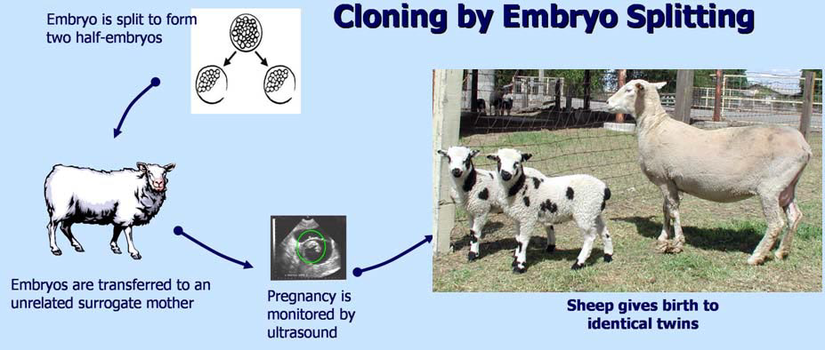
A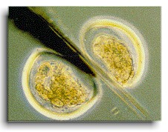 B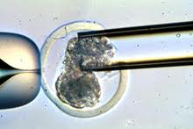
A – Cutting the 2-celled embryo; B- Aspiration of blastomeres at 6-8-celled embryo
Figure 58 – Cloning by embryo splitting method
(http://169.237.28.91/animalbiotech/Biotechnology/Cloning/index.htm)

Currently, embryo splitting of Mammals has successfully been established in livestock species. In several livestock species, the embryo splitting is efficiently and safely for animals used in assisted reproduction. Experimentally all techniques including embryo splitting and single blastomer cloning were developed in mice system. As we mentioned before, experiments with human had been promoted by success with embryo splitting of nonhuman primate embryos which resulted in several pregnancies. Human embryo splitting has been started only recently. The experiments have shown that embryo splitting at the 6-8 cell stage provided a much higher developmental potential compared to splitting of 2-5 celled embryo.
In spite the fact that embryo splitting intensively used at farm animals, the efficiency of procedure and stages of embryo development are still under discussion. The experiments with sheep revealed that more efficiently to split 2- and 4-cell embryos because in this stage about 36% of embryos developed to term following transfer to recipient females. In cattle, the 4-celled embryos separated into blastomeres could further develop to term and give rise to multiple monozygotic (identical) healthy calves. The effectivity of embryo splitting in cattle after bisection of early bovine embryos was comparable with control because gave pregnancy rates similar to rates of pregnancy obtained from intact control embryos. That’s why embryo twinning in cattle was proposed for suitable applications in field conditions. Moreover, the success was proved by experiments with cryopreserved bovine embryos which were split after their time-separated thawing, then transferred into uterine за surrogate mothers and finished by live-born monozygotic calves of different ages. Monozygotic twin kids of goat were produced from bisected 2-celled early embryos. Split embryos of the pig were capable of full-term development giving rise to healthy genetically identical twin piglets. In the horse, split embryos created using blastomer biopsy at 2- or 8-celled stage resulted in term pregnancy and healthy monozygotic foals appearance. The genetic identity of split embryos to these foster females were they been transferred after splitting and developed in term in allogeneic pregnancies support the success of embryo splitting at farm animals.
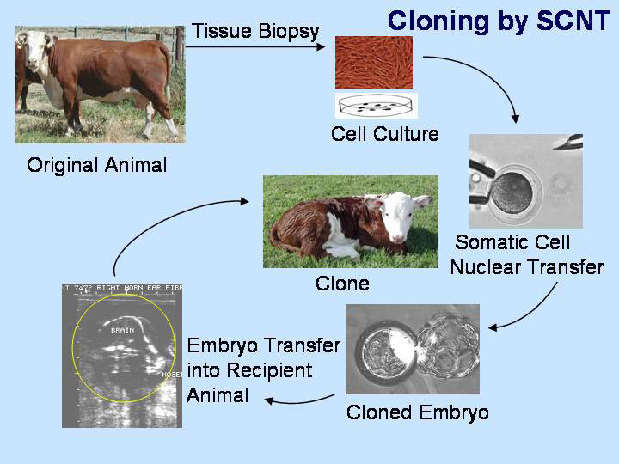
Figure 59 – Cloning by Somatic cell nuclear transfer (SCNT) method
(http://169.237.28.91/animalbiotech/Biotechnology/Cloning/index.htm)

Another methodological approach to cloning is based on somatic cell nuclei transfer. Nuclear transfer is when the nucleus of a differentiated adult cell is placed in an enucleated egg cell. Later this technique was refined and became known as somatic cell nuclear transfer (SCNT). SCNT represented an extraordinary advance in the biotechnology, particularly in cloning area, because a genetically identical clones of an already grown animals are easy to produce using this technology. It was very appreciated by farmers. The scientific impact is in understanding the fact that it was possible for the DNA of adult differentiated somatic cells to revert to an undifferentiated embryonic stage by reestablishing pluripotency and create a new normal embryo. The possibility to reprogram the nuclei of somatic cells to a pluripotent state significantly influenced research into therapeutic cloning and stem cell therapies.
To understand this, we need to remind the preliminary experiments with nuclear transfer. The experiments of Briggs and Kings with cloning a frog (Rana pipiens) embryo which done in November of 1951 gave a base for development of SCNT. They did not simply break off a cell from an embryo, they carefully took the nucleus out of a frog embryo cell and then replace the nucleus into unfertilized enucleated frog egg cell (see figure 60).
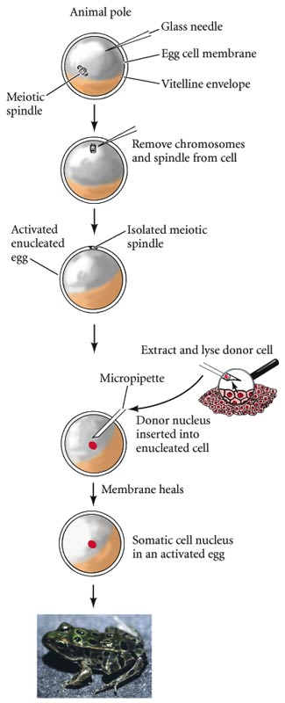
Figure 60 – R. Briggs and T.J. King experiment: cloning the Rana pipiens by SCNT

The experiments of Gurdon which done in 1962 at Xenopus laevis revealed that the nuclei from differentiated cells could be reprogrammed step by step if he used the serial nuclear transfer of specialized nuclei into enucleated eggs. By nuclear transplantation he introduced the nuclei from intestinal epithelial cells into eggs that had been enucleated by ultra violet irradiation. After serial transplantation these nuclei gave rise to a complete animal (figure 61). Serial nuclear transfer is a way to return differentiated cells to a nondifferentiated states. Sir John Gordon got a Nobel Prize in Physiology or Medicine in 2012 for his research in the field of developmental biology and for the discovery that mature cells can be converted to stem cells.

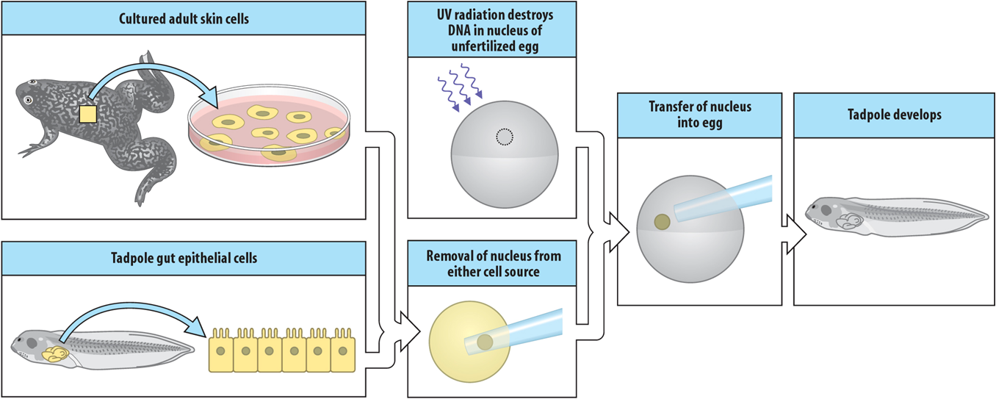
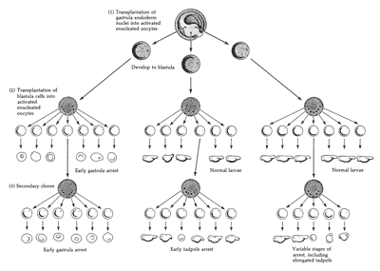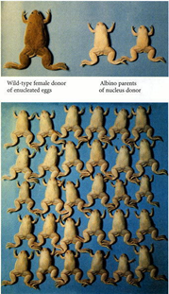
Figure 61 – J. Gordon experiment: cloning the Xenopus laevis by nuclear transfer using serial nuclear transplantation

The famous cloned mammalian - Dolly was part of a series of experiments done in Roslin Institute (Scotland) in attempts to develop a better method for producing genetically modified animals. Scientists believed that if experiment with cloning sheep by nuclear transfer of differentiated nucleus would successful, it would lead to decrease the number of animals need to be used in future experiments. Another task of experiment with Dolly sheep was to learn more about differentiation capability of cells during animal development and to answer the question whether a specialized cell, such as a cell of skin or brain, could be used to make a complete healthy animal.
The team of Professor Sir Ian Wilmut carried out experiments on SCNT resulted in cloning Dolly. Ian Wilmut’s team was interdisciplinary and included biotechnologists, geneticists, embryologists, surgeons, vets and, of course, farm staff. The reason was the nature of the research. The project started in 1986. The claimed goal was to create a sheep that produced a certain chemical in its milk. Ian Wilmut decided to genetically alter adult cells, which were successfully cultivated in laboratory in vitro conditions, then clone them and produce animals with the altered gene in all cells of the organism. The paperwork began in 1987, and research started in 1990. Lots of experimental work was done, and a lamb was born from a genetically different surrogate mother on July 5, 1996, as a result of cloning from a frozen mammary cell taken from another adult sheep. Cell-donor of nucleus was taken from the mammary gland of a six-year-old Finn Dorset sheep. An egg cell was taken from a Scottish Blackface sheep (see figure 62).
It should be mentioned, that when scientists working at the Dolly creation, the only lamb born from 277 attempts. From 277 cell nuclear transfer procedures, only 29 early embryos developed and were implanted into 13 surrogate mothers. But only one pregnancy went to full term (148 days) and finished successfully by appearance of 6.6 kg Finn Dorset lamb named Dolly. Dolly was born by Scottish Blackface surrogate mother. The phenotype of Dolly’s white face was one of the first signs that clone was produced because her surrogate mother was black faced, but donor of nucleus had a white face. So, Dolly’s DNA came from a mammary gland cell of Finn Dorset sheep. Interestingly, that name Dolly the cloned sheep received after the country singer Dolly Parton, whose phenotypic characteristics were very expressive (figure 62).
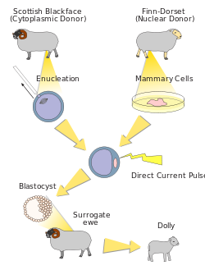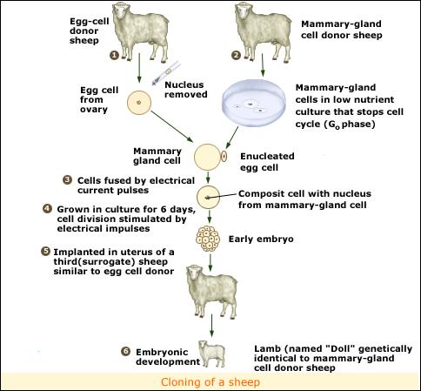
Figure 62 – Ian Wilmut experiment: cloning the sheep Dolly

World got acquainted with Dolly after sensational publication in Nature on 22nd February, 1997. And this publication immediately attracted the attention of mass media, and Dolly captured the public’s imagination. Possible benefits and dangers of cloning were the most discussed topics in public debates.
A sheep Dolly was attracted the attention because she was the first mammal cloned from an adult cell. Dolly’s birth proved that specialized cells of adult mammals can be used for creation a genetically identical copy of the animal they came from. This knowledge changed existing scientific developmental theories and opened up lots of possibilities to use the SCNT in biology and medicine. One of the most important possibility is the development of personalized stem cells which can be used for therapy of serious and inherited diseases. The possibility to reprogram specialized cells of adult mammals developed in induced pluripotent stem cells (iPS) technology.
But cloning technology has some implications. When Dolly was in age of one year, the analysis of her DNA revealed that, in Dolly’s body cells, the telomeres length was shorter than it would be expected for a normal sheep of the same age. The telomeres are the repeated DNA sequences on the ends of chromosomes that protect the DNA from damage. Each cell division following after DNA replication make telomeres shorter, and this is a reason that with ageing of an animal or human their telomeres become progressively shorter, exposing the DNA to more damages.
Dolly had shorter telomeres because her DNA came from an adult sheep which underwent multiple cell divisions, and Dolly’s telomeres had not been fully restored during her new development. Due to genetic age Dolly was “older” than her actual age. But at the time, the extensive screening of Dolly’s health status did not find any conditions which could be directly related to premature or accelerated ageing.
All her life Dolly spent at The Roslin Institute with the other sheeps, quite apart from the occasional media appearance. From her normal crossing with a Welsh Mountain ram called David Over a total of six lambs were born. The first lamb named Bonnie was born in April 1998. The twins (Sally and Rosie) were born in 1999, and triplets (Lucy, Darcy and Cotton) were born the year after.
After burning the triplets, the health screening of Dolly (September, 2000) revealed that she had become infected by a JSRV virus (Jaagsiekte sheep retrovirus), which causes lung cancer in sheep. It was a common infection because other sheep at The Roslin Institute had also been infected with JSRV in the same outbreak.
Soon, in 2001, farm staff noticed her walking stiffly, and Dolly was diagnosed with arthritis. Dolly was successfully treated by anti-inflammatory medication, and she continued to have a life of normal quality until February, 2003, when she developed a cough. A computer tomography scan revealed tumors which growing in lungs. Scientists decided to euthanize Dolly rather than risk of her suffering. So, Dolly was put to sleep at the age of six on February 14, 2003.
As we mentioned before, the main goal of experiment with cloning Dolly was learn to clone sheep and other large animals in hopes at producing medicines in the milk of such animals. Biotechnologists from Roslin Institute have managed to transfer human genes that produce useful proteins into big farm animals as sheep and cows. Currently farm animals can produce, for instance, the factor IX, blood clotting agent to treat hemophilia, or alpha-1-antitrypsin to treat cystic fibrosis and other lung conditions.
Among “farming” products produced by cloned farm animals there are human antibodies against infectious diseases and even cancers. “Foreign” genes have been transferred also into zebra fish, which are widely used in laboratories as a model object. Cloned embryos from these fish successfully express the foreign protein. So, SCNT development allows us to imagine the flocks of genetically engineered animals all producing medicines in their milk.
The research interest in cloning also based on other medical and scientific reasons. The SCNT is already being used in combination with genetic techniques in xenotransplantation, that means the development of animal organs for transplant into humans. For example, alongside genetic techniques the cloning of pigs would lead to a reliable source of suitable donor organs for transplantation, for the first time it achieved in March 2000. The usage of pig organs for xenotransplantation has been hampered by the presence on the surface of pig cells a sugar and alpha gal, but the “knockout” technology done in 2002 helped scientists to turn off the genes encoding these undesirable proteins. Knockouted pigs could be bred naturally. However, virus transmission, which used for genetic transformation, is still worries about. Implication of cloning are still expected. For example, cloned mice become obese, and related symptoms manifest, such as raised plasma insulin and leptin levels. But the offspring of cloned mice do not suffer from obesity and are normal.
The achievements in animal cloning and study of clones and cloned cells could lead to better understanding of the embryo development and problem of ageing and age-related diseases development. The SCNT cloning technology could be used for creation better animal models of human diseases. This approach could in turn lead to further progress in understanding the disease mechanisms and cure protocols to treat persons suffering from disease. SCNT cloning technology could even enhance the biodiversity by supporting the continuation of rare breeds and endangered species.

Chapter 14. Transgenic technologies in animal biotechnology
The term transgenic animal refers to an animal which was genetically modified by introducing one or more foreign genes in its genome. The foreign DNA construction should be made by recombinant DNA technology, then foreign DNA is introduced into the animal, and then it must be transmitted through the germ line. So every cell of transgenic organism should contain the same modified genetic material a pass it through generations. The term transgenic was first used by Gordon and Ruddle (1981).
The combining contributions of genetic engineering and developmental biology allowed rapid development of the technology for the creation of transgenic animals. Gordon and Ruddle (1981) firstly used the DNA microinjection technique in mice. It was the first evidence of transgenic technology successful in mammals, and soon this technology was applied to various other species such as rats, rabbits, sheep, pigs, birds, and fish. The retrovirus-mediated transgenesis was proposed by Jaenisch (1976), and embryonic stem cell-mediated gene transfer – by Gossler et al. (1986). These three main techniques significantly promote the success in producing transgenic animals. Rapid development of usage of genetically engineered animals opened up an increasing number of applications for the technology.
The milestones in transgenic research are presented in table 13.

Table 13 - Milestones in transgenic animal research
Date | Event | Researcher(s)
1971 | First demonstration of sperm-mediated gene transfer | Brackett et al.
1977 | mRNA transferred into Xenopus eggs | Gordon
1980 | mRNA transferred into mammalian embryos | Brinster et al.
1980-1981 | Transgenic mice was first recorded | Palmiter et al.
1981 | Transgenic mice was first documented | Six research groups
1982 | Transgenic mice demonstrate an enhanced growth phenotype (Super-mouse) | Palmiter et al.
1985 | First transgenic pigs and sheeps were produced | Hammer et al.
1997 | Production of transgenic sheep by nuclear transfer of nuclei from transfected fetal fibroblasts | Schnieke et al.

In the past few years, the techniques and science of producing genetically engineered animals have advanced very rapidly. Currently it is possible to create animals carrying useful novel properties for dairy, meat, or fiber production, for environmental control of waste production, for biomedical purposes or other human consumption, or generate a plenty copies of farm animals which represent the valuable traits, such as good quality milk or meat production, high fertility.
There are a number of methods which currently used for genetic engineering of various animal species. Most of techniques were developed using fully genetically investigated animal model systems, such as mouse and Drosophila. Application of these to domesticated animals has only more recently been extended.
Access to the germline of mammals can be obtained by:
- direct manipulation with the fertilized egg, followed by implantation of reconstructed egg into the uterus;
- manipulation with sperm used to generate the zygote;
- manipulation with early embryo tissues and cells;
- the usage of ES cell lines which, after genetic manipulation and selection ex vivo, can be introduced into early embryos, some of whose germline will develop from the ES cells (Smith, 2001);
- manipulation with cultured somatic cells, whose nuclei then can be transferred into enucleated oocytes and thereby provide the genetic information required to produce a complete animal.
The manipulation with ES cells allows to researchers to do preliminary selection of desirable genetic modifications before the undertaking the expensive and lengthy process of generating animals. ES cells usage are not available for all animal species of interest. But, usage of nuclear transfer from modified somatic cells for generation of transgenic embryos is a suitable approach for genetic engineering and cloning of nearly genetically identical animals. This method was proposed by Westhusin et al. (2001).
For example, manipulation with the avian germline is difficult because ES lines are not available and the early embryo is difficult to access from birds. Many scientists focus on the blastodermal cells or primordial germ cells usage. These embryonic cells can be cultured in vitro briefly and allow to manipulate with germline cells for genetic modifications prior introducing into fresh embryos to create chimeras from which modified lines can eventually be developed. This approach was proposed by Aritomi and Fujihara (2000). However, the effectivity of getting transgenic avian is still low.
Steps of genetic transformation:
- Cloning of needed genes
- Construction of genetic vector
- Introduction of genetic vector to the host cell or early embryo
- Selection of genetically transformed cells or organisms
- Checking the foreign gene expression in needed cells or organs
- Creation of homozygous genetically transformed strain
The most important question in creating of transgenic animals is ensuring that the desirable foreign gene product is expressed in the correct place (specialized cells or tissues), at the appropriate level and time. Many specifics are known how this goal can be achieved, and the approaches vary considerably depending on used animal system. But, some general principles can be elucidated. First of all, there is a big range of tissue-specific promoters, which can be chosen for transgenic construction. But most of such promoters are complex, large, and hard to regulate in animal bodies. Therefore, scientists use the small range of well-characterized promoters to fuse them with genes of interest. Another approach is explained by the fact that transgenes expression depends on the place of transgene insertion into the host genome. This question is especially actual for transfection method of foreign DNA introducing, because the transgene insertion will be occasional, and presence of control elements around the integration site of host DNA can influence of transgene expression (Wolf et al., 2000). These consequences were called as positional effect. The positional effects often lead to gene silencing or unregulated expression, not only for the transgene, but also for the surrounding host genes (Bonifer et al., 1996; Henikoff, 1998). To elucidate the problem Wolf et al. (2000) proposed to use some special DNA sequences, such as insulators, or locus-control regions, but the efficiency of these techniques is still not predictable. While these effects do not directly affect the safety or utility of transgenic animals, they do introduce considerable inefficiency into transgenic animal producing.
Gene knockout technology
The separate goal of transgenic technology is the creation of genetically engineered animals that lack specific genes (knockout), or replacement of undesirable gene by another gene which specially has been engineered.
To study the genes or proteins interactions scientists can directly turn of some genes function. Producing a homozygous strain on disabling gene (contain two copies of disabled gene alleles) in model animal system, it is possible to obtain information about descendants' development in the absence of a particular protein and elucidate protein function or genes interactions. This knockout technology was developed in 2001 (University of Guelph) and widely used at mouse models. The methodological approach to create of “knockout” animal includes: usage of ESCs for genetic transformation; introducing of modified ESC into developing embryo; embryo transfer into the womb of a host animal to get a chimeric organism; selecting the host offspring for genetically transformed individuals, which are resulting from a portion of transformed ESC carrying the knocked-out gene in germ line of chimeric organism.
In many cases it is no needed delete the undesirable gene, it also can be modified in expression or function. A “targeted mutation” effect refers to situation when a gene is altered but not shut down. The differences between two described methodologies reflected on terms (MGD, 2002): “knockin” gene instead “knocked” gene.
Impossibility to use the xenotransplantation of organs or tissues from non-primates (i.e. pigs) to humans is an example of gene knockout technology application. It is well known that galactose-1,3-galactose is present on the surface of pig cells, but it not expressed by primate cells (Galili, 2001). This carbohydrate induces a dramatic “hyperacute” immune response of human recipients. To elucidate the xenotransplantation problem scientists applied the knockout technology for gene encoding the galactosyl transferase (GT) enzyme in donor pigs (Lai et al., 2002). GT-deficient pigs are used for growing the tissues or organs to replace human organs.
Another practical requirement related to elimination cattle genome the gene encoding prion-related protein (PrP). PrP protein induces the scrapie in sheep and bovine spongiform encephalopathy (BSE), which called mad cow disease. Using the mouse model scientists did a knockout of this gene (Bueler et al., 1992). Removal of Prp gene makes mice completely resistant to this disease. So, if mouse model will be proved at cattle, homozygous knockout of bovine PrP could lead to the elimination of BSE.
The variety of mouse ES cell lines supports the gene knockout or knockin technology applications. The protocols for knockout/knockin gene include the mechanisms of homologous recombination between identical sequences in the genome and the transfecting vector DNA. The technology was developed by Bronson and Smithies in 1994. The most common protocol describes the usage of neomycin resistance gene as a selective marker, which is inserted in vector construction into the homological to targeted gene region of host DNA. After vector transfection, due to homological recombination the marker gene inserted into the recipient targeted gene destroying its structure and functioning. The successful insertion is established by selection on the medium containing the neomycin-related antibiotic G418. Because the insertion of transgene is occasionally event, the progeny animals will be heterozygous for the knockout/knockin gene. To make a homozygotes researcher needs set up the system of crossing between transgenic mice and breed the homozygous animals. Each result should be proved by molecular genetic analysis. The galactosyl transferase-knockout pigs were obtained in this way using genetic modification of cultured fetal fibroblasts. Nuclei from modified cells then were transferred into enucleated egg as described before.
Nuclear transfer method in producing transgenic animals
Very fast development of SCNT technology and its success, in operating with animals, promise become an efficient tools of propagation of farm animals with desired traits. There is no difference, whether animals are naturally selected from population or genetically modified (Betthauser et al., 2000; Lanza et al., 2001; Westhusin et al., 2001). Mouse models have become the main objects used in the field of transgenesis due to their good learned genetics, their short generation time, small size and low cost of housing in comparison to that for larger vertebrates.
As for big animals, the ability to reprogram the specialized donor cell nuclei for successful nuclear transfer will depend on many factors, such as possibility of culturing cells which will serve as a donor of nuclei; nuclear transfer procedure; used animals (donor of egg, recipient, surrogate mothers) cell cycle synchrony (Stice et al., 1998; Wilmut et al., 1998); the developmental peculiarities of used animal species etc. The actively dividing animal cells (epithelial cells, fibroblasts etc.) have been used successfully for this purpose (Cibelli et al., 1998; Kasinathan et al., 2001; Kuhholzer et al., 2001). The hypothesis concluded in the fact, that differences in timing of embryonic genome activation contributes to differences in cloning efficiency among animal species (Stice et al., 1998), is actively discussed now. Many experimental results showed that only oocytes can be used successfully as a recipient for foreign nucleus because only egg can convert the differentiated nuclei into undifferentiated stages and can stimulate the development of reconstructed embryo (Campbell, 1999; Fulka et al., 2001). But molecular mechanisms of this reprogramming is currently unknown.
These complications explain the fact that currently the propagation of farm animals by SCNT technology is inefficient. Statistical data show that in average about 10 percent of reconstructed embryos resulting in live offspring (Cibelli et al., 2002). It was shown that most of abnormalities occur during embryo development. For example, for cattle and sheep embryo lethality most often occur in the first third of the pregnancy, and the frequency of perinatal deaths of reconstructed embryos is much higher than normally obtained embryos. Scientists believe, that, in cattle, problems with in vitro culturing more influence on this situation than nuclear transfer technology itself.
But, even with this existing of SCNT low efficiency at farm animals, there are many potential applications of this technology to reproduce highly valuable genotypes, such as rare or endangered species, household pets, elite sires or dams, breeds with desirable production traits but low fertility, sterile animals such as castrates and mules, or transgenic animals that have high value and for which rapid propagation is desirable. The application of SCNT technology for dissemination of germplasm as embryos and consequent reduction of the disease spread associated risk is also very important. In this way the researcher should take into account the significant differences in fertilizing capacity of farm animal sperm. For example, in cattle, the single bull ejaculate can fertilize 400-500 eggs in AI programs. As for pigs, the single boar ejaculate can be used to breed only 10-20 females. That’s why nuclear transfer technology for propagation of pigs is more preferable that artificial insemination.
Genetic transformation tools
In genetic transformation, if desirable gene has been cloned, for transfer it into another cell vectors are used. Vector is a specific DNA sequences used as a vehicle to artificially transfer of foreign genetic material into target cell, where it can be replicated and then expressed. A recombinant DNA technology provide all tools for vector construction.
The four major types of vectors known in genetic engineering:
- plasmids,
- viral vectors,
- cosmids,
- artificial chromosomes.
Selectable markers genes allow select and identify the vector in transformed cells or organisms.
There gene markers types:
- visible (coding phenotypic trait)
- markers of cell surface
- biochemical (antibiotic resistance, alcohol sensitive, enzymes of additional way of nucleotide biosynthesis)
To be recognizing marker gene must code the negative trait or trait which differ from wild type. As a rule marker is represented by the mutated gene, and recipient cell or organism must by normal. Most common selectable markers are antibiotic resistance.
Constructing the vector scientists do not need use the promoter sequence of transgene in nature because sometimes they are not strong working in occasional place of foreign chromatin. There are commercial proposals of very strong promoters, most of them have viral origin (HSV1, CMV, HPV etc.). Sometimes scientists use the inducible promoter which can turn on or turn of the transcription of transgene in some environmental conditions (promoter of human metalothioneine gene).
Common to all engineered vectors are an origin of replication, good promoter, cloning foreign gene (transgene), a selectable marker, and regulatory sequences.

System of bi-directional selection
One metabolic pathway – the additional way for nucleotide biosynthesis - has been particularly useful in cell-fusion and genetic transformation experiments with animal cells. And specially development the system of bi-directional selection, which allows select mutant and normal cells by little modification of cultural medium HAT (contains hypoxanthine, aminopterin, thymidine).
Most animal cells can synthesize the purine and pyrimidine nucleotides de novo from simpler carbon and nitrogen compounds, rather than from already formed purines and pyrimidines (Figure 62, top). The folic acid antagonists amethopterin and aminopterin interfere with the donation of methyl and formyl groups by tetrahydrofolic acid in the early stages of de novo synthesis of glycine, purine nucleoside monophosphates, and thymidine monophosphate. These drugs are called antifolates, since they block reactions involving tetrahydrofolate, an active form of folic acid. Many cells, however, contain enzymes that can synthesize the necessary nucleotides from purine bases and thymidine if they are provided in the medium; these salvage pathways bypass the metabolic blocks imposed by antifolates (Figure 63, bottom).

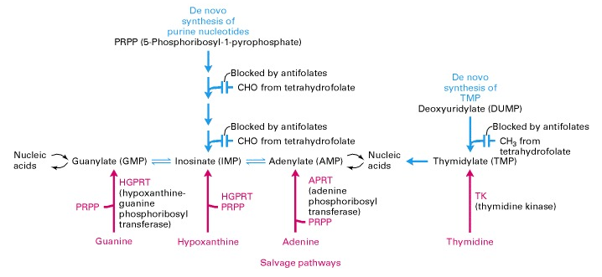
Figure 63 – De novo and salvage pathways for nucleotide synthesis
(Lodish H. et al. Molecular Cell Biology. 4th edition. New York: W. H. Freeman. 2000)

In a normal medium, cultured animal cells synthesize purine nucleotides (AMP, GMP, IMP) and thymidylate (TMP) by de novo pathways (blue). These require the transfer of a methyl or formyl group from an activated form of tetrahydrofolate (e.g., N5, N10-methylenetetrahydrofolate), as shown in the upper portion of the diagram. Antifolates, such as aminopterin and amethopterin, block the reactivation of tetrahydrofolate, preventing purine and thymidylate synthesis. Normal cells can also use salvage pathways (red) to incorporate purine bases or nucleosides and thymidine added to the medium. Cultured cells lacking one of the enzymes of the salvage pathways — dehydrofolate reductase (HGPRT), adenofolate reductase (APRT), or thymidine kinase (TK) — will not survive in media containing antifolates.
A number of mutant cell lines lacking the enzyme needed to catalyze one of the steps in a salvage pathway have been isolated. For example, cell lines lacking TK can be selected on the medium containing the thymidine analog 5-bromodeoxyuridine because TK⁻ cells (with a TK mutation) are resistant to this otherwise toxic substance. TK⁺ cells can convert 5-bromodeoxyuridine into 5-bromodeoxyuridine monophosphate. This nucleoside mono- phosphate is then converted into a nucleoside triphosphate by other enzymes and is incorporated by DNA polymerase into DNA, where it exerts its toxic effects. This pathway is blocked in TK⁻ cells because they lost normal TK enzyme function. However, TK⁻ mutants are resistant to the 5-bromodeoxyuridine toxic effects. Cells lacking the HGPRT enzyme also have been selected in the same manner because they are resistant to the otherwise toxic guanine analog 6-thioguanine. HGPRT⁻ cells and TK⁻ cells are useful partners in cell fusions with one another or with cells that have salvage-pathway enzymes but that are differentiated and cannot grow in culture by themselves.
The special culture medium which most often used to select mutant and normal cells was called HAT medium, because it contains hypoxanthine (a purine), aminopterin, and thymidine. Normal cells can grow in HAT medium because even though aminopterin blocks de novo synthesis of purines and TMP, the thymidine in the media is transported into the cell and converted to TMP by TK and the hypoxanthine is transported and converted into usable purines by HGPRT. On the other hand, neither TK⁻ or HGPRT⁻ cells can grow in HAT medium because each lacks a functional enzyme of the salvage pathway. However, hybrids formed by fusion of these two mutants will carry a normal TK gene from the HGPRT⁻ parent and a normal HGPRT gene from the TK⁻ parent. The hybrids thus will produce both functional salvage-pathway enzymes and grow on HAT medium. Likewise, hybrids formed by fusion of mutant cells and normal cells can grow in HAT medium. The system of bidirectional selection of mutated and normal gene variants is presented on figure 64.

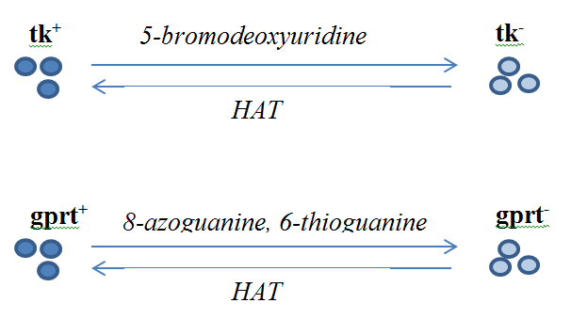
tk – thimidine kinase; gprt – hypoxanthine phosphoribosyl transferase;
HAT – HAT medium
Figure 64 – Bidirectional selection of cells on HAT medium

Introducing of foreign DNA into recipient cells and organisms
Several methods were developed for genetic transformations of animal cells growing in culture:
- Hypertonic salt method – It based on osmotic pressure shift. In presense of 0.5-1.0 M NaCl water solution of transgene easy go into the recipient cell.
- DEAE-dextran method – Polycatione diethyl-aminoethyl-dextran, in which transgene packed, attracts to negative charged cell membrane.
- Calcium-phosphate method – CaCl₂ in presence of phosphate buffer precipitate on cell surface and cell phagocytes transgene.
- Method of fusion of cultured cells with bacterium protoplasts in the presence of PEG – In presence of polyethileneglicol the bacterium protoplasts containing transgene easy fuse.
- Use of liposomes – Specialized to definite cell type liposome can do the targeted transformation.
- The use of transducing retroviral vectors – Retroviral vectors infect animal cells.
- Method of microinjection – Direct injection of transgene into cell and its nuclei using glass needle (see figure 65).
- Electroporation – Short-timed and high-powerful electric pulse makes cell membrane permeable for transgene (see figure 66).
- Gene gun - Inertial movement of small particles covered by transgene after the bullet stopped. It is not used for animal cell culture because the method is not targeted and shot can damage the cell.
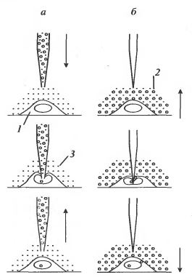
1 – recipient cell; vector DNA carrying transgene; 3 – buffer solution
- Injection; B- Piercing
Figure 65 – Modifications of microinjections method

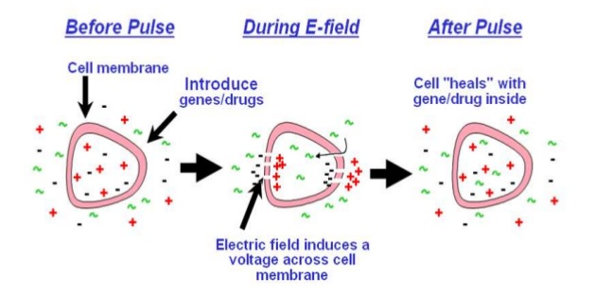
Figure 66 - Electroporation

There are two basic methodology currently used for inserting transgene into vertebrate animal germline cells: transfection and infection with retrovirus vectors. A third approach includes the usage of mobile genetic elements. This kind of vectors has been commonly used for insects and is being explored for germline modification of vertebrate animals (Izsvak et al., 2000).
The three principal methods used for the creation of transgenic animals are (see figure 67):
- DNA microinjection
- embryonic stem cell-mediated gene transfer
- retrovirus-mediated gene transfer.
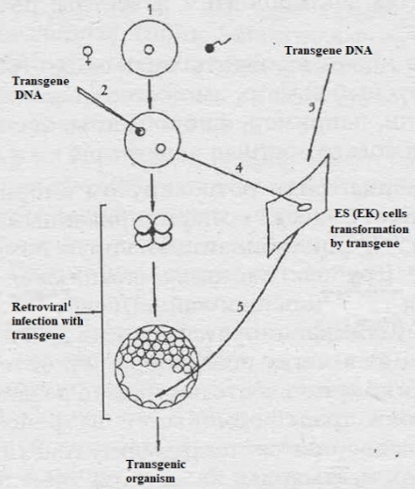
- Egg; 2 – Microinjection of transgene to fertilized egg;
3 – Transgene transfection of ES cells; 4 – nuclei transfer;
5 – transfer of transformed ES cells into the blastocyst
Figure 67 – The scheme of approaches to obtaining transgenic animal

Transfection
The usage of viral vectors for transfer of foreign DNA into the animal cells or embryos is based on the animal-specific transfection properties of retroviruses and adenoviruses. Another preferable property of retroviruses and adenoviruses is their ability to integrate into chromosomes. Technically transfection methods include the following procedures:
  - direct microinjection of DNA into the cell nucleus;
  - electroporation - introduction of DNA through transient pores opened by controlled electrical pulses;
  - usage of polycations to neutralize charges on DNA and the cell surface that prevent efficient uptake of DNA;
  - lipofection, or enclosure of DNA in lipid vesicles that enter a cell by membrane fusion much in the manner of a virus;
  - sperm-mediated transfection, possibly in conjunction with intracytoplasmic sperm injection (ICSI) or electroporation.
Each researcher decides how to introduce the transgene and what method to choose basing on used animal system. And the manner of transgene transfection determined empirically for each kind of animal. Excepting the possibility of homologous recombination, the structure of carrying transgene DNA vector does not determine the integration site in recipient DNA. Very often only a fragment of the transfected DNA is integrated into the chromosome, frequently in multiple copies. In case of retroviral transfection, vector is often integrated in region of long tandem repeats (LTR) in result of homological recombination between viral and host LTRs. In case of transfecting cultured somatic cells or ESC, a selectable marker (for example gene encoding phosphotransferase), is often included as part of the DNA allowing selection for its presence either in eukaryotic cell lines or in the bacteria in which the DNA was massively produced.
Retrovirus Vectors
Retroviruses are viruses containing RNA. Retroviruses are known as viruses that specifically infect the animal cells. The replication of retroviruses is a unique mechanism involving copying of the viral RNA genome that convert it to DNA (cDNA). This process called reverse transcription. Reverse transcription followed by its specific and stable integration into host cell DNA using the mechanism of homological recombination between viral and host LTRs. The inserted viral DNA then can be expressed using the normal transcriptional machinery of the cell. Retroviruses commonly are used to introduce foreign genes into cells in culture or into somatic tissue of experimental animals, such as mice (Soriano et al., 1986; Miller, 1997). Retroviruses also have been used for fish fertilized eggs modification (Amsterdam et al., 1997), for mollusks (Lu et al., 1996), chickens (Thoraval et al., 1995), mice (Soriano et al., 1986). They have been used for genetic transformation of cattle (Chan et al., 1998). In addition to gene of interest, selectable marker and regulatory elements, retroviral vector construction contributes the presence of transcriptional viral promoter and flanked sequences (LTRs) which necessary for replication and integration into the host genome. Sequences necessary for packaging of the transcript in virions and gene encoding reverse transcriptase also must be included. So, retroviral vectors are quite big. The capacity of retroviral vector contributes not more than 8 thousand base pairs long transgene. The retroviral vector introduction into cells leads to the creation of infectious virions containing an RNA copy of transgene. After transfection procedure, the vector’s RNA is copied into DNA and integrated at random sites in the recipient genome.
Transposons
Transposons or mobile elements are the DNA sequences that can change their location in genome. The retrotransposons contain gene encoding transposase, the enzyme with the same function as a reverse transcriptase of retroviruses. Retrotransposons (or transposons) are the most used type of mobile elements for genetic transformation of animal cells. A variety of transposons have been found in insects (Handler, 2001), and in fish (Ivics et al., 1997). Usage of transposons as a vector for genetic transformation of insects was very effective (Braig and Yan, 2002). No active transposons of these types which have been observed in mammals, although the human genome contains thousands of copies of a DNA sequence homological to Drosophila transposons (Lander et al., 2001). Several reports suggest that natural transposons found in insects might provide a useful and efficient tools of transgenes integration in animal germlines. Sherman (1998) showed the activity of Mariner transposon in chick zygotes which was introduced by microinjected plasmid into the germline. Interestingly, that modified copy of Sleeping Beauty transposon originated from fish has been successfully used for animal cells and embryo transformation (Ivics et al., 1997; P. Hackett, University of Minnesota). However, the effectivity of transposon usage in animal transformation is still under discussion.

DNA microinjection

The microinjection method involves the direct microinjection of a vector containing a single foreign gene or a combination of genes into the pronucleus of a fertilized ovum or nucleus of a cell in culture. As shown by Gordon and Ruddle (1981), microinjection is the first method that proved to be effective in mammals. The transgene integration may result in the over- or under-expression of certain genes or to the expression of genes entirely new to the animal species. It is known that insertion of foreign DNA is a random not site-specific process. There is a high probability that the introduced transgene will insert into a right site on the host DNA that will permit its expression and will not to disrupt the important genes. The microinjection method proved the effectivity on many types of animal cells and early embryos. An important advantage of this method is its applicability to a wide variety of species.

Embryonic stem cell-mediated gene transfer.
As mentioned before, this technology involves the usage of in vitro culture of embryonic stem cells, retroviral vector and its insertion to the recipient genome by mechanism of homologous recombination. Because ESC are undifferentiated, they have the potential to differentiate into any type of cell and therefore to give rise to a complete organism. After genetic modification these cells might be incorporated into an embryo at the blastocyst stage of development, and then placed into the foster mother uteri. A chimeric animal growth up from this modified blastocyst. ESC-mediated gene transfer is the method of choice for gene inactivation by knockout/knockin technology.
This technology is of particular importance for the study of mechanisms of developmental processes genetic control. The development of this technique was carried out om mouse model. A particular advantages of this method include: the precise targeting of defined mutations in the gene via homologous recombination; the preliminary selection of transgene copies and integrated sites; availability of selection for transgene homozygous state.

Retrovirus-mediated gene transfer.
As mentioned before, retroviruses are most common used vectors for genetic transformation of animal. Offspring derived from retrovirus-mediated gene transfer are chimeric. Transgene transmission is possible only if the retrovirus integrates into some place of the germ cells genome.
In spite of many advantages and variety of techniques for animal transgenesis, the success rate in terms pregnancies and live birth of animals containing the transgene is extremely low. The often result of genetic manipulation with vertebrate animals is chimeric organism which called a founder of transgenic strain. If genetic manipulation does not lead to abortion of modified embryo, the first generation of animals should be tested for the transgene expression. So-called germ line chimeras or animal-founders after birth should be selected for transgenic offspring and then inbred for 10 to 20 generations until homozygous transgenic animals are obtained and the transgene is present in every cell, and transgene will be inherited in clear manner. After this, embryos carrying the transgene in homozygous state can be isolated, frozen and stored for subsequent implantation or storage.
Usage of way to transform the animal depend on cell specialization, physiologically characteristic, transgene size and function. The researcher can select desirable method to introduction transgene. Because using the mouse as a model all genetically transformation tools were development, the mouse demonstrates success in different methods of transformation (see Table 14).
Table 14 – State of the art of transgenic technology for selected organisms
(https://www.ncbi.nlm.nih.gov/books/NBK207572/)
Organism | Transfection | Viral vectors | Transposon | ES cells | Nuclear transfer
Mouse | 4 | 2 | 1 | 4 | 2
Cow | 3 | 1 | 0 | 0 | 2
Sheep | 3 | 0 | 0 | 0 | 2
Goat | 3 | 0 | 0 | 0 | 2
Pig | 3 | 0 | 0 | 0 | 2
Rabbit | 3 | 0 | 0 | 1 | 0
Chicken | 1 | 2 | 1 | 0 | 0
Altlantic salmon | 3 | 0 | 0 | 0 | 0
Channel catfish | 2 | 0 | 0 | 0 | 0
Tilapia | 3 | 0 | 0 | 0 | 0
Zebrafish | 1 | 0 | 0 | 1 | 1
Crustaceans | 1 | 1 | 0 | 0 | 0
Mollusks | 1 | 1 | 0 | 0 | 0
Drosophila | 2 | 2 | 2 | 2 | 0
Mosquito | 1 | 0 | 2 | 0 | 0
0 – no significant progress
1 – has been accomplished experimentally (proof of concept)
2 - Routine experimental use
3 - Commercialization sought
4 - Widespread production

Positive –negative selection
Very important question for transgene expression are the chromosomal localization of vector DNA and its orientation. After transfection of embryonic stem cells in culture with a DNA vector that is designed to insert within a specific chromosomal site, some cells will have transgene integrated at nontarget (wrong) sites, whereas in other cells, integration will occur at the target (correct) site. The target site should be located in a region of genomic DNA that does not contain the important genes encoding essential products. So that after transgene integration, there is no interference with any developmental or cellular functions. Moreover, it is important that the transgene can be integrated into a part of the genome that does not prevent it from being transcribed, for example, in euchromatin regions rather than heterochromatin.
In most of the embryonic stem cells, the foreign DNA will not be integrated at all. To achieve the correct transgene integration to the target site, a technique called positive-negative selection is implemented. This strategy uses positive selection for cells that have vector DNA integrated anywhere in their genomes and negative selection against the vector DNA sequence that is integrated at wrong occasional sites.
A targeting DNA vector for the positive-negative selection procedure usually contains:
  - two blocks of DNA sequences (HB1 and HB2) that are homologous to separate regions of the target site;
  - the transgene, which will confer a new function on the recipient;
  - a DNA sequence that codes for resistance to the compound G-418 (Neo^{r});
  - two different genes for thymidine kinase (tk1 and tk2) from herpes simplex virus types 1 and 2 (HSV-tk1 and HSV-tk2).
The arrangement of these sequences is key to the positive-negative selection procedure. Between the two blocks of DNA that are homologous to the target site are the genes for the transgene and G-418 resistance (Neo^{r} gene). Outside of each of the homologous blocks are the genes HSV-tk1 and HSV-tk2. If integration occurs at a spurious site, i.e., not at HB1 and HB2, either one or both of the HSV-tk genes have a high probability of being integrated along with the other sequences (Fig. 68).
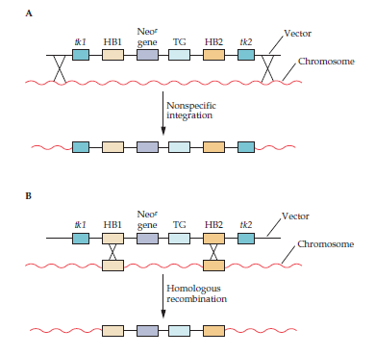
- Nonspecific integration: Both genes for thymidine kinase (tk1 and tk2), the two DNA sequences that are homologous to a specific chromosomal region in the recipient cells (HB1 and HB2), a gene (Neo^{r}) that confers resistance to the cytotoxic compound G-418, and the transgene (TG) are incorporated into the chromosome. After transfection, cells are selected for resistance to both G-418 and the compound ganciclovir, which becomes cytotoxic to cells that synthesize thymidine kinase. Other nonhomologous integrations may occur and produce inserts with one or the other of the thymidine kinase genes. After treatment with G-418 and ganciclovir, all the cells with nonspecific integration of the input DNA that includes at least one of the thymidine kinase genes are killed.
- Specific integration - result of homologous recombination. The product of a double crossover between homologous blocks (HB1 and HB2) of DNA on the vector DNA and on chromosomal DNA does not contain either of the two thymidine kinase genes (tk1and tk2). After treatment with G-418 and ganciclovir, only cells that have undergone homologous recombination survive.
Figure 68 – Positive –negative selection
(B.R. Glick & J.J. Pasternak. Molecular Biotechnology - Principles and Applications of Recombinant DNA. 3rd Edition). 2003)
A more direct way to detect embryonic stem cells that carry a transgene at a targeted chromosomal site is to use PCR. The targeting DNA vector contains two blocks of DNA that are homologous to the target site, with one on either side of both the transgene and a cloned bacterial or synthetic (unique) DNA sequence that is not present in the mouse genome (figure 69). After the transfection of embryonic stem cells, the cells are pooled and samples are screened by PCR. One of the primers (P1) for PCR is complementary to a sequence within the cloned bacterial or synthetic (unique) DNA sequence of the integrating vector. The other primer (P2) is complementary to a DNA sequence that is part of the chromosome adjacent to the region of one of the homologous blocks of DNA. If integration is at a random site, the predicted amplified DNA product is not synthesized. However, if site-specific integration occurs, the PCR amplifies a DNA fragment of known size. In this way, pools of cells with embryonic stem cells containing the desired gene at the targeted site can be identified. By subculturing from these pools, cell lines carrying the site-specific integration can be established.
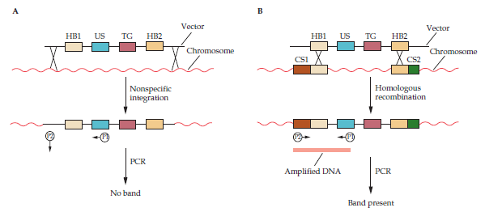
- After nonspecific integration of the vector DNA, one of the primers (P2) is not able to hybridize to a chromosomal site that is a predetermined distance from the site of hybridization of P1, so a DNA fragment with a specific size is not amplified. P1 hybridizes to a unique segment (US) of the input DNA that does not occur in the chromosomal DNA of the recipient cells. TG, transgene; HB1 and HB2, homologous blocks.
- Homologous recombination between DNA sequences (HB1 and HB2) of the input DNA that are complementary to chromosomal sites (CS1 and CS2) creates hybridization regions for both P1 and P2 that are a predetermined distance apart. Amplification by PCR generates a DNA fragment of a specific size that can be visualized by gel electrophoresis. In this case, the transgene (TG), which lies between the homologous blocks (HB1 and HB2), is integrated at a specific chromosomal location.
Figure 69 – Testing for nonspecific integration and homologous recombination in
transfected cells by PCR
(B.R. Glick & J.J. Pasternak. Molecular Biotechnology - Principles and Applications of Recombinant DNA. 3rd Edition). 2003)
Not only can a transgene be inserted into a specific chromosome site by homologous recombination in embryonic stem cells to provide a new function, but a specific mouse gene can also be targeted for disruption by the incorporation of a DNA sequence, usually a selectable marker gene, into its coding region (Fig. 70). One of the aims of targeted gene disruption (gene knockout) is to determine the developmental and physiological consequences of inactivating a particular gene. In addition, a transgenic line with a specific disabled gene can be used as a model system to study the molecular pathology of a human disease.
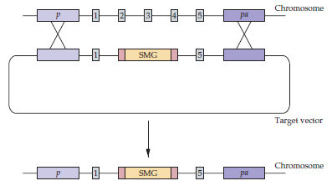
The target vector carries a selectable marker gene (SMG) with flanking DNA sequences that are homologous to regions of the targeted gene. In this example, the targeted gene has five exons (1 to 5). Homologous recombination disrupts (i.e., knocks out) the targeted gene. p, promoter; pa, polyadenylation signal.
Figure 70 – Gene disruption by targeted homologous recombination
(B.R. Glick & J.J. Pasternak. Molecular Biotechnology - Principles and Applications of Recombinant DNA. 3rd Edition). 2003)

Necessity of transgene identification and selection of transgenic animals
First of selection criteria is a manifestation of selectable gene marker. In case of applying the microinjection to the fertilized egg this selection will be informative. But in case of usage the ES cells transformation in culture and following return transformed cells into the blastocyst the result of genetic transformation is a mosaic (or chimeric) animal-founder. And researcher needs to check the transgene presence using molecular-genetic tools. Polymerase chain reaction (PCR) using specific primers to transgene DNA sequence is most popular method for it. It helps to quickly select the transformed and non transformed animals among offspring of animal-founder checking their DNA samples. The Southern blot hybridization using labeled probes which complement to transgene also shows the transgene presence. But this method is more complicated. The in situ hybridization on cytogenetical slide helps to establish the sites of transgene localization in chromosomes. For transgene expression control scientists needs to check transgene RNA or coding protein presence doing RT-PCR, Nothern blot hybridization or Western blotting. Immunostaining of histological slides by specific antibodies to transgene product can help recognize the tissue or cell localization.
Animal germline modification remains a technology of “hit-or-miss”. Usage of most techniques result in fact that only a very small fraction of obtained progeny has the desired properties of transgene insertion, expression, copy number, and absence ща genetic damages. So, large numbers of animals must be screened for the presence and copy number of the inserted transgene sequence, for its properly regulated expression, for the ability of this expression to survive transmission through the germline and, finally, for the desired phenotypic characteristics and absence of unintended genetic side effects. Such selection and testing could require several generations of breeding before one can be confident of the absence of recessive genetic damages, and the failure rate of the overall process is very high. As nuclear transfer technology improves, techniques requiring direct introduction of DNA into the animal germline followed by extensive screening of progeny are likely to be replaced by much simpler manipulation and prior selection of cells in culture, followed by recreation of animals with the desired properties directly from the nuclei of the manipulated cells.
Applications of transgenic animals
Combination of the successful transfer of genes into mammalian cells and the possibility of creating genetically identical animals by transplanting nuclei from somatic cells into enucleated eggs (nuclear transfer, or nuclear cloning) led researchers to consider putting single functional genes or gene clusters into the chromosomal DNA of higher organisms.
The strategy used to achieve this:
  - A cloned gene is injected into the nucleus of a fertilized egg.
  - The inoculated fertilized eggs are implanted into a receptive female because successful completion of mammalian embryonic development is not possible outside of a female.
  - Some of the offspring derived from the implanted eggs carry the cloned gene in all of their cells.
  - Animals with the cloned gene integrated in their germ line cells are bred to establish new genetic lines.
This approach has many practical applications. If, for example, the product of the injected gene stimulates growth, animals that acquire this gene should grow faster and require less feed. An enhancement of feed efficiency by a few percent would have a profound impact on lowering the cost of production of either beef or pork.
Transgenesis has become a powerful technique for studying fundamental problems of mammalian gene expression and development, for establishing animal model systems for studying human diseases, for producing foreign proteins in bird eggs, and for using the mammary gland to produce pharmaceutically important proteins in milk.
With this last application in mind, the term “pharming” was coined to convey the idea that milk from transgenic farm (“pharm”) animals can be a source of authentic human protein drugs or pharmaceuticals. There are a number of reasons why the mammary gland should be used in this way. Milk is a renewable, secreted body fluid that is produced in substantial quantities and can be collected frequently without harm to the animal.
A novel drug protein that is confined to the mammary gland and secreted into milk should have no side effects on the normal physiological processes of the transgenic animal and should undergo posttranslational modifications that at least closely match those in humans. Finally, purification of a protein from milk, which contains only a small number of different proteins (Table), should be relatively straightforward.
Transgenic mice: Applications
Transgenic mice (see figure 71) can be used as model systems for determining the biological basis of human diseases and devising treatments for various conditions. In addition, transgenesis of mice is an exemplary system for proving whether the production of a potential therapeutic agent is feasible. Whole animal models simulate both the onset and progression of a human disease. However, a mouse is not a human, even though it is a mammal, and so the information gathered from some transgenic models may not always be medically relevant. In other instances, however, critical insights into the etiology of a complex disease can be gained.
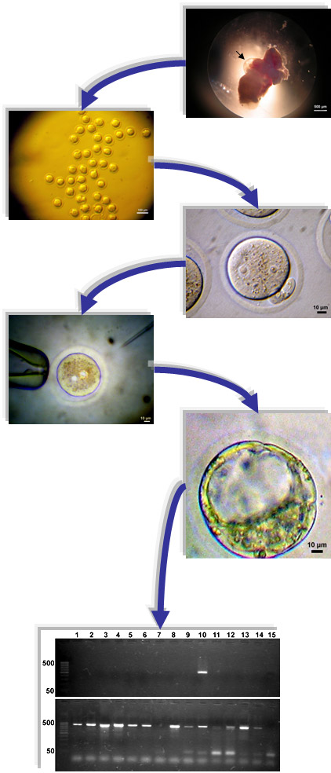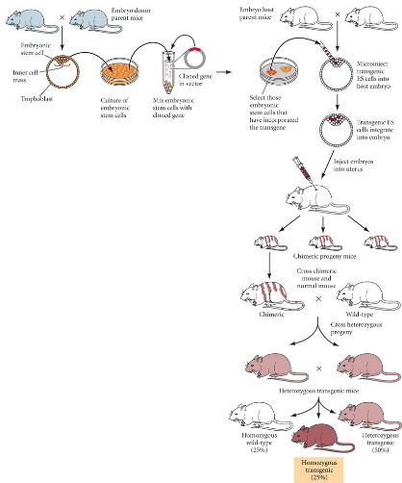
Figure 71 - The scheme for obtaining transgenic mice (http://11e.devbio.com/wt031002.html)
With this in mind, mouse models for human genetic diseases, such as Alzheimer disease, amyotrophic lateral sclerosis, Huntington disease, arthritis, muscular dystrophy, tumorigenesis, hypertension, neurodegenerative disorders, endocrinological dysfunction, and coronary disease, as well as many others, have been developed.

Transgenic cattle: Applications
Conceptually, the methods used to generate transgenic cattle are similar to those used for transgenic mice. The essential steps in a modified mouse transgenesis DNA microinjection protocol entail:
- Collecting oocytes, for example, from slaughterhouse-killed animals;
- In vitro maturation of oocytes;
- In vitro fertilization with bull semen;
- Centrifugation of the fertilized eggs to concentrate the yolk, which in normal eggs prevents the male pronuclei from being readily seen under a dissecting microscope;
- Microinjection of input DNA into male pronuclei;
- In vitro development of embryos before blastocyst stage;
- Nonsurgical implantation of one embryo into one recipient foster mother in natural estrus;
- DNA screening of the offspring for the presence of the transgene.

First, although mice have proven to be useful in biomedical research as models of human diseases and for testing of disease treatments, the physiology, anatomy, and life span of a mouse are different from those of humans. Thus, livestock are often better animals in which to model disease processes, gene regulation, and immune system development. Second, many livestock animals produce large amounts of milk and therefore can be used to produce and secrete large amounts of recombinant proteins and other molecules of pharmaceutical importance. Third, genetic engineering can be used to rapidly and specifically improve livestock traits, such as growth rate, disease resistance, and milk quality.
There are some main applications of transgenic livestock:
- Production of Pharmaceuticals
- Production of Donor Organs
- Disease-Resistant Livestock
- Improving Milk Quality
- Improving Animal Production Traits
Some human proteins that have been expressed in the mammary glands of transgenic animals: Antithrombin III; α1-Antitrypsin; Calcitonin; Erythropoietin; Factor IX; Factor VIII; Fibrinogen; Glucagon-like peptide; α-Glucosidase; Growth hormone; Hemoglobin; Serum albumin; Insulin; Insulin-like growth factor 1; Interleukin 2; α-Lactalbumin; Lactoferrin; Lysozyme; Monclonal antibodies; Nerve growth factor; Protein C; Granulocyte colony-stimulating factor; Superoxide dismutase; Tissue plasminogen activator.

Transgenic poultry: Applications
Several features that are unique to avian reproduction and development make the production of transgenic strains by microinjection of DNA into fertilized eggs extremely inefficient. For example, during fertilization in birds, several sperm penetrate the ovum instead of one, as usually occurs in mammals. As a result, it is impossible to identify the male pronucleus that will fuse with the female pronucleus. Also, DNA injected into the cytoplasm of the fertilized egg does not integrate into genomic DNA. Finally, even if nuclear DNA microinjection were practicable, the technique would be difficult to implement because the avian ovum after fertilization becomes, in rapid succession, enveloped in a tough membrane, surrounded by large quantities of albumin, and enclosed in inner and outer shell membranes. Despite these disadvantages, it is possible to inject a transgene into the region (germinal disc) on the yolk that contains the female and male pronuclei. The germinal disc is present before the eggshell is formed. After the administration of DNA to a germinal disc, each egg is cultured in vitro, and when an embryo forms, it is placed in a surrogate egg to produce a hatchling. Despite the technical difficulties, some transgenic lines of chickens have been established by this method (see figure 72). By the time an avian egg outer shell membrane has hardened, the developing embryo (blastoderm stage) has two layers consisting of 30,000 to 60,000 cells. In trial experiments, inoculation of the blastoderm stage with replication-defective retrovirus vectors containing bacterial marker genes resulted in a few chickens and quail carrying these DNA sequences in their germ lines.

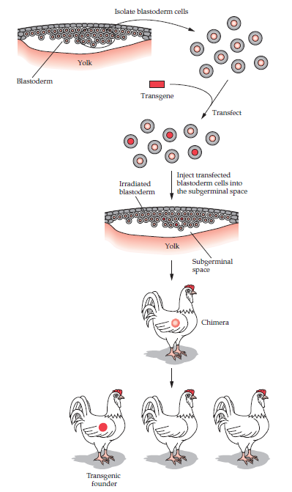
Figure 72 – The scheme of obtaining transgenic chickens
(B.R. Glick & J.J. Pasternak. Molecular Biotechnology - Principles and Applications of Recombinant DNA. 3rd Edition). 2003)
Transgenesis could be used to improve the genetic makeup of existing chickens with respect to built-in (in vivo) resistance to viral, bacterial, and coccidial diseases; better feed efficiency; lower fat and cholesterol levels in eggs; and better meat quality.
Avian researchers have also suggested that the egg, with its high protein content, could be used as a source for pharmaceutical proteins. The expression of a transgene in the cells of the reproductive tract of a hen that normally secretes large amounts of ovalbumin could lead to the accumulation of a transgene-derived protein that becomes encased in the eggshell. Ovalbumin constitutes more than 50% of the protein of egg white; therefore, expression of a transgene under the control of the ovalbumin promoter and regulatory elements can yield high levels of recombinant protein. Yields of up to 1 g of recombinant protein have been achieved per egg, and considering that a single hen lays more than 300 eggs per year, the productivity of these animal bioreactors could be substantial. The recombinant protein could either be fractionated from the sterile egg packages or consumed as a nutraceutical. Currently, as “proof-of-principle” experiments, transgenic chickens that synthesize monoclonal antibodies, growth hormone, insulin, human serum albumin, and alpha interferon have been created. Regulatory approval of therapeutic proteins produced in eggs may be more straightforward, as chicken eggs are already used to produce vaccines for injection into humans.

Transgenic fish: Applications
As natural fisheries become depleted, production of this worldwide food resource has come to depend more heavily on aquaculture. In this context, enhanced growth rates, tolerance of environmental stress, and resistance to diseases are some of the features that may be created by transgenesis. To date, transgenes have been introduced by microinjection or electroporation of DNA into the fertilized eggs of a number of fish species, including carp, catfish, trout, salmon, Arctic char, and tilapia.
The pronuclei of fish are not readily seen under a microscope after fertilization; therefore, linearized transgene DNA is microinjected into the cytoplasm of either fertilized eggs or embryos that have reached the four-cell stage of development. Unlike mammalian embryogenesis, fish egg development is external; hence, there is no need for an implantation procedure. Development of transgenic fish occurs in temperature-regulated holding tanks. The survival of fish embryos after DNA microinjection is high (35 to 80%), and the production of transgenic fish ranges from 10 to 70%. The presence of a transgene is scored by PCR analysis of either nucleated erythrocytes or scale DNA. Founder-fish are mated to establish true-breeding transgenic lines.

Concerns related to germline transgenic technology
Introduction of foreign DNA into an animal cell (somatic or germline) is not a well-controlled process and can lead to a number of undesired genetic consequences. Here we should discuss a number of safety issues that arise as a consequence of manipulation of the animal germlines. All safety problems can be divided into several levels of concern: 1) from the animal or group of animals; 2) to the human handler, 3) recipient, or user of the transgenic animal or its products; 4) to the human population as a whole; 5) to the environment.

- Unintended genetic side effects
Insertion of transgene into random or wrong sites in the germline is a mutagenic event that will affect any gene that happens to be at or near the site of integration. The most obvious effect is the gene integrity disruption at location were the insertion occurs. It is well known that a large part of the mammalian genome is noncoding DNA derived from various kinds of silenced transposable elements. Not all integration events will lead to gene inactivation. However, a fraction of animals selected for the presence of a transgene/transgene product has been found to carry associated genetic damages. For example, in mice, it has been recorded by Boeke and Stoye (1997), that about 5% of MLV proviruses integrated into the germline have led to mutations of this kind. Direct transgene introduction can lead to numbers of integrated copies at multiple sites, that leads to a risk of creating animals with a variety genetic defects. Thus, the transgenic animals should be carefully screened for in the course of subsequent breeding. For instance, one of the first transgenic mouse strain generated, intended to contain an inserted active oncogene, also suffered a lesion that caused a severe recessive developmental limb defects (Woychik et al., 1985). A number of other examples of insertional inactivation of transgenes introduced into mice are known, and this approach has been proposed as a useful technique for mutagenesis (Woychik and Alagramam, 1998). Another concern related to the fact that vector DNA contains not only transgene sequences, but also the regulatory elements. So, regulatory sequences can influent on expression of transgene and other host genes. And the damage can be at a location different from the active transgene. This kind of damage is often recessive because it not selected by the experimenter. Thus, it can only be detected by inbreeding of animal-founder offspring at homozygous state.
As a rule, researchers use the strong promoters for vector construct, and this promoter can induce the gene expression in the vicinity of the transgene. This kind of unfavorable activity is the mechanism of cancer induction in animals infected by a variety of retroviruses, and it has been well-studied as a model for oncogenesis. Rosenberg and Jolicoeur (1997) revealed that promoter and enhancer insertion, as well as gene fusion and introduction of elements that stabilize messenger RNA, can prevent this negative effect of adjacent activation. The altered methylation can stimulate unfavorable activity of genes at genome sites far removed from a transgene inserted location (Muller et al., 2001). In transgenic animals, the negative activation effects are likely to reveal themselves as dominant mutations that can have a variety of phenotypic consequences, from derailing normal development to causing a high rate of cancer later in life.
- Unexpected Effects of the Modification
Except for the expected effects of transgene expression, genetic modifications can stimulate unexpected effects on the physiology of the transgenic organism. For example, knockout of galactosyl transferase gene in pigs which leads to human hyperacute immune reaction rejection at xenotransplantation of organs and tissues, also provide protection against zoonotic infection by enveloped viruses (Weiss, 1998). The similarity of pigs and viral galactosyl-galactose structure is the reason of expected immune reaction at human. This response can result in rapid elimination of viruses transmitted from animals before infection could occur. But, pigs with knockouted gene would have a potential to transmit viruses, such as influenza, much more readily to human handlers. And human genes are encoding cell-surface proteins and introduced into pig genome as transgenes could render pigs susceptible to human viruses, that will increase their risk of disease and providing alternative hosts for the spread of human disease. Racaniello and Ren (1994) showed that the human poliovirus receptor (CD155) renders mice susceptible to poliovirus infection when introduced as a transgene. Weiss’s experiments (1998) revealed that the human complement-response modifying proteins CD46 and CD55, which are being introduced into pigs to protect xenografts from rejection, also serve as receptors for measles and Coxsackie human viruses. This not only could render these animals susceptible to infection by the human viruses, but also could provide a new evolutionary pathway for adaptation of pig viruses to human cells. And because receptors for many other viruses have not yet been identified, the potential for this kind of undesirable effects exists whenever a human cell-surface protein is introduced into another animal species.
- Marker Genes
When researcher construct the vector for genetic transformation he should select the marker gene which function is differ than the desired transgene. Commonly used marker genes are typically genes encoding drug-resistance or some phenotypic trait. The main properties of marker gene are its fast selectivity and its harmlessness or neutrality regarding to the organism being modified. For example, the neo gene encoding neomycin phosphotransferase has been widely used for selecting animal transgenic cells in culture containing neomycin. At genetic transformation the marker genes remain in vectors sequences. There is a potential for marker genes to cause undesired side effects to the recipient animals, for example, provide a novel antibiotic resistant pathogens or novel allergens. Possibly this potential is far from real danger, but it is hard to prove that marker genes are harmless in consumer products. The presence of marker genes in transgenic construction raises concerns about the food and environmental safety of genetically engineered animal products.
- Undesired Inserts
Excepting transgene, vector design includes marker gene and regulatory sequences which often originate from prokaryotes (microbes and viruses). The cloning of extracted DNA fragments includes their propagation in bacterial systems. Despite the intensive purification of DNA fragments, some amounts of contaminating material derived from the host bacterium can remain. And they are difficult to detect in DNA samples by standard methods like gel electrophoresis because such fragments can be heterogeneous in size and sequence.
Chakraborty (1994) and Scadden (1990) put the attention on particular problem arising from usage of retroviral vectors, because host cells, often mice cells, could contain large numbers of endogenous virus and virus-like sequences. In some cases, they can present in vector DNA samples, accidental introduction of such sequences into the transgenic animal germlines is not only provide a potential for creating unintended genetic damages, but also can contribute by recombination to the generation of novel infectious viruses. Purcell with team (1996) obtained an evidences of generation of replication-competent MLV's containing multiple such recombinants during the growth of a vector containing a globin gene. MLVs were highly pathogenic in rhesus monkeys, causing a fatal lymphoma, which symptomatically similar to the disease induced by MLV in mice.
- Potential for Mobilization
Usage of viral vectors stimulates other particular concern regarding the mobility of these kind of vectors. In case of viral vectors usage for the introduction of genes into the germline of animals, there is a potential for inadvertent transmission of the gene to other individuals, not necessarily of the same species. If genetically modified animal were to be infected with a vector sufficiently similar to the virus, it can be package into virions as a virus. Usage of avian retrovirus vector for creation of transgenic chicken may results in infection of the transgenic chicken by any related virus. Such viruses are quite commonly found in commercial poultry operations. This could lead to the production and releasing of a virus that could transmit the gene to other animals where its presence and expression might be highly undesirable, for example in wild bird populations. Since many species contain endogenous retroviruses in their genomes, the generation of a replicating virus could occur in the absence of exogenous infection. For example, usage murine leukemia virus-based vector constructs in cats leads to mobilization of introduced genes and transfection of other cats or their hosts. Researchers use a HIV based vectors in hopes to improve the efficiency of introduction of new genes into the germline of many animal species. However, HIV-vectors in germline could also be mobilized and transfect recipient’s close relatives. It should be mentioned, that viruses closely related to HIV were found only in African primates. However, phylogenetically related to HIV viruses were described at other animals. For example, Lentiviruses are fairly common in cats (feline immunodeficiency virus or FIV), cattle (bovine immunodeficiency virus or BIV), and sheep (visna-maedi virus or VMV). Despite the quite distant relationship, the Lentiviruses can induce the mobility of HIV-based sequences. Some studies (Berkowitz et al., 2001; Browning et al., 2001) present the evidence that FIV was able to transfer HIV-based vector constructs from one cell to another.
A related concerns arise from the usage of mobile elements as vectors for genetic transformation of animals. For example, Mariner and related transposons, such as Sleeping beauty, have been found in multiples copies (about 14000 copies) in planaria, nematodes, centipedes, mites, insects (Robertson, 1997), and in human genome (Robertson and Zumpano, 1997; Lander et al., 2001). Scientists suggest the possibility of horizontal gene flow via transposition among highly diverse hosts (Robertson and Lampe, 1995; Hartl et al., 1997; Hamada et al., 1997; Kordis and Gubensek, 1998; 1999; Jordan et al., 1999; Sundararajan et al., 1999). A risk of mobile elements transfer in the animal germline could result in unexpected genetic damages. The most compelling argument for horizontal gene flow in eukaryotes is the ubiquity of transposable elements and endogenous retroviruses in genomic DNA.
Transposase or hopase are the enzymes encoding by viral genes, they cause the mobility of viruses and transposons. Vectors containing these genes in the trans configuration could express the transposase or hopase, and after integration to chromosome, these genes were deleted from the transgene constructs. Thus, once inserted into the host's chromosome, the element should be immobilized. The hazards of their presence in vectors could be minimized or eliminated if this requirement was strictly observed in transposable element vector systems for genetic engineering of animals.
- Potential for Creation of New Pathogens
Vector transgene sequences also can contribute elements to infecting agents that might modify their ability to cause disease. The example of this theoretical risk represents by the usage a drug-resistance genes to bacteria. Their widespread presence in transgenic livestock is a potential risk. The possible generation of new retroviruses following recombination between endogenous or exogenous viruses, which are used as a vectors for animal transgenes, is an another concern. The recombination event could result in appearance of new genes or regulatory elements (such as LTRs), that could adversely modify the pathogenic potential of the infecting virus. An example from naturally event is the generation of a highly virulent virus HPRS-103 (or subgroup J avian leukemia virus (ALV)) through recombination between an infectious avian retrovirus and a distantly related endogenous element (Payne et al., 1992; Benson et al., 1998). The natural possibility of the HPRS-103 appearance has a very small probability, but, nevertheless, this virus quickly spread worldwide and had become a source of considerable economic loss to poultry breeders (Venugopal, 1999).
The recombinant DNA technology for genetically modifications of domestic animals is being advanced at a very rapid rate. And we should expect some problems from the use of unnecessary genes and regulatory sequences in vector constructions used for generation of engineered animals, and undesirable effects of the technology on the welfare of the engineered animals themselves.

